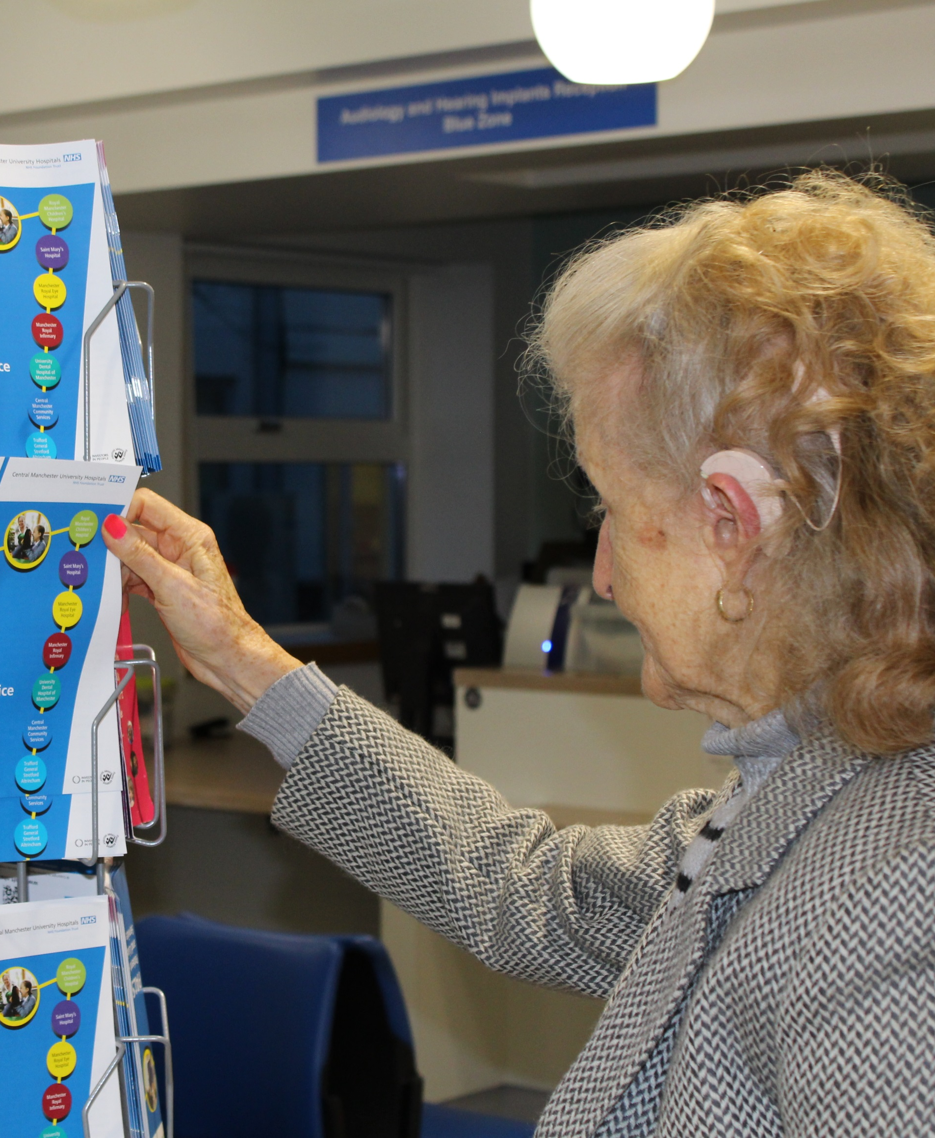
The Richard Ramsden Centre for Hearing Implants Annual Report 2016-2017
ADULT COCHLEAR IMPLANT PROGRAMME

- Introduction

Cochlear implantation has been established in the UK for over 3 decades and there are currently just over 16000 patients in the UK using cochlear implants (see Figure 1).

Figure 1: Total number of maintained patients in the UK (from BCIG’s annual data collection 2016-17)

The auditory implant programme in Manchester was established in 1988 by ENT Consultant Richard Ramsden, using funding to provide cochlear implants obtained from the HEAR (Help Ear & Allied Research) Charity. In the mid 1990’s government resources became available to fund cochlear implants for patients with severe-profound sensori-neural hearing loss. By the end of March 2017, 1168 adults have received a cochlear or an auditory brainstem implant on the programme manufactured by Advanced Bionics, Cochlear and MED-EL.

- The team

Andy Cooper – Assistant Audiologist

Angela Fuller – Assistant Audiologist

Anne Stockbridge – Administrator

Christine Melling – Speech and language therapist

Deanne Jayewardene-Aston – Audiologist

Deniece Walker – Administrator

Deborah Mawman – Audiologist and Coordinator

Elizabeth Whittle – Audiologist

Karen Smith – Hearing Therapist

Martin O’Driscoll – Audiologist and Head of Department

Sarah Hornby – Audiologist

Simon Freeman – Surgeon

Simon Lloyd – Surgeon

Unai Martinez de Estibariz – Audiologist

Vicki Carek – Clinical Psychologist

- Criteria for referral to the adult programme for cochlear implants

There is no maximum age for referral and patients with additional needs are not excluded (www.nice.org.uk/guidance/ta166):

    - Bilateral, severe to profound sensori-neural hearing loss (≥ 90 dB HL at 2 and 4 kHz).

    - Limited or no benefit from hearing aids (a score of less than 50% on BKB sentence testing at a sound intensity of 70 dB SPL in the ear to be implanted).

    - Simultaneous bilateral cochlear implantation is recommended as an option for adults who are blind or who have other disabilities that increase their reliance on auditory stimuli as a primary sensory mechanism for spatial awareness.

    - Cochlear implantation is considered for adults only after an assessment by a multidisciplinary team. As part of the assessment adults should also have had a valid trial of an acoustic hearing aid for at least 3 months (unless contraindicated or inappropriate).

- Clinical activity between April 2016 and March 2017

- Treatments
During the financial year 2016-2017, a total of 98 cochlear implant procedures were performed in adults.

- Surgery

In recent years, patients with residual low frequency hearing ≤ 80 dB at 500 Hz have undergone hearing preservation surgery (Bruce et al., 2011).

Figure 2: Surgical procedures

The aim of this surgery is to preserve as much natural hearing as possible. This cohort of patients may be suitable for an Electro-Acoustic Stimulation (EAS) device which combines both electrical stimulation through a cochlear implant and acoustic amplification through a hearing aid. This is contingent on patients having hearing thresholds ≤ 65 dB at 500 Hz. In 2016-17, patients who fit this criterion were implanted with the MED-EL Synchrony Flex 28 implant or the Cochlear 522 implant. A Sonnet EAS or Cochlear Hybrid speech processor was fitted post operatively if there was enough residual hearing to aid acoustically. If the preserved hearing was not sufficient, the patient was fitted with a standard cochlear implant speech processor, namely a Sonnet for MED-EL users and N7 for Cochlear users. (See figure 2 for a detailed distribution on types of surgery performed in 2016-17).
- Explantations

4 explantations were carried out in this financial year, all due to medical reasons, following the International Classification of Reliability for Implanted Cochlear Implant Receiver Stimulators by Battmer et al. (2010) (see figure 3). All these explantations would be categorised as ‘Medical Problem (D)’. Three of the explanted patients were successfully re-implanted. One patient continues to suffer from recurrent ear infections in the implanted ear which may be related to a pre-existing medical condition and his management is on-going.

Figure 3: Classification of device reliability

- Devices
A total of 90 devices were fitted in this financial year. Detailed charts on the types of internal devices, manufacturers and type of speech processor are shown in figures 4 to 6.

Figure 4: Implant electrodes used in 2016-17

Figure 5: Implants by manufacturer 2016-17

Figure 6: Type of processor used

- Demographics

The average age of adult cochlear implant patients was 59 years (range = 23 - 84 years). Figure 7 shows the age distribution of the implanted adult population during the 2016-2017 financial year period.

Figure 7: Age of patient at implant

- Post-implant support

Patients typically attend 5 appointments with the adult team within their first six weeks of implant use. During these appointments the speech processor is programmed and patients receive rehabilitation through an individualised auditory and communication skills training programme. The training programme includes tactics for using the telephone, music therapy and advice about using assistive listening devices. Patients are then followed up at three, nine and twenty-one months after their initial activation. Additional rehabilitation sessions are offered to patients as required. Following this, a patient led appointment is sent on an annual basis. Every 6 years the patient will be offered a speech processor upgrade.

- Outcomes

Speech perception scores are measured for each patient at the pre-implant stage. Following implantation, outcomes are measured at one week, three months, nine months and twenty-one months, and then annually as required. Figure 8 shows the average scores obtained on speech perception test for Bamford-Kowal-Bench (BKB) sentences in quiet and noise in the cochlear implant only (n=62) and bimodal (patients using a cochlear implant in one ear and a hearing aid in the other ear) condition (n=15) for patients tested in the 2016-2017 period.

Figure 8: Speech perception outcomes

Sound-field aided thresholds with their cochlear implant are also measured at the different review stages. Figure 9 shows the average aided thresholds at the 9 month stage. Thresholds ≤ 40 dB HL at frequencies between 250 and 8000 Hz allow good access to normal conversational speech levels and everyday sounds.

Figure 9: Average aided threshold at 9 months of implant use
✦ Satisfaction
A satisfaction questionnaire is sent to all newly implanted users at their 9 month post implant stage to gauge their views on their cochlear implant progress and our service. All responses are anonymous. Below are a few facts from this survey as collected from the 16-17 financial year period:

- 75% of respondents report that their cochlear implant exceeded their expectations.
- 100% of respondents report using their cochlear implant every day, all day long
- 92% of respondents report obtaining great benefit from their cochlear implant
- 92% of respondents feel it was worthwhile having a cochlear implant
- 100% of respondents would recommend a cochlear implant to a friend or relative if they had a similar hearing problem
- 92% of respondent were satisfied with the treatment/support that they received from the staff on the cochlear implant programme
- 100% of respondents rated the treatment/support that the staff at the cochlear implant programme provided as very good

Below are statements from respondents with regards to why they felt this treatment was worthwhile:

- “ Made a huge difference ”
- “ It definitely opened up a whole new world ”
- “ I am hearing more and have been able to use the telephone “
- “ More aware of the surroundings ”
- “ I can hear sounds I've not heard for years ”
- “ I feel more confident in social areas ”
- “ I was apprehensive beforehand but so glad I went ahead ”

Among the disadvantages noted by cochlear implants users, the following were reported: short battery life, travel distance to center, wind noise annoyance and limited enjoyment of music.

AUDITORY BRAINSTEM IMPLANT PROGRAMME

- Introduction
The programme has the largest population of auditory brainstem implant (ABI) users in the UK. The majority of these patients have Neurofibromatosis Type 2.

The auditory brainstem implant (ABI) depicted in figure 10 evolved from cochlear implant technology to address the problems of rehabilitating patients with total deafness with a damaged or absent cochlear nerve, and are therefore unsuitable for cochlear implantation. The great majority of these patients suffer from the genetic disorder neurofibromatosis type 2 (NF2). This condition affects one in 33,000 live births and is characterised by the development of bilateral vestibular schwannomas. More recently other indications for ABI have been suggested including cochlear nerve aplasia or severe dysplasia in infants, extreme degrees of inner ear dysplasia even in the presence of normal looking auditory nerves, severe cochlear obliteration from otosclerosis or meningitis, and head injury with cochlear nerve avulsion. These conditions prevent effective cochlear implantation.

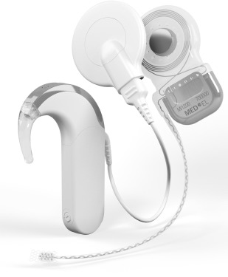
Figure 10: The auditory brainstem implant and external speech processor

The ABI stimulates the cochlear nucleus complex directly. It is located in a fairly predictable position and is usually easy to identify in the undistorted brainstem. The paddle shaped electrode array is placed on the surface of the cochlear nucleus complex in the floor of the foramen of Luschka in the lateral recess of the fourth ventricle (see figure 11).
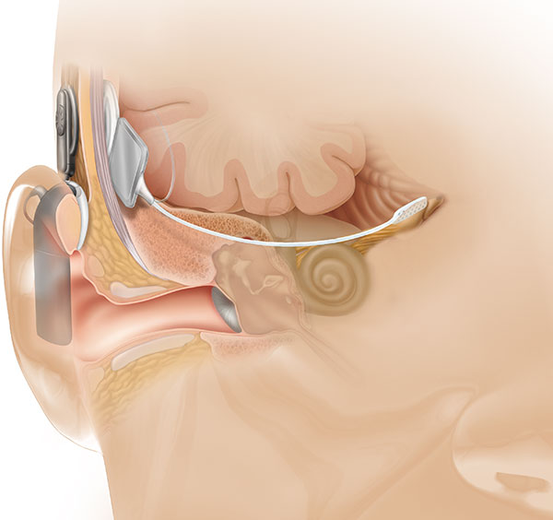
Figure 11: Placement position of the auditory brainstem implant

The external speech processor is activated about 6 weeks post-surgery and patients undertake a similar programme of tuning and rehabilitation to cochlear implant patients. The ABI provides limited speech understanding for patients although it can help patients to understand speech better with lipreading (see figure 12). It also helps patients to hear and identify everyday sounds.

Figure 12: Comparison of scores using the ABI only, lipreading (LR) only and the ABI with lipreading.

Manchester is one of only two centres in the UK commissioned to provide ABI’s for NF2 patients. The ABI surgery takes place at Salford Royal Hospital and subsequent rehabilitation with the implant takes place at the Manchester Royal Infirmary.

To date, the team has performed 73 ABI surgeries in 71 adults. Two patients had bilateral ABI’s. Two non NF2 patients also received an ABI. The first patient was treated because of advanced cochlear ossification. The second patient was treated because of cochlear polyposis.
MEDIA AND PUBLIC RELATIONS

In a television first, Channel 4 broadcasted an observational documentary LIVE from the Richard Ramsden Hearing Implant Centre titled “Breaking the Silence”. The programme allowed viewers to share the moment eight patients heard for the first time when their cochlear implant was switched on. Staff and patients from the Manchester implant centre as well as other centers from around the UK, were involved in the ground breaking documentary.

http://www.channel4.com/programmes/breaking-the-silence-live/on-demand/63119-002

Following the live broadcast, our Head of Department, Martin O’Driscoll, appeared on the BBC Breakfast TV programme to talk about the benefits of cochlear implantation.

REFERENCES

- Hearing preservation cochlear implantation in children: The HEARRING Group consensus and practice guide.
Rajan G, Tavora-Vieira D, Baumgartner WD, Godey B, Müller J, O'Driscoll M, Skarzynski H, Skarzynski P, Usami SI, Adunka O, Agrawal S, Bruce I, De Bodt M, Caversaccio M, Pilsbury H, Gavilán J, Hagen R, Hagr A, Kameswaran M, Karltorp E, Kompis M, Kuzovkov V, Lassaletta L, Yongxin L, Lorens A, Manoj M, Martin J, Mertens G, Mlynski R, Parnes L, Pulibalathingal S, Radeloff A, Raine CH, Rajeswaran R, Schmutzhard J, Sprinzl G, Staecker H, Stephan K, Sugarova S, Zernotti M, Zorowka P, Van de Heyning P.
Cochlear Implants Int. 2018 Jan;19(1):1-13. doi: 10.1080/14670100.2017.1379933. Epub 2017 Oct 26.

- Review of outcomes and measurement instruments in cochlear implantation studies.
Schaefer S, Henderson L, Graham J, Broomfield S, Cullington H, Schramm D, Waltzman S, Bruce I.
Cochlear Implants Int. 2017 Sep;18(5):237-239. doi: 10.1080/14670100.2017.1353761. Epub 2017 Jul 25. No abstract available.

- Hearing optimisation in neurofibromatosis type 2: A systematic review.
Lloyd SKW, King AT, Rutherford SA, Hammerbeck-Ward CL, Freeman SRM, Mawman DJ, O'Driscoll M, Evans DG.
Clin Otolaryngol. 2017 Dec;42(6):1329-1337. doi: 10.1111/coa.12882. Epub 2017 Apr 26.

- United Kingdom national paediatric bilateral project: Results of professional rating scales and parent questionnaires.
Cullington HE, Bele D, Brinton JC, Cooper S, Daft M, Harding J, Hatton N, Humphries J, Lutman ME, Maddocks J, Maggs J, Millward K, O'Donoghue G, Patel S, Rajput K, Salmon V, Sear T, Speers A, Wheeler A, Wilson K.
Cochlear Implants Int. 2017 Jan;18(1):23-35. doi: 10.1080/14670100.2016.1265189. Epub 2017 Jan 18.

- United Kingdom national paediatric bilateral project: Demographics and results of localization and speech perception testing.
Cullington HE, Bele D, Brinton JC, Cooper S, Daft M, Harding J, Hatton N, Humphries J, Lutman ME, Maddocks J, Maggs J, Millward K, O'Donoghue G, Patel S, Rajput K, Salmon V, Sear T, Speers A, Wheeler A, Wilson K.
Cochlear Implants Int. 2017 Jan;18(1):2-22. doi: 10.1080/14670100.2016.1265055. Epub 2016 Dec 23.

- Outcomes of cochlear implantation in patients with neurofibromatosis type 2.
North HJ, Mawman D, O'Driscoll M, Freeman SR, Rutherford SA, King AT, Hammerbeck-Ward C, Evans DG, Lloyd SK.
Cochlear Implants Int. 2016 Jul;17(4):172-177.

- Auditory Brainstem Implantation in Neurofibromatosis Type 2: Experience From the ManchesterProgramme.
Ramsden RT, Freeman SR, Lloyd SK, King AT, Shi X, Ward CL, Huson SM, Mawman DJ, O'Driscoll MP, Evans DG, Rutherford SA; Manchester Neurofibromatosis Type 2 Service.
Otol Neurotol. 2016 Oct;37(9):1267-74. doi: 10.1097/MAO.0000000000001166.

- Compliance with cochlear implantation in children subsequently diagnosed with autism spectrum disorder.
Valero MR, Sadadcharam M, Henderson L, Freeman SR, Lloyd S, Green KM, Bruce IA.
Cochlear Implants Int. 2016 Jul;17(4):200-206. Epub 2016 Aug 4.

- Consensus statement: Long-term results of ABI in children with complex inner ear malformations and decision making between CI and ABI.
Sennaroğlu L, Colletti V, Lenarz T, Manrique M, Laszig R, Rask-Andersen H, Göksu N, Offeciers E, Saeed S, Behr R, Bayazıt Y, Casselman J, Freeman S, Kileny P, Lee DJ, Shannon RV, Kameswaran M, Hagr A, Zarowski A, Schwartz MS, Bilginer B, Kishore A, Sennaroğlu G, Yücel E, Saraç S, Ataş A, Colletti L, O'Driscoll M, Moon IS, Gärtner L, Huarte A, Nyberg G, Mocan BÖ, Atay G, Bajin MD, Çınar BÇ, Batuk MÖ, Yaralı M, Aydınlı FE, Aslan F, Kirazlı MC, Özkan HB, Hans JM, Kosaner J, Polak M.
Cochlear Implants Int. 2016 Jul;17(4):163-171. Epub 2016 Jul 21. No abstract available.

- Unilateral cochlear implantation in children with a potentially useable contralateral ear.
Sadadcharam M, Warner L, Henderson L, Brown N, Bruce IA.
Cochlear Implants Int. 2016 Apr;17 Suppl 1:55-8. doi: 10.1080/14670100.2016.1155832.

- Cochlear implantation in early deafened, late implanted adults: Do they benefit?
Kumar RS, Mawman D, Sankaran D, Melling C, O'Driscoll M, Freeman SM, Lloyd SK.
Cochlear Implants Int. 2016 Apr;17 Suppl 1:22-5. doi: 10.1080/14670100.2016.1161142.

- Preliminary assessment of the feasibility of using AB words to assess candidacy in adults.
Vickers DA, Riley A, Ricaud R, Verschuur C, Cooper S, Nunn T, Webb K, Muff J, Harris F, Chung M, Humphries J, Langshaw A, Poynter-Smith E, Totten C, Tapper L, Ridgwell J, Mawman D, de Estibariz UM, O'Driscoll M, George N, Pinto F, Hall A, Llewellyn C, Miah R, Al-Malky G, Kitterick PT.
Cochlear Implants Int. 2016 Apr;17 Suppl 1:17-21. doi: 10.1080/14670100.2016.1161143.

Figure XXX: BKB sentence scores (auditory alone)

