Better Payment Practice Code
Our Trust is committed to dealing fairly and professionally with all of our supplier partners. One way that we do this is by working to the Better Payment Practice Code. In short, this means that we aim to pay at least 95% of invoices within the agreed terms, unless there is a dispute. For most of our partners, this would be within 30 days of the date of invoice. However, for suppliers who can demonstrate that they are a Small or Medium Enterprise (SME), we bring payments forward to 10 days or sooner.
In order to qualify as an SME, a company must meet the following criteria:
Have less than 250 employees
AND
Have a turnover of less than €50m (approx. £35.7m) OR a balance sheet of less than €43m (approx. £30.7m)
If you believe that your company falls into this category and you would like to be promoted to 10 day payment terms, please contact accounts.payable@cmft.nhs.uk
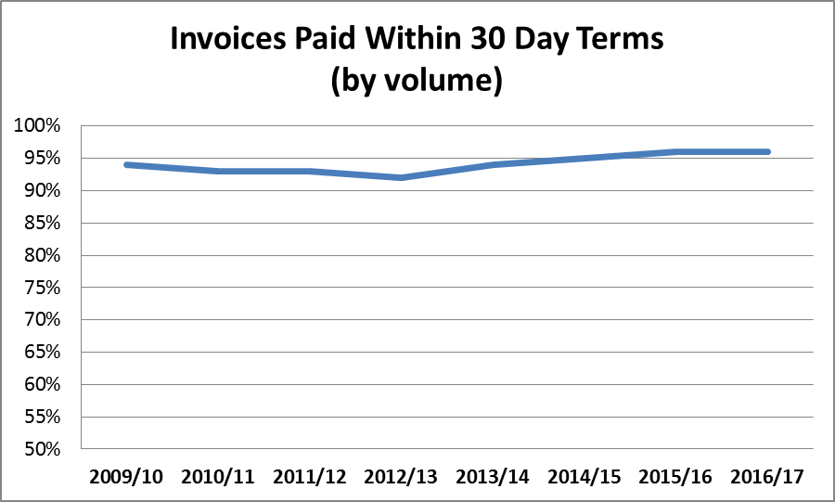
For reference, our performance over the last few years is shown below:

