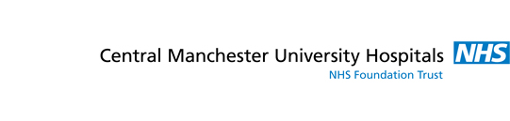

Sustainable Procurement Policy
Central Manchester is committed to promoting the conservation and improvement of the environment.

Sustainable procurement is a process whereby organisations meet their needs for goods, services, works and utilities in a way that gets value for money on a whole life basis. This means generating benefits both to the organisation and to society and the economy, as well as minimising damage to the environment.
Central Manchester’s policy on sustainable procurement is to:
- Comply with environmental legislation and regulatory requirements
- Make suppliers and contractors aware that we promote environmental awareness
- Wherever possible, avoid buying environmentally damaging products and services
- Consider environmental factors when making procurement decisions
- Develop awareness of environmental issues
We will:
- Aim to include environmental conditions or criteria in specification and tender documents wherever possible
- Evaluate specifications and tenders with appropriate weight given to environmental points
- Encourage small and medium enterprises (SMEs) and local suppliers to bid for appropriate work through relevant frameworks
- Encourage suppliers and contractors to support our lead by taking their own action
Trust staff must:
- Question the need for new items (Do we really need it? Could it be borrowed or shared? Could we use fewer?)
- Operate and dispose of products in an environmentally friendly way, including finding alternative owners or applications and avoiding landfill
Procurement staff will:
- Aim to check and draft specifications that allow recycled, used or innovative items or services to be acquired
- Apply life cycle costing wherever possible in procurement decisions

