7878

Accredited Laboratory
Reference No: 03-GB-009.991

A Guide to the
Histocompatibility
and
Immunogenetics Services
(Tissue Typing)
Provided in support of

Disease Diagnosis and the Prediction of

Adverse Drug Reactions

Revised May 2018 Dr Kay Poulton, Alison Logan, Dr Helena Lee, Karen Wood, Jennifer Lord, Dr Anna Barker, Natalia Diaz Burlinson and Julie Johnson
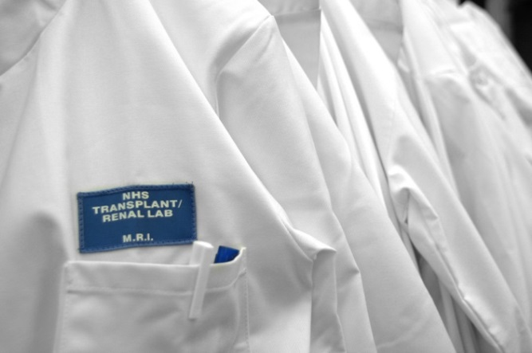

This guide outlines the Histocompatibility and Immunogenetics (H&I) services provided by the Transplantation Laboratory, Manchester Royal Infirmary in support of the disease diagnosis and the prediction of adverse drug reactions. The guide is of use to clinical and support staff in the Manchester Royal Eye Hospital, Rheumatology and Neurology departments, Sexual Health clinics, Genitourinary Medicine and GP surgeries.

Next Review due April 2019

Contents
Introduction 3
2. General Information 6
2.1 Postal Address 7
2.2 Business Hours 7
2.3 Laboratory Key Personnel 7
2.4 Essential Telephone Numbers 8
2.5 Essential Email Addresses 8
2.6 Internet page 8
3. Use of the Laboratory 9
3.1 Service Availability 9
3.2 Labelling of sample containers 9
3.3 Transportation of routine samples to the laboratory 10
3.4 Urgent samples 10
3.5 Acceptance time limit after sample drawing 10
4 General Information and Notes on Services & Tests Available 11
4.1 Descriptions of Standard Tests 12
5. Requesting Tests/Samples Required 13
5.1 HLA Disease Association Request 13
6. Reporting of Results 14
Appendix 1 15
Requirements for sending specimens by post:- 15

Introduction

The Transplantation Laboratory is a regional speciality pathology service and as such offers a wide range of high quality, efficient and cost-effective services using state of the art technologies to Manchester University NHS Foundation Trust, other regional Trusts, and healthcare providers.

The main services provided by the Transplantation Laboratory are described below:

- Solid Organ Transplantation
The Transplantation Laboratory provides Histocompatibility & Immunogenetics (H&I) support for –
- Kidney, kidney and pancreas, pancreas and islet cell transplantation programmes at Manchester Royal Infirmary.
- Cardiothoracic organ transplantation at Wythenshawe Hospital
  - Corneal transplantation at the Manchester Royal Eye Hospital, Victoria
Hospital, Blackpool and North Manchester General Hospital.
There is a 24 hour on-call service for kidney / kidney and pancreas / pancreas only / islet transplantation and all thoracic organ transplants.

- Haematopoietic Progenitor Stem Cell Transplantation
The Transplantation Laboratory provides H&I support for the haematopoietic progenitor stem cell transplantation programmes at Manchester University NHS Foundation Trust (MRI and RMCH). The laboratory provides both intermediate and high resolution molecular typing of patients and their potential donors who may need a stem cell or bone marrow transplant.

- Immunogenetics testing
The Transplantation Laboratory provides testing for Manchester University NHS Foundation Trust, Primary Care Centres and regional hospitals to support
- disease diagnosis and management
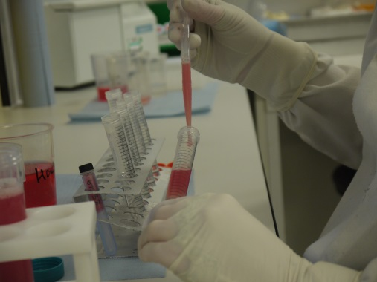
- the prediction of drug hypersensitivity.
- A range of tests is provided, including HLA-B*27 and HLA-B*57:01 definition and HLA typing of other loci to support the diagnosis of Actinic Prurigo, Uveitis, Birdshot Retinopathy, Narcolepsy and Coeliac Disease.
- Testing can be individually tailored according to clinical requirement upon request.

- Research and Innovation
The Transplantation Laboratory participates in research and innovation relevant to the clinical services provided to ensure that we continually improve our service provision in line with the clinical evidence base. Projects are closely tailored to local clinical practice to ensure the right services are provided at the right time for the right patients.
The Transplantation Laboratory is part of a network, which is cross-directorate and is known as the Manchester Institute of Nephrology and Transplantation (MINT). MINT is a multi-professional body of physicians, surgeons, nursing staff, scientists, other professions allied to medicine and managers. Its aim is to improve and develop the research and educational activities of the nephrology, dialysis and transplantation services to achieve the best possible care for transplant patients.
e) Audit
The Transplantation Laboratory is actively involved in audit related to laboratory activities as well as clinical audit in conjunction with the services we support. The process of clinical audit directly relates to the Trust’s Clinical Effectiveness Strategy that aims to improve the quality and outcome of patient care. The laboratory also has an internal audit cycle against ISO 15189:2012 and European Federation for Immunogenetics standards to ensure continual compliance and continual improvement.

f) Quality assurance
The Transplantation Laboratory has full UKAS ISO 15189 accreditation (UKAS Reference No 7878) for medical laboratory services and EFI (European Federation of Immunogenetics) accreditation.
7878
The laboratory has a well-established quality management system in operation which allows the laboratory to be focused on continual improvement in line with needs and requirements of our users. The QMS provides a structured framework for the laboratory and is monitored and maintained by the Laboratory Operations and Quality Manager. The Quality Policy which is reviewed annually describes the aims of the services.
Any test performed in the laboratory is subject to a variety of factors that may influence the outcome of the result. Some of these factors include the sample itself, the test method, reagents used and different operators carrying out the same process. Variations can also be caused by procedures that involve the measurement of analytes and reagents whereby environmental factors such as temperature and humidity may affect results. Any equipment used in the process will further introduce the opportunity for variation. To provide a measure of confidence in results produced it is necessary to identify all factors which may contribute to variation in a process and assess their potential to influence uncertainty. Once identified these factors must be reduced or controlled to an acceptable level and a value for the range of acceptable uncertainty assigned where possible.
The Transplantation laboratory has chosen, where possible, to utilise internal Quality Control material and data to establish Uncertainty of Measurement where applicable. Upon request the laboratory shall make its estimates of measurement of uncertainty available to laboratory users.
Participation in external quality assurance programmes such as UK NEQAS and UCLA schemes together with continual internal quality assessment monitoring of our tests ensures that the laboratory's high quality standards are maintained.
UK NEQAS schemes conform to high standards of professionalism, impartiality, clinical relevance and strict financial accountability across all disciplines and specialities, so that all concerned with the quality of laboratory investigations may have confidence in the service provided.
A highly experienced consultant team offers support to clinicians and service users 24 hours a day, seven days a week. The team provides information related to using the service, interpretation of test results and clinical advice. Reviews and changes to the service provision will be in consultation with our users and will be clearly defined in revised Service Level Agreements (SLAs), where applicable.
The Transplantation Laboratory actively supports and encourages staff training and continual professional development. It is recognised by the Royal College of Pathologists, the National School for Healthcare Sciences and the British Society for Histocompatibility and Immunogenetics as a training laboratory in Histocompatibility and Immunogenetics. Where appropriate staff members are registered with the Health and Care Professions Council (HCPC).
Details of our accreditation, including current certificates and performance data, are available upon request from the Laboratory Operations and Quality Manager (julie.johnson2@mft.nhs.uk).
In order to help us improve our service, you may be asked to complete a questionnaire. We greatly appreciate and value your input and would like to thank you in anticipation of your assistance and suggestions.
g) Complaint Procedure
The Transplantation Laboratory is continually aware of, and takes into consideration the requirements of its users and staff, whilst striving to create the best standards of professional care. According to Trust policy, any complainants are referred to the Patient Advice and Liaison Service (PALS) who can support staff and patients to achieve speedy solutions. Complaints can also be directed to the Laboratory Director, a Consultant Clinical Scientist or any Transplantation Laboratory representatives at Multidisciplinary Team meetings. Please make any concerns you have about the quality of the service known to us as soon as possible; we take your complaints seriously.
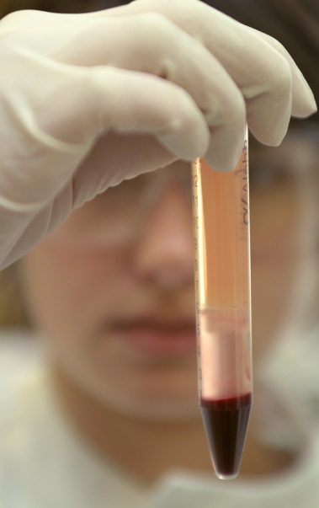
Any suggestions from users on any aspect of our service provision, or indeed how the User Guide could be improved, are very welcome. Please forward any suggestions to the Laboratory Operations & Quality Manager (julie.johnson2@mft.nhs.uk).

h) Clinical Liaison and Advice

A Consultant Clinical Scientist or deputy will always be available to attend multi-disciplinary team meetings as required in order to ensure optimum communication between the laboratory and clinical teams and provide advice relating to the Histocompatibility and Immunogenetics Service.
An experienced consultant team offers support to clinicians and service users 24 hours a day, seven days a week. The team provides information related to using the service, interpretation of test results and clinical advice.
A 24-hour, 365-day on-call service is provided for deceased donor HLA typing and crossmatching and a Consultant Clinical Scientist is similarly available for the provision of advice.
- Confidentiality and Personal Information

The Transplantation Laboratory adheres to Manchester University NHS Foundation Trust’s policies on data protection and disclosure.

2. General Information

2.1 Postal Address

Transplantation Laboratory

2nd Floor, Purple Zone

Manchester Royal Infirmary

Oxford Road

Manchester M13 9WL

Tel 0161 276 6397

Fax 0161 276 6148

2.2 Business Hours

Opening Hours for routine work: 08.30 – 17.00

Out of hours, weekends and Bank holidays: On call staff & Consultant Clinical Scientist can be paged via MFT switch

Tel: 0161 276 1234

2.3 Laboratory Key Personnel

Laboratory Director

Dr Kay Poulton PhD, FRCPath

Consultant Clinical Scientist,

0161 276 6397

Email: kay.poulton@mft.nhs.uk

Deputy Director

Mr Stephen Sheldon, FRCPath

Consultant Clinical Scientist

Tel: 0161 276 6397

Email: stephen.sheldon@mft.nhs.uk

Consultant Clinical Scientist

Ms Natalia Diaz Burlinson, FRCPath

Consultant Clinical Scientist

Tel: 0161 276 6397

Email: Natalia.DiazBurlinson@mft.nhs.uk

Immunogenetics Support Services enquiries:

Dr Helena Lee PhD, FRCPath

Principal Clinical Scientist

Telephone: 0161 276 6662

E-mail: helena.lee@mft.nhs.uk

Alison Logan MPhil

Principal Clinical Scientist

0161 276 6661

Email: alison.logan@mft.nhs.uk

Laboratory Operations and Quality Manager

Julie Kane MSc, HCPC

Principal Clinical Scientist

0161 276 6424

Email: julie.johnson2@mft.nhs.uk

General Enquires

Business and Administration Manager

Judith Spencer

Tel: 0161 276 6397

Fax: 0161 276 6148

Email: judith.spencer@mft.nhs.uk

2.4 Essential Telephone Numbers

Specimen Reception: 0161 276 6471

Admin office: 0161 276 6397

Immunogenetics Service: 0161 276 6661/6662

2.5 Essential Email Addresses

Enquiries: cmm-tr.Transplantationlabhsct@nhs.net Transplantationlaboratory.HSCT@mft.nhs.uk

2.6 Internet page

http://www.cmft.nhs.uk/royal-infirmary/our-services/transplantation-laboratory

3. Use of the Laboratory

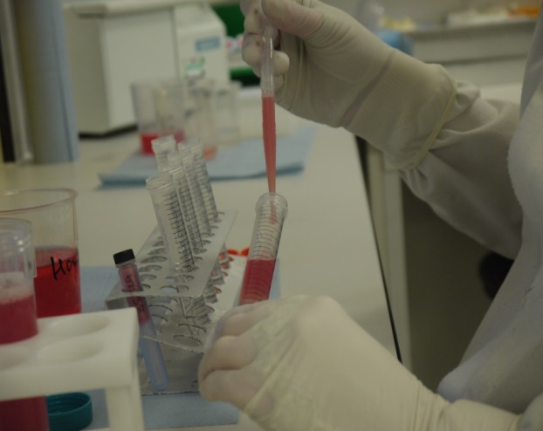
3.1 Service Availability

The laboratory is open for receipt of routine specimens from 08:30 to 17:00 between Monday and Friday. Internal on site samples may be sent directly to the laboratory using the pneumatic pod system (Transplantation Pod No: 805).

There is an on-call service provision available outside of normal working hours provided by an on call team consisting of a HCPC registered Clinical Scientist, a technologist and a Consultant Clinical Scientist. This service is generally restricted to solid organ transplant programme and the Tissue Typing team are contactable by pager via the hospital switchboard (0161 276 1234).

3.2 Labelling of sample containers
The Transplantation Laboratory will make every effort to ensure requests are processed in a safe and timely manner but it is essential that request forms and samples are labelled appropriately and legibly. The minimum acceptance criteria for request are 3 key identifiers that should include at least:

- Patient’s name (forename and surname)
- Date of birth
- Hospital number and/or MRI District number
- NHS number
- Home Address of the patient.

These are all identifiers specific to the patient which help us to confirm identity and are essential. *NB It is recognised and accepted that in certain instances some patient identifiers must be anonymised.

It is also important to clearly identify the investigations required when completing the request card, please only select the test required and send only the appropriate sample tube.

If you have any concerns regarding this please ring 0161 276 6471 / 6397 for further advice.

Specimens will not be accepted for analysis if:
- There is insufficient unique identification of the patient i.e. they do not meet the minimum data set for identification
- Incorrect sample type or tube
- Incorrect transportation conditions mean that the sample is unsuitable
- Sample is received in a hazardous condition e.g. leaking or sharps attached.
- Sample is unlabelled or incorrectly labelled with less than the minimum data set required for patient identification
- Mismatch of details between the form and sample(s)
- The information provided is illegible

Samples that fail to meet the above criteria will be discarded as unsuitable for analysis, and the sender will be informed. The only exception to this is for patients whose identity is anonymous and they have their own unique identifier, for example patient samples from Genitourinary Medical Centres or potential bone marrow donors.

3.3 Transportation of routine samples to the laboratory
All users are advised to refer to P650 Packaging Instruction@ which applies to UN No. 3373 (Diagnostic Specimens) for information on the correct procedures for packaging and transporting samples. When sending samples to the laboratory it is important to follow the correct courier and postal procedures and ensure the specimens are appropriately packaged.
All specimens should be transported at room temperature (between 22ºC - 25ºC), unless otherwise instructed, avoiding where possible prolonged over exposure to heat. The samples should be transported directly to the laboratory as quickly as possible after collection to maintain the integrity of the sample and avoid compromising the results.
Internal on site specimens may be transported directly to the Transplantation Laboratory via the porter’s rounds during the normal working day or by pneumatic pod system to Pod No. 805. Samples should be placed in a specimen bag with the request for transportation around the trust.
Please contact the laboratory on 0161 276 6471 / 6397 if there are specific questions regarding transportation of specimens.

3.4 Urgent samples
If a result is required urgently and the sample will arrive during working hours the laboratory MUST be notified by telephone so that we can prioritise your request.

All samples should be packaged and transported as above.

If you need to submit a sample out of normal working hours for testing on-call please contact the Tissue Typer on-call via the hospital switchboard (0161 276 1234).

3.5 Acceptance time limit after sample drawing
EDTA blood for HLA typing No time limit

EDTA samples can also be kept overnight at room temperature avoiding any excessive heat exposure.
Request cards can be obtained from the Admin Manager, please call on 0161 276 6397 or email: judith.spencer@mft.nhs.uk. These request cards are also available in electronic format upon request.

4. General Information and Notes on Services & Tests Available

HLA molecules are crucial to normal immune processes, enabling the cells involved in immune responses to recognise foreign organisms and react against them. An individual’s HLA type defines the combination of these HLA molecules on the surface of their body cells .The HLA genes are unique in the human genome because of their considerable variability, which results in many different HLA types otherwise known as “tissue types".
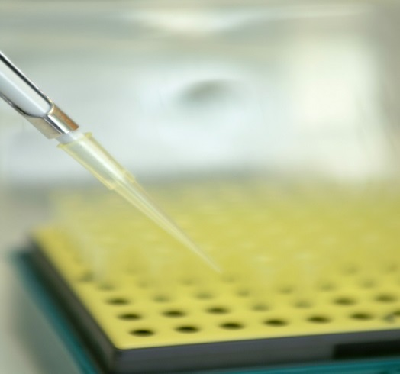

The HLA genes are identified by letters and subdivided into various distinct loci e.g. HLA-A and HLA-B. HLA molecules identified within these loci are numbered, e.g. HLA-A*29 and HLA-B*27. For some illnesses and conditions, it has been shown that all the patients have the same HLA type. The HLA type may be involved in the disease process, but it also acts as a marker for a particular disorder and clinicians can use this information, together with patient’s symptoms, to decide how best to treat and care for the patient.

The most common requests for HLA typing to support disease diagnosis are in the following illnesses and conditions, where a very strong association with the disease is established:
- Ankylosing Spondylitis and Uveitis (B*27)
- Narcolepsy (DQA1*01:02 / DQB1*06:02)
- Coeliac Disease (DQB1*02:01 / *03:02, DQA1*05:01 / *03:01)
- Behçets Disease (B*51)
- Actinic Prurigo (DRB1*04:07)
- Birdshot Retinopathy (A*29)

We also provide HLA typing services to support clinical care in cases where the HLA association is less strong, but where ruling out susceptible HLA types would help direct diagnosis. Please contact one of the Consultant Clinical Scientists if you have a need for this service.

In addition, HLA types are used as markers to predict severe drug hypersensitivity reactions prior to therapy, eg B*57:01 and Abacavir sensitivity. When taking Abacavir, it is possible for the drug to be incorporated into the HLA molecule in HLA-B*57:01 positive individuals, causing abnormal antigen presentation. This causes the immune system to develop a misplaced and severe self-directed reaction. HLA types have also be associated with hypersensitivity to other drugs, and testing for these less common associations can be performed upon request. This can be arranged via a Consultant Clinical Scientist.

4.1 Descriptions of Standard Tests

What is HLA Typing (Tissue Typing)?

HLA (Tissue) typing refers to the series of DNA based laboratory tests whereby an individual’s HLA genes are characterised and hence the HLA molecules expressed on the surface of their cells identified. HLA molecules are on the surface of all the nucleated cells (i.e. in humans, all cells apart from red blood cells) but for ease of sampling, DNA from peripheral blood cells is routinely used.

DNA based tests are able to define variations in the HLA genes. This means that not only can tests offering much higher resolution typing be performed, but DNA can be extracted from blood samples taken some days earlier.

The DNA based tests used for HLA typing in this laboratory are referred to as Next generation sequencing technology, LABType®SSO, PCR-SSP and Linkseq.

The sample used for HLA typing is 5ml EDTA blood.

5. Requesting Tests/Samples Required

The Transplantation Laboratory has its own distinctive request cards which can be obtained from the Administrative Manager. (Judith.Spencer@mft.nhs.uk) Internal MFT requests should be made through ICE using the Transplantation Laboratory tab, following the CMFT procedure. All other requests should be made using the Transplantation Laboratory request card following the procedure described below for the test required. The Disease Association test request card has a black and white striped margin at the bottom of the card.

5.1 HLA Disease Association Request

Complete the request card – an example is shown below. Send 5ml EDTA blood

As a minimum requirement, include patient surname and forename (or alternative identifiers), date of birth, hospital number, referring hospital, consultant, person requesting the test and the date sample was taken.

It is essential that the patient is clearly identified on the card and on the specimen.

*NB It is recognised and accepted that in certain instances some patient identifiers must be anonymised.

In the interest of safety, inadequately labelled specimens cannot be accepted.
THE TRANSPLANTATION LABORATORY, MANCHESTER ROYAL INFIRMARY

TEL: 0161 276 6397 FAX: 0616 276 6148

SURNAME* FORENAME* DATE OF BIRTH* SEX
HOSPITAL*

HOSPITAL NUMBER* NHS NUMBER BLEED DATE BLEED TIME

CONSULTANT*

REQUESTED BY DIAGNOSIS / COMMENTS ETHNIC ORIGIN

TESTS REQUIRED*:

HLA B57
SEND 5ml EDTA BLOOD

HLA B27 UVIETIS
- SEND 5ml EDTA BLOOD ⇨ 5ml EDTA

HLA – DR SUB TYPING (ACTINIC PURIGO) BIRDSHOT RETINOPATHY
⇨ 5ml EDTA ⇨ 5ml EDTA

OTHER (please specify)

__________________________ SEND 5ml EDTA BLOOD

* ESSENTIAL INFORMATION REQUIRED IN ORDER TO PROCESS REQUEST

6. Reporting of Results
To maintain patient confidentiality and comply with the Data Protection Act and other legal requirements results are reported in writing or electronically by email to an authorised individual. Reports are signed by a Consultant Clinical Scientist or named deputy, with the addition of an interpretive comment for clarity. Results are only reported by telephone after agreement by a Consultant Clinical Scientist. Provision of non-urgent results by fax is available upon request during office hours.
Turnaround Time (TAT)
Over 90% of the results are reported within 5 working days of receipt of samples. Special arrangements requiring a shorter turnaround may be established on a user-specific basis, by arrangement with the Consultant Clinical Scientist and subject to the technical limitations of the assays. The turnaround times quoted are supported by audit data.
All times are quoted as working days from the receipt of the sample in the Transplantation Laboratory

Appendix 1

Requirements for sending specimens by post:-

In order to comply with UN code number UN3373 there should be three layers of packaging.

- The primary container containing the specimen
- Secondary packaging e.g. a sealable plastic bag that contains enough absorbent material to contain the entire contents of the primary container without leakage occurring.
- Outer packaging, to be labelled with the destination address, the name of the sending department and address, and be clearly marked “Diagnostic Specimen”

Appropriate packaging is available from suppliers including the Royal Mail, Royal Mail Safebox, FREEPOST, SWC1 143, Ross–on-Wye, HR9 7ZB.

