 



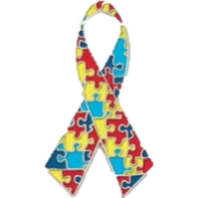**Autism[ASD] and Learning Difficulties (LD) at the Royal Manchester Children’s Hospital**

**Information for Patients and Carers**



Royal Manchester Children’s Hospital (RMCH) we recognise that many of our patients have Autism [ASD] and/ or Learning Difficulties (LD) ASD The purpose of this leaflet is to tell you about the support that is available to you and your family during your visit to the hospital. **Please contact us if you have any questions – please see the contact details at the end of the leaflet.**

# http://cdn.shopify.com/s/files/1/0606/1553/products/Hospital_Sister2_compact.png?v=1417849271How will staff know my child has LD or ASD?

If this is your first visit to the Royal Manchester Children’s Hospital (RMCH) please speak to a member of staff and inform them about your child’s LD or ASD.

We have sent a poster to all GPs in Great Manchester asking them to tell the service your child has been referred to about their LD or ASD but we cannot guarantee that this information has been passed on. **If in doubt – please speak to a member of staff as soon as possible.**

If your child has visited RMCH before, we do have systems in place to inform staff about their LD or ASD, but again **if you are unsure the staff are aware, please speak to them as soon as possible.**

If your child has a planned visit to the hospital in the future, please contact RMCHRALMP or Hospital Play Services Department to discuss your child’s needs in advance of their appointment. Contact details are at the end of the booklet.

# What support is available?

**Play Specialists** - RMCH has a number of Health Play Specialists who can discuss your child’s individual needs with you in preparation for your visit to the hospital, whether this is as an in-patient or out-patient. This is often done via a telephone 🕿 call to help identify your child’s individual needs to help make some reasonable adjustments.



* The Hospital can place a symbol on our systems to help make staff aware of your child’s specific needs.If you agree please tell a member of staff.

**Autism - Learning Disability Champions** –

* 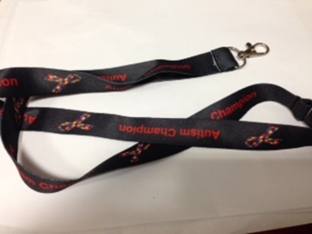Many of the wards and departments at RMCH have Autism - Learning Disability Champions who have been trained to recognise and respond to the needs of patients with LD and Autism. They will be wearing lanyards that say ‘Autism Champion’. The Autism Champions will also have limited resources, such as communication aids (Flash Cards), photo journeys and be able to help you and your child if they are finding a situation difficult.



* **Please speak to a member of staff and ask about the Autism – Learning Disability Champion.**
* **Electronic resources** are available on our dedicated website – please see the details at the end of this leaflet.

# My child really struggles with busy and noisy waiting rooms

# http://cdn.shopify.com/s/files/1/0606/1553/products/James-11_compact.png?v=1417852947

We understand that patients with LD and ASD sometimes become very distressed if they have to wait long times or sit in busy, noisy waiting areas. **Please speak to a member of staff as soon possible and let them know if your child has difficulty with waiting and waiting rooms.** We will try to find you a quieter waiting area, if one is available, and to ‘get you seen’ as soon as possible. There are pagers available in our Out patients department please ask [Image]

# What can I do to plan my child’s visit?

* Visit:

http://www.cmft.nhs.uk/childrens-hospitals/our-services/services-for-children-with-autism and or learning disabilities and download the referral form to the Play Services Team whose contact details are at the end of this leaflet. 

* Ask for future appointments to be at the beginning of the clinic to avoid long waiting times.
* Contact the Hospital Play Services team.
* Please bring your child’s ‘communication passport’ with you, and any special interest objects or communication tools.

# We recently visited RMCH and no-one was aware of my child’s LD/ASD

We are sorry if you have recently visited RMCH and we were not aware of your child’s needs. Please contact the Hospital Play Services Team to discuss your recent experience and to plan future visits.

# C:\Users\andrea.brammer\Desktop\feedback-comments-symbols-blue-text-symbol-surrounded-icons-43069923.jpg Improving Services

We are constantly trying to improve support and services to patients with LD and Autism and their families. In order to do so, we value feedback about your experiences and suggestions. Please ask for the evalauation form or see our website (details below) to access an electronic copy.

# Contact Details

Recognising Autism and Learning Disabilities Management Programme

Royal Manchester Children's Hospital

Harrington Building

Oxford Road

M13 9WL

* Telephone (0161) 701 5504 0161 701 5683 [admin]

 RMCHRALMP@mft.nhs.uk

 Frances.Binns@mft.nhs.uk Anna.Ostmeier-Brill@mft.nhs.uk

Monday – Tuesday Wednesday Friday 9.00 am to 5.00 pm. An answerphone is available at all other times.

Hospital Play Services Team

Royal Manchester Children's Hospital

Oxford Road

M13 9WL

 playservices@mft.nhs.uk

* Telephone 0161 701 0698

Hospital Website:

http://www.cmft.nhs.uk/childrens-hospitals/our-services/services-for-children-with-autism

# No Smoking Policy

The NHS has a responsibility for the nation’s health.

Protect yourself, patients, visitors and staff by adhering to our no smoking policy. Smoking is not permitted within any of our hospital buildings or grounds.

The Manchester Stop Smoking Service can be contacted on Tel: (0161) 205 5998 (www.stopsmokingmanchester.co.uk).

# Translation and Interpretation Service

These translations say “If you require an interpreter, or translation, please ask a member of our staff to arrange it for you.” The languages translated, in order, are: Arabic, Urdu, Bengali, Polish, Somali and simplified Chinese.

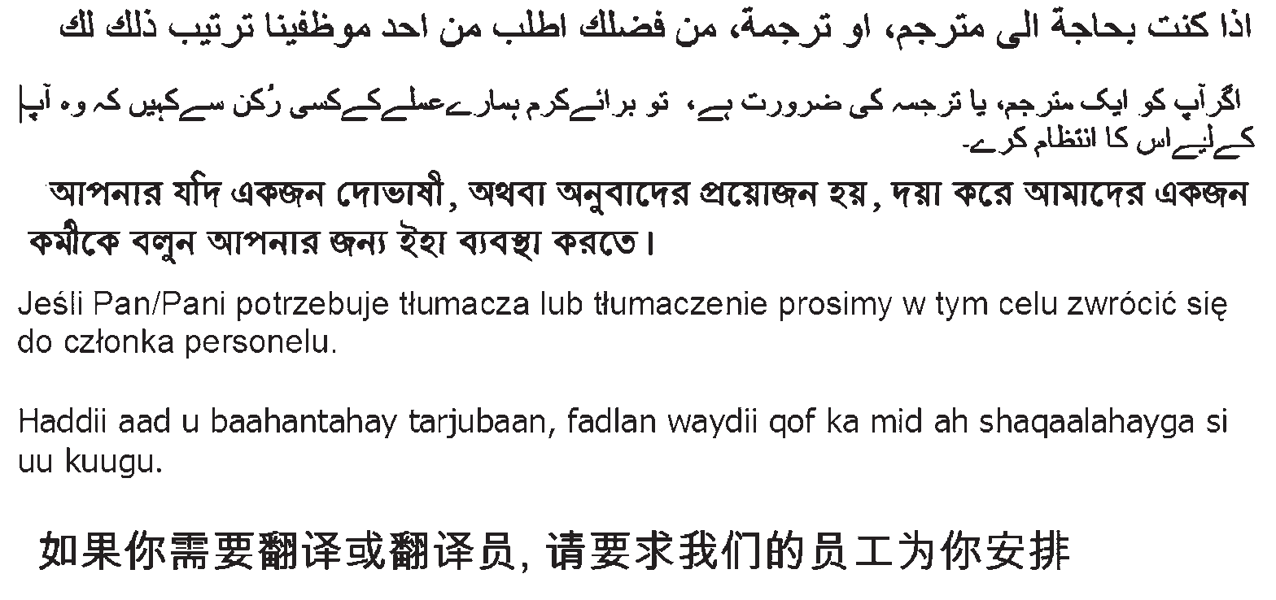

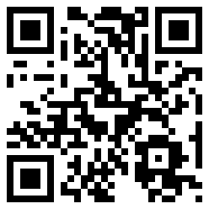@MFTNHS Follow us on

Facebook

[**www.mft.nhs.uk**](http://www.mft.nhs.uk)

© Copyright to Central Manchester University Hospitals NHS Foundation Trust

TIG / Produced September 2013 Review Date September 2015 (SF Taylor CM15073)