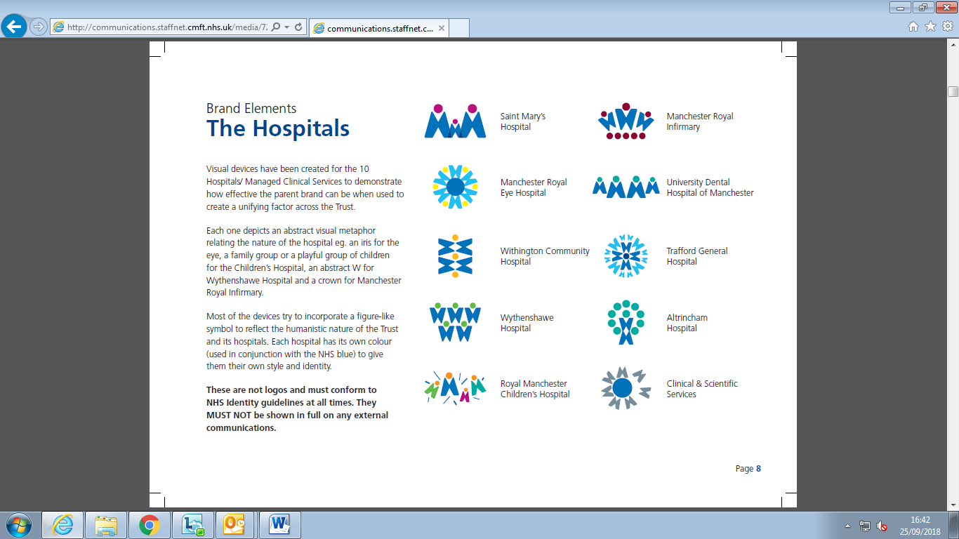

**Recognising Autism & Learning Disabilities Management Programme**

**(RALMP)**

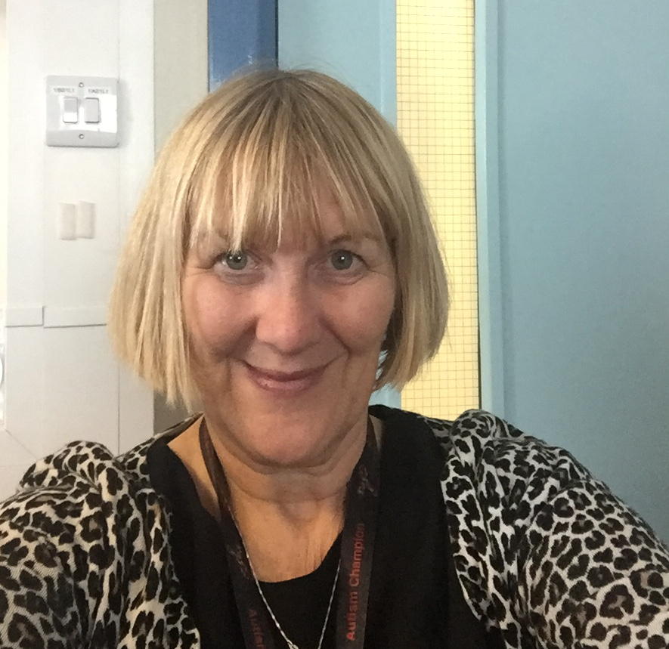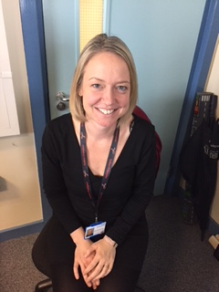

**Frances Binns Anna Ostmeier-Brill**

**Consultant Specialist Adviser Autism & Learning Disabilities Liaison Practitioner**

**For enquiries please contact:**

[**RMCHRALMP@mft.nhs.uk**](mailto:RMCHRALMP@mft.nhs.uk)

**0161 701 5683/4514/5504**

**Please contact us if you are a;**

* **Member of staff who needs advice about caring for a patient with Autism or learning disability**
* **A patient with Autism or learning disability**
* **Parent / Carer of a patient with Autism or learning disability**

**And refer to:**

[**http://www.mft.nhs.uk/childrens-hospitals/our-services/services-for-children-with-autism**](http://www.mft.nhs.uk/childrens-hospitals/our-services/services-for-children-with-autism)

**RMCH Clinical Handbook Autism and Learning Disabilities** [**http://pch.staffnet.cmft.nhs.uk/specialities/autism.aspx**](http://pch.staffnet.cmft.nhs.uk/specialities/autism.aspx)

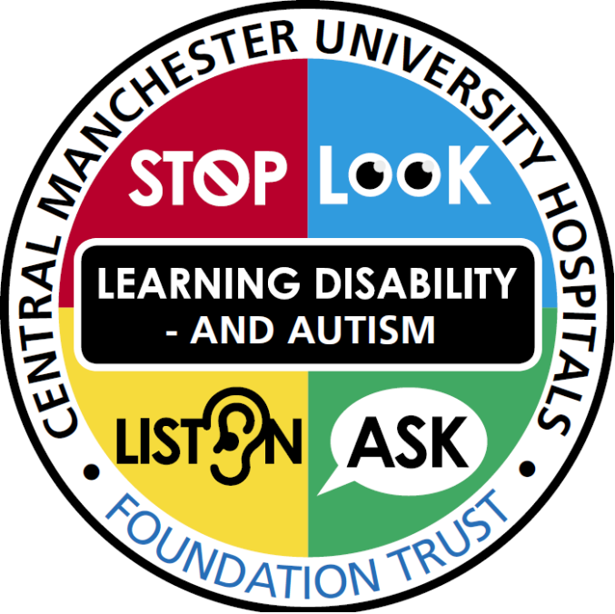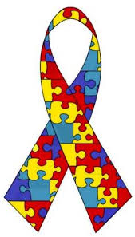

**I’M HERE TO HELP**