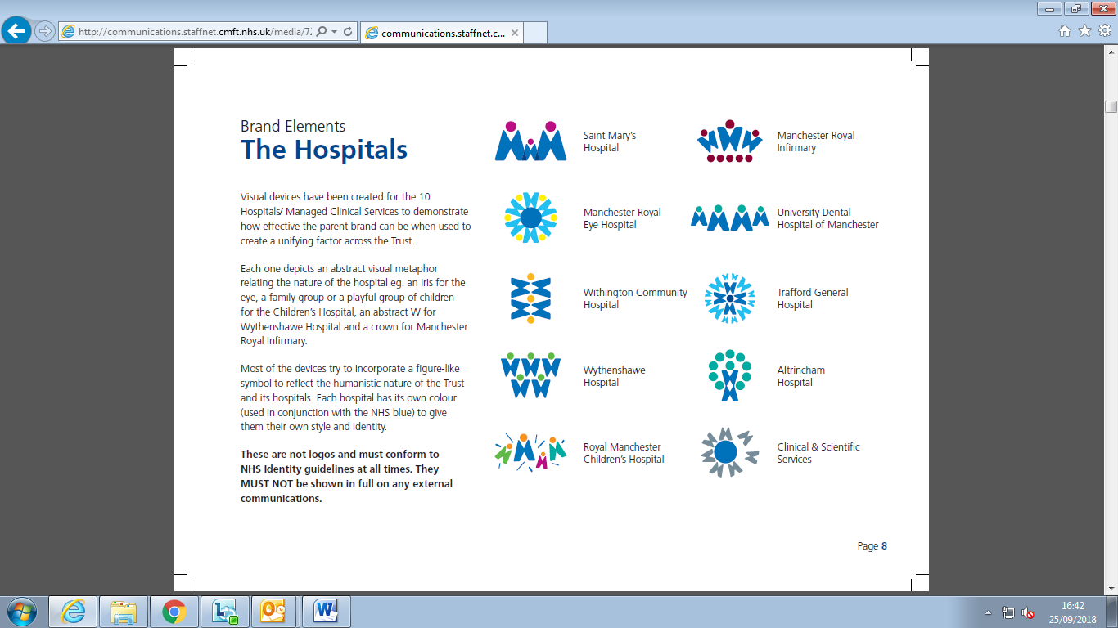

Royal Manchester Children’s Hospital
Reasonable Adjustments Required
Person Centred Assessment of Child’s Individual Specific Needs
(TO BE PLACED IN THE FRONT OF CHILDS NOTES/CARE PLAN)
Patients Name:
Hospital Number: |  | Clinician:
Patient with:  Autism  Learning Disability  Medical Complexity | ◻  ◻  ◻ | Communication Flag requested on:  Patient Administration System  Bedman  Other |  | ◻  ◻  ◻
Ethnicity: |  | DOB:  Age:
Mental Capacity Assessment:  (ask if over 16)  Yes ◻ No ◻ |  | Contact Numbers:  Home  Mobile
Translator / Interpreter required?  Yes ◻ No ◻ |  | Interpreter requested?  Yes ◻ No ◻ N/A ◻
Date to be Admitted / Seen: |  | Ward / Area:
Referred by: |  | Room required due to individual sensory needs? Yes ◻ No ◻ N/A ◻
Assessment completed by who?

Professional □ Parent /Carer □ Other □
Signature |  |  | Print Name
Professional Status |  |  | Date Completed

Important points to be Aware of on Admission or Appointment :
 | Dislikes  High Priority |  | ●  ●  ●  ●
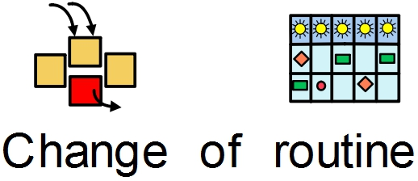 |  |  |  | 
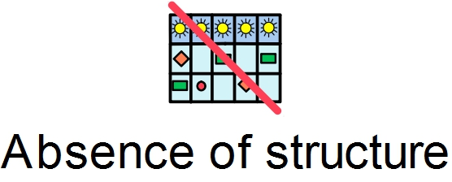 |  |  |  | 
 |  | 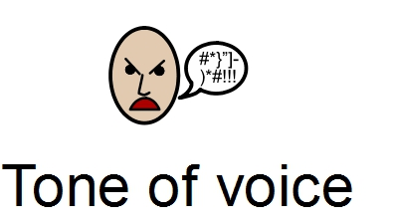

 | Medium Priority | ●  ●  ●  ●

 | Likes  Special Interests | ●  ●  ●  ●


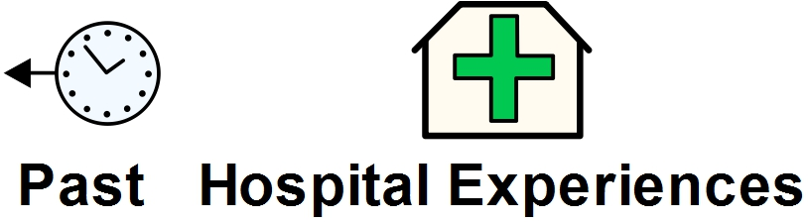
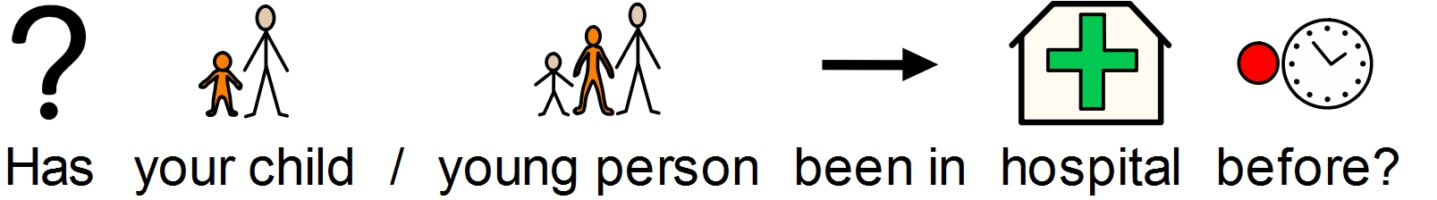
 | 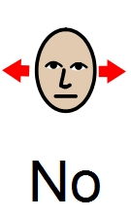


●

●

●

●

●

●

●

●

●

●

●

●

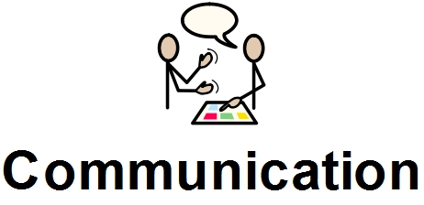


 | 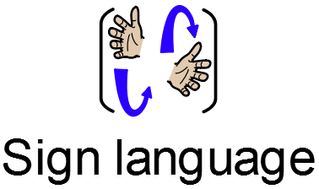 | 
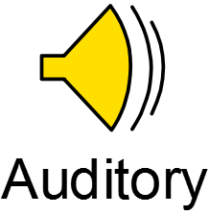 | 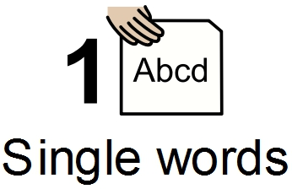 | 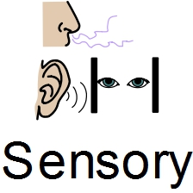

●

●

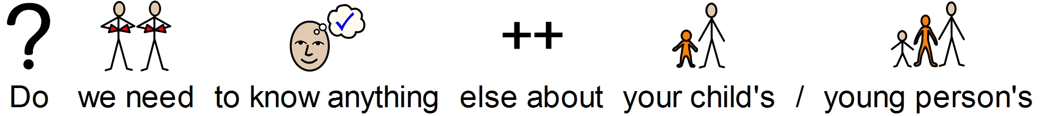











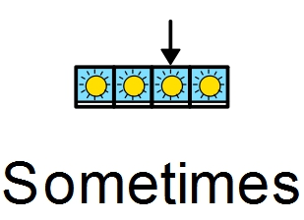




●

●

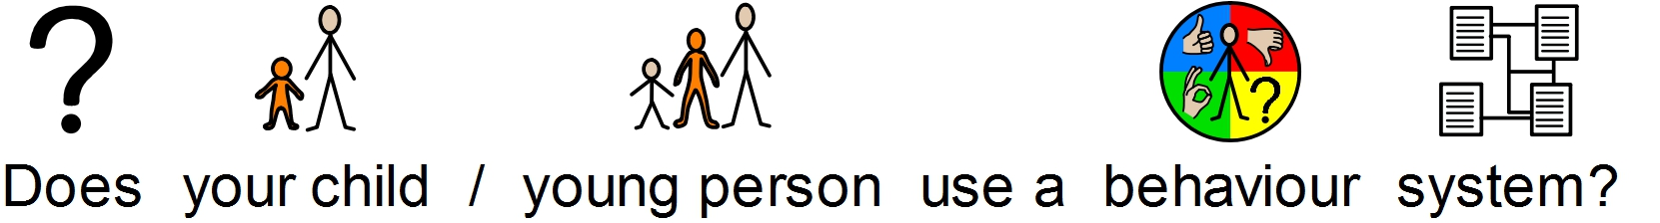




●

●



 |  | 
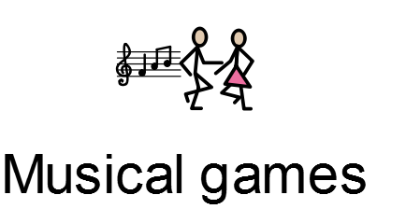 |  | 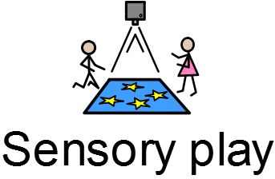
 |  | 
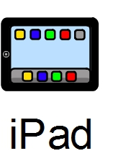 | 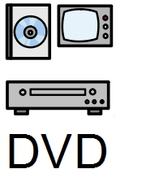
●

●

●

●

●

●


●
●
●

●
●
●


●
●
●

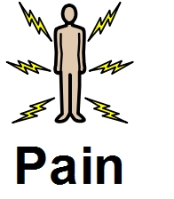
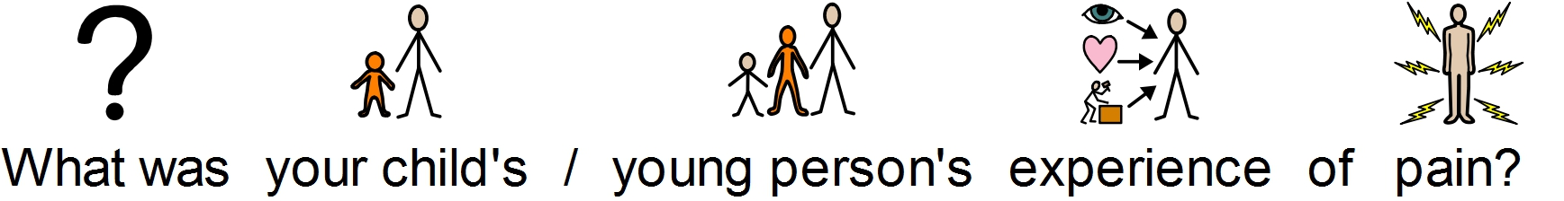
 | 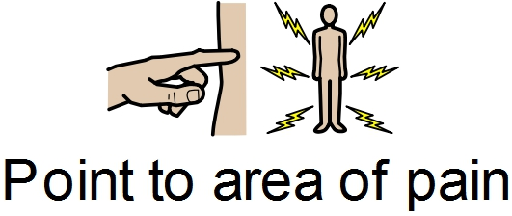
 | 
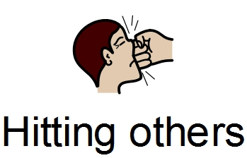 | 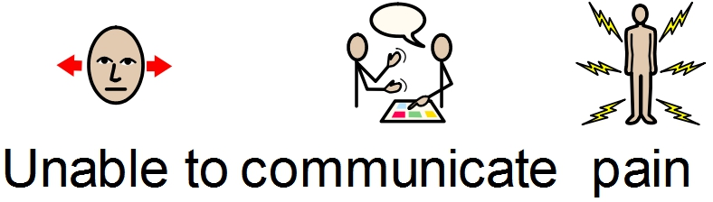

●

●

●

●

●

●




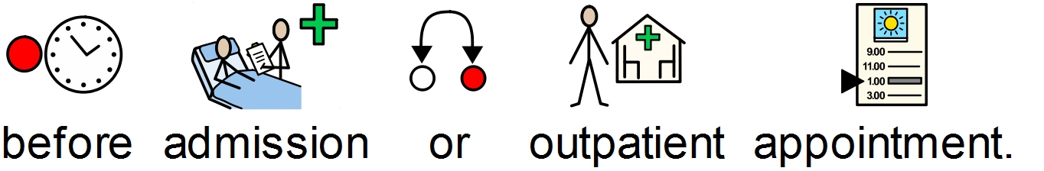

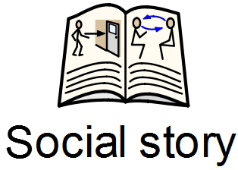
●

●

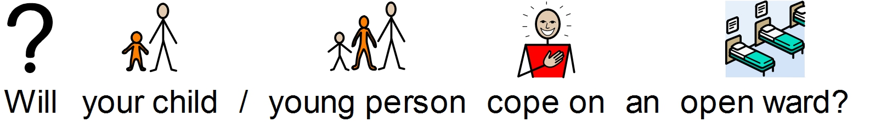

●

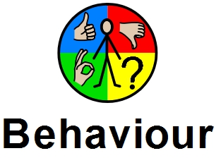


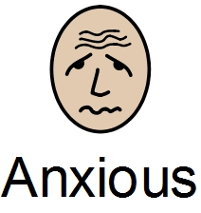 | 
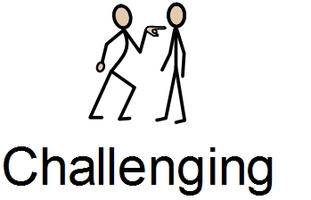 | 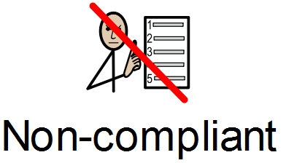

●


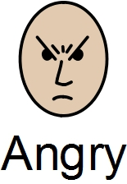 | 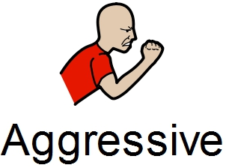
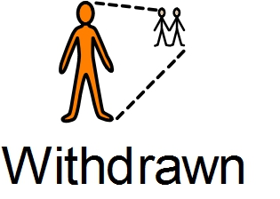 | 

●

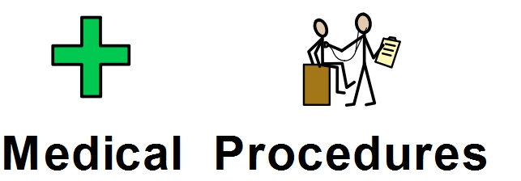


 | 
 |  |  |  |  |  |  | 
 |  |  | Attending Clinics  e.g. out patients | 
●
●
 |  |  | Tolerate being in busy waiting areas
●
●
 |  |  | Examined by doctor/nurse
●
●
 | 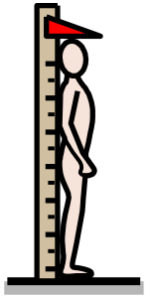 |  | Weight/Height
●
●
 |  |  | Taking medicine
●
●
 |  |  | Taking tablets
●
●
 |  |  | Wearing a hospital name band
 | 
●
●
 | 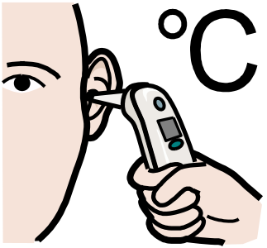 |  | Temperature
●
●
 | 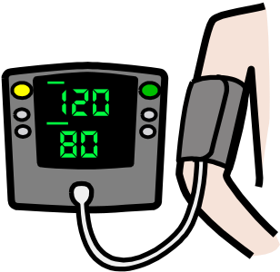 |  | Blood pressure taken
●
●
 |  |  | Needle procedures  ● blood tests  ● Injections  ● cannulas
●
●
 |  |  | Local anaesthetic cream
●
●
 |  |  | Plasters
●
●
 | 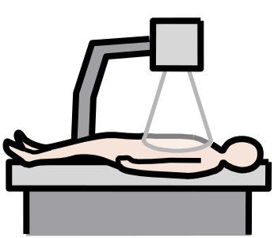 |  | Having an X-ray  Having a scan
●
●
 |  |  | Going to theatre
●
●
 |  |  | Wearing a hospital gown
●
●
 |  |  | Having a mask on
●
●
 | 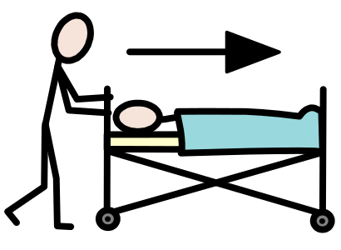 |  | Going/returning on the theatre trolley
●
●
 | 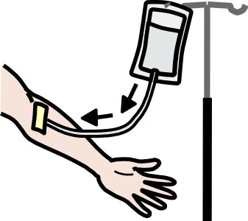 |  | Having a cannula post theatre
●
●




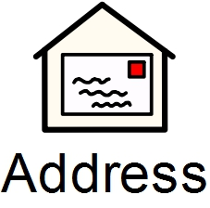
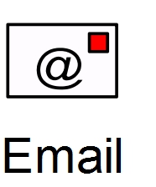


●
●




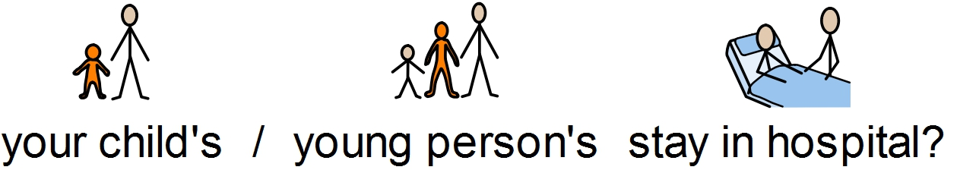

●

●

●

●

●

●

●

●

●

Royal Manchester Children’s Hospital
Patient with:
Patient with Autism |  | Learning Disability |  | Medical Complexity
Communication Flag requested on:
Patient Administration System (PAS) |  | Bedman |  | Other

- Administrative Flag requested for hospital administration systems to aid communication

 | Yes | No

- Has the child/young person and their families carried out a reasonable adjustments person centred assessment?
 | Yes | No

- Reasonable adjustments agreed with child/young person and their family disseminated to healthcare professionals required
 | Yes | No

- Methods of communication identified and arranged
 | Yes | No

- A Health Care Professional or designated member of staff available to liaise support and coordinate services for the child and families individual needs.
 | Yes | No

- Service user evaluation requested and completed with actions for further admission or appointments documented where required
 | Yes | No

Assessment Completed Via:
 | Parent / Carer | Professional

Completed by: | Date:
Print name: | Designation:

