Trafford Children’s Therapy Service

PRIMARY SCHOOL - GETTING READY TO SIT

Helpful for: Children who slouch, fidget, fall frequently, are clumsy

Ideal sitting position:

Check that the child is sitting correctly:
- Bottom back in seat
- Head should be central and relaxed and not bent over the page
- Hips, knees and ankles all at 90 degrees
- Both feet placed flat on the floor or on a step
- When the shoulders are relaxed and the elbows are comfortably bent, the table should be 2 inches above the height of the bent elbow.
- The non-writing hand should be used to stabilise the paper and not to engage in a variety of other more creative activities such as resting in the lap, twirling hair, gripping the table or propping up a head!

Activities to develop muscles needed for sitting:
Bicycle legs
Lie on back with feet in the air and pretend to ride a bike – ‘cycle’ legs up in the air. Try to do 20 ‘cycles’, have a rest then try 20 more.
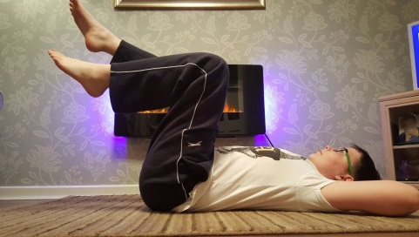

Beanbag throws
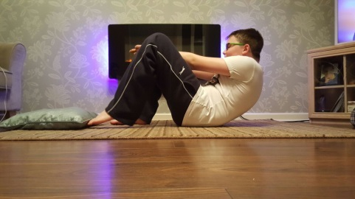
Lie on back with legs facing a target, about 1.5m from feet. Bend knees and open them slightly so that child can see through knees. Lift head and throw beanbags between knees at the target. Ensure the child uses both hands to throw and does not support the body on elbows while throwing.

Superman
Lie on stomach and lift up head first, followed by arms and legs. Try to keep the limbs straight off the floor and hold this position for 20 seconds. Keep arms open with palms facing downwards or forwards, not backwards. If this is difficult initially have the child lie on their stomach, extend and raise their head and arms off the floor.
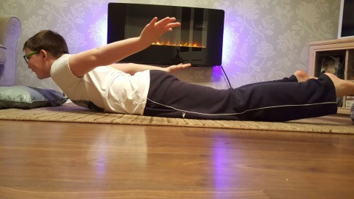

Acrobat balance
Starting on hands and knees, raise one arm out straight in front, and then stretch the opposite leg out behind. Try to hold this for as long as possible (start by aiming for 10 seconds, then increase to 15 seconds). Try on each side and repeat 5 times.

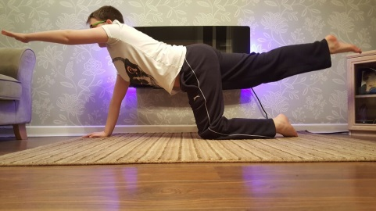
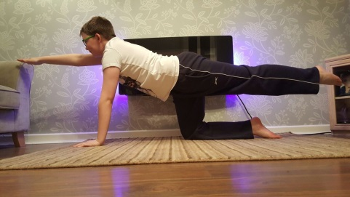

Bridging
Lie on the floor with knees bent and feet flat on the floor. The child lifts their bottom off the floor and tries to hold for as long as possible (aim for 20 seconds). Hold the position and pass a ball underneath their bottom.

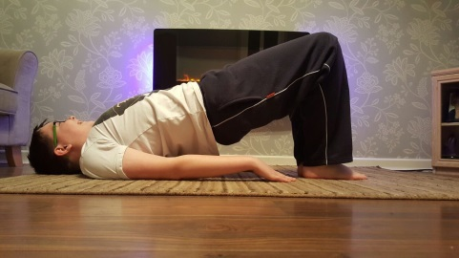

Ball push
Lying on tummy, face your partner and push a large ball backwards and forwards to each other. Encourage the child to keep his/her body straight and their hips and chest flat on the floor. The aim is to have them lift both arms off the floor to push the ball to their partner. This can also be done as an individual game against a wall.

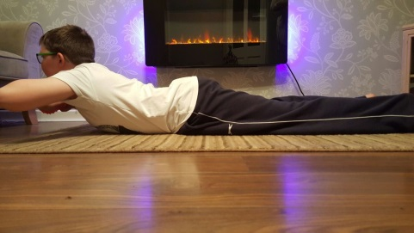

Crab Football
Try to assume the ‘crab’ position. Start by simply trying to walk in that position for as many steps as possible. Once again, you may like to count how many the child can do. Once child is good at this, encourage them to kick or push a ball or balloon to you maintaining this position. Maybe you can then play ‘crab football’ against each other!
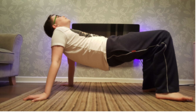

Push ups
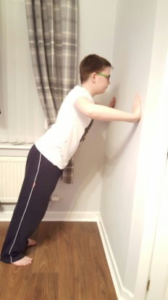
Do push ups while on hands and knees. Alternatively to make this easier try push ups against a wall.

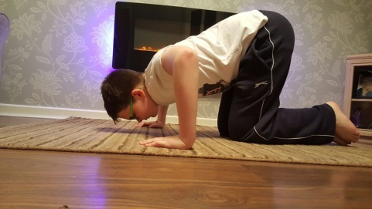

Resistive pushing/pulling
Your child could try activities including; tug-of-war, push-me-over, pushing against a gym ball.

Use of playground equipment
Your child could try activities such as playing on monkey bars, climbing structures requiring upper extremity strength, balance beams, see-saws and stepping stones.

