Division of Laboratory Medicine

Protocol for Requesting
Laboratory Costs for
Research/Clinical Trials

CONTENTS PAGE Page No.

- INTRODUCTION 3

- SUMMARY OF PROCESS TO OBTAIN LAB COSTS / PRICE QUOTES 4

- LAB COSTS / PRICE QUOTES 4
  - Initial Enquiries
  - Study Set Up Meetings

- COMPLETING THE DLM STUDY AGREEMENT FORM 5
  - DLM SAF 5
  - DRM sign off tab 6

- DLM LAB APPROVAL 6
  - Lab Approval 6
  - Out of hours and send away support 8
  - PSSV/SIV support 10
  - ICE / Yellow Bar-Coded Labels 12
  - Recruitment Delays / End of Study 13
  - Changes to Study Protocol 13

- REFERENCE RANGES 14

- ACCREDITATION CERTIFICATES 14

- SERVICE LEVEL AGREEMENTS 14

- APPENDIX 15
  - BIOBANK
  - MCRF (Manchester Clinical Research Facility) 15

- INTRODUCTION
The Division of Laboratory Medicine (DLM) laboratories offer a comprehensive pathology service for research and clinical trials, and use only standardised validated testing platforms, methods and reference ranges for the duration of each study. We are committed to the maintenance of quality of service and uncompromising ethical standards in all the clinical and commercial research services we offer.

We provide comprehensive, competitively priced pathology testing, including:

- Biochemistry
- Haematology
- Immunology
- Histopathology
- Microbiology
- Virology
- Cytology

See an A-Z List of Lab Tests carried out by the DLM

For more information on specific services you require as part of your research/clinical trial, click on the following links:

Division of Laboratory Medicine:
http://www.cmft.nhs.uk/info-for-health-professionals/laboratory-medicine.aspx

Division of Laboratory Medicine – Research / Clinical Trials:
http://www.cmft.nhs.uk/info-for-health-professionals/laboratory-medicine/clinical-trials.aspx

Michael Sumner
Research and Clinical Trials Administrator (DLM CTA)
Division of Laboratory Medicine
Manchester University NHS Foundation Trust,
Oxford Road,
Manchester,
M13 9WL
Email: micaheal.sumner@mft.nhs.uk

HISTOPATHOLOGY
Catherine Keeling
Division of Laboratory Medicine
Manchester University NHS Foundation Trust,
Oxford Road,
Manchester,
M13 9WL
Tel: 0161 701 1943 Email: Catherine.Keeling@cmft.nhs.uk

CYTOPATHOLOGY
Adanna Ehirim (GYNAE CYTOLOGY) Email: Adanna.Ehirim@cmft.nhs.uk
Nadira Narine (NON-GYNAE CYTOLOGY) Email: Nadira.Narine@cmft.nhs.uk

The Division of Laboratory Medicine (DLM) is committed to providing accurate and timely laboratory testing services for research/clinical trials. The DLM Research Office recognises that each study is unique and strives to customize services for each one. The following information is designed to give you (the investigator/study coordinator) a process to follow to obtain current laboratory prices and allow you to determine a budget for your research/clinical trial.

Divisional Research Manager (DRM) (Research & Innovation Division - Divisional Research Managers)
Your DRM will provide the appropriate support regarding the set-up of a trial/funding opportunities. Laboratory costs/quotes must be obtained before any formal submissions are made.

- SUMMARY OF PROCESS TO OBTAIN LAB COSTS / PRICE QUOTES

- PI/Trial Coordinator to complete and return the DLM Study Application/Agreement Form (SAF)
- PI/Trial Coordinator to provide supporting documentation e.g. protocol/SSI/Lab Manual (or drafts if available)
- DLM will review all documentation and provide lab costs/quotes or arrange a meeting to discuss the study requirements should this be necessary
- PI/Trial Coordinator will be asked to review costs/quote and return the DLM SAF and ensure the DRM signs the form.
- The DLM CTA will confirm DLM Lab Approval subject to contract / Research Office Approval by email to the PI/Trial Coordinator.

- LABORATORY COSTS / PRICE QUOTES
  - Initial Enquiries

Download the latest version of the SAF from the intranet and complete study info and per patient budget tabs. The form is returned to the DLM by clicking the submit button once all the relevant fields have been completed.
To process your application, we will also require the study Protocol / SSI / Lab Manual (or drafts). These documents will be reviewed together with the SAF and allow us to determine which laboratory services you require/can be supported by the DLM.

- Study Set Up Meetings
Studies that involve complex testing regimes may benefit from a study set up meeting involving the clinical and laboratory teams. Please contact the DLM CTA should you require a meeting. The DLM will endeavour to provide laboratory costs within a target turnaround time (TAT) of 5 days. However, this will depend on the requirements of your study and the adequacy of the information you provide the DLM.

- COMPLETING THE DLM SAF
  - DLM SAF - Details of Study and Laboratory Requirements
(Click on this link for an up-to-date version of the SAF: Laboratory Medicine - Clinical trials)

Please endeavour to provide the DLM with a lab manual/ SOP as soon as possible as the protocol entails the bare minimum about the actual samples and what happens to them. The DLM will need to review the lab manual / SOP to determine whether the requirements of your study can be supported.

Complete all questions in full ensuring that where the number of participants is estimated e.g. 10-12, that the largest number is entered. The length of the study must also be entered in numeric format e.g. 2 years and 3 months should be entered as 2.25.

Once the study info tab has been completed, the Per Patient Budget tab should then be completed. Begin by clicking into the first empty department cell and using the drop down box and choose the correct department. Click into the investigation box and choose the correct investigation. If the test required cannot be found in the drop down list, leaving the department field blank, type the name of the test required into the investigation field. The CTA will liaise with the DLM departments to find an appropriate cost for the test required. The definitions tab can be used to provide information on the tests that are available within profiles and other useful information for the users. Once the correct test has been found or typed in manually if it is not in the drop down menu, using the dropdown menu on the investigation cost category column select the correct funding category for the test. Finally in the total number of samples tab, insert the number of times the test will be required for an individual patient.

Once you have completed the SAF, please click the ‘SUBMIT’ button. The SAF will automatically be emailed to the DLM CTA. Please email ‘supporting documentation’ in a separate email. If you are unsure about anything, please contact the DLM CTA for support.

Send Away Tests – There may be a requirement for the DLM to ‘Send Away Tests’ if they are not undertaken in-house. The DLM will make the necessary arrangements, however this may have an impact on the DLM TAT (i.e. 5 days) for providing lab costs. If so, the PI/Trial Coordinator and Research Office will be advised accordingly and this will be reflected on R-PEAK. If the test is not a ‘standard’ send-away, the research team will be advised to inform the sponsor who will need to consider other arrangements.

  - Completing the DRM sign off tab.
Once the DLM has obtained costs from the relevant departments, the SAF will be emailed back to the PI/Trials coordinator and will now include a summary tab showing all the cost elements of the trial along a with a DRM sign off tab. Once the trials team have confirmed they are happy with the costs, the PO number or cost centre details should be entered (if known) and the form emailed to the DRM to be signed, dated and then returned to the CTA. If the PO number or cost centre details are not available when the SAF is being completed, the invoice details must be forwarded to the CTA before the first patient sample is sent to the laboratories.

NOTE: The Labs will not be able to process any samples until the invoicing details for the study have been completed in full.

5. DLM LAB APPROVAL
DLM Laboratory Approval is subject to contract / Research Office Approval and will be confirmed once the DLM CTA has:
1. A signed DLM Study Application/Agreement Form
2. Site Specific Information - e.g. Protocol, lab manual/SOP, SSI Form
3. R&D approval
4. Ethics Approval

An email will be sent to the PI/Research Coordinator confirming that the DLM has granted laboratory approval for the study. Samples MUST NOT be sent to the labs prior to this.
Notes:
NIHR AcoRD:
This guidance provides a framework for the NHS and its partners to identify recover and attribute the costs of health and social care R&D (AcoRD), in a transparent and consistent manner. It clarifies the distinction between the three costs of research:

- Research costs
- NHS support costs
- Treatment costs
Screening Samples
Please refer to the NIHR AcoRD document for guidance pertaining to SCREENING tests and costs applicable to these.
(Click on this link: Attributing the costs of health and social care research - Publications - GOV.UK

In-Hours / Out-of-Hours (OOH) Requirements. Unless it has been made clear, it will be assumed that’ core hour sampling’ is required (The core opening hours of the laboratory are 8.00am to 5.00pm Monday-Friday). The DLM recognises that each study is unique and strives to customize services for each one. Therefore, if your study requires OOH support, please provide as much information as you possibly can and contact the DLM so that a meeting can be set up to discuss your requirements, (particularly if complex). The DLM CTA will arrange for relevant lab staff to attend the meeting.

IMPORTANT: If Central Specimen Reception (CSR) has agreed to provide ‘Out-of-Hours’ support, please note that CSR would request 2 weeks’ notice for research/clinical trials requiring this service for study visits.

NOTE: Central Specimen Reception (CSR) cannot support requirements at the weekends or after 8pm Mon – Friday

PROTOCOL FOR DLM RESEARCH / CLINICAL TRIAL Out of Hours (OOH) TESTS
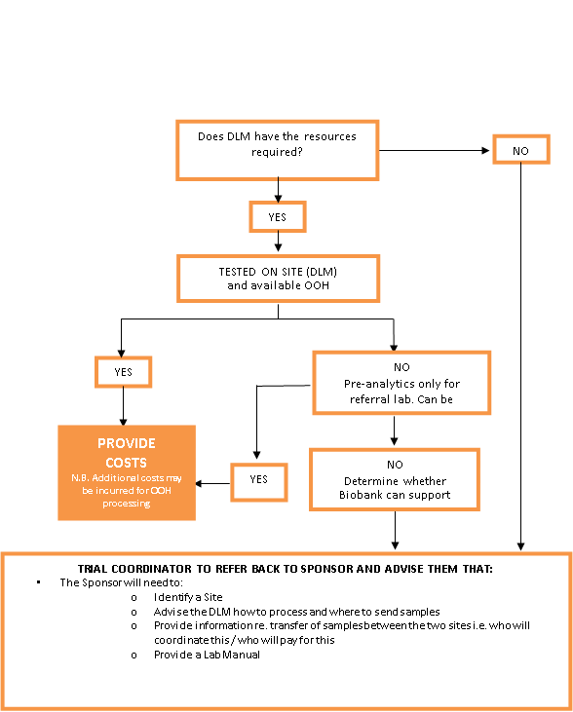

DLM PROCESS FOR RESEARCH / CLINICAL TRIAL SEND AWAY TESTS
TESTED ON SITE (DLM)

Can CSR provide support ?
NO
NO
YES
NO
Can Lab provide support ?
NO
ROUTINE
SEND-AWAY ?
YES
Can Biobank provide support?

PROVIDE
COSTS
NO
YES
YES

STUDY TRIAL COORDINATOR TO REFER BACK TO SPONSOR AND ADVISE THEM THAT:

- The Sponsor will need to:

    - Identify a Site
    - Advise the DLM how to process and where to send samples
    - Provide information re. transfer of samples between the two sites i.e. who will coordinate this / who will pay for this
    - Provide a Lab Manual

Pre-Analytic Support – Costs for pre-analytic support MUST be covered by the study

Pre-analytics refers to all processes that occur prior to the actual laboratory analysis, starting from specimen collection (e.g. blood, saliva or urine), to sample stabilization, storage and transport/courier. If you require this service from the laboratories, the following should be factored in:
- Funding (costs for pre-analytical work should be covered by the study)
- A Laboratory Manual / Standard Operating Procedures (SOP) will be required
- Are arrangements in place for specimen collection, storage, packaging, courier

If your study requires:
- Pre-analytic support only – the DLM will review the requirements of your study and every effort will be made to support the research/clinical trial, however if the DLM is unable to do so, you will be advised to contact the Manchester Clinical Research Facility (MCRF) or the BIOBANK. If you have already made arrangements with the BIOBANK/MCRF please clearly indicate this on the SAF.

- Pre-analytic support and sample processing – If you have already arranged for MCRF/BIOBANK to undertake pre-analytics for your study and only require the DLM to ‘process samples’, please clearly state this on the SAF.

- Storage: The DLM can only provide short-term storage i.e. 2 weeks. If your study requires a longer term, please contact the BIOBANK.

- Shipping: provide details including information pertaining to equipment/packaging/courier.

- Funding: The study must cover the costs for storage/shipping.

Pre-Study Site Visit (PSSV) or Site Initiation Visit (SIV) – DLM’s Process and Requirements

All requests and enquiries pertaining to support from the DLM for research/clinical trial Pre-Study Site Visits (PSSV) or Site Initiation Visits (SIV) should be directed to the DLM Research & Clinical Trials Administrator (DLM CTA) in the first instance.

PSSV/SIV Timescales:
Research Teams must provide the DLM adequate notice (i.e. a minimum of 2 weeks), if representation is required at a PSSV/SIV.

Note: Without sufficient notice, it may not be possible for the DLM to accommodate the visit.

The DLM CTA will require the following:

- Details of the Visit
- Date/time/venue of intended PSSV/SIV.
- Confirmation of which lab e.g. biochemistry, haematology etc. input is required from

- Documentation (or drafts)
- A completed DLM Study Application/Agreement Form (Section 1)
- Protocol
- SSI
- Lab Manual

Note: If sufficient information/documentation is not available prior to the PSSV/SIV, the DLM may not be able to accommodate the visit.

- Visitor Requirements (what is expected from the DLM):
- Representation at the PSSV/SIV meeting / a visit to the labs / or both ?

For Lab Visits, the DLM CTA will also require the following information:
    - number of non-lab personnel visiting (inc. names/titles/contact details)
    - details of the person who will escort visitors to, from and between labs
    - details of the equipment visitors want to see (if any)
    - details of documentation required in advance of the visit e.g. equipment specs / calibration details /Reference Ranges / UKAS certs etc.

Note: Controlled documents will not be provided if the DLM has not received confirmation that CMFT will be a participating site. Further details pertaining to requests for controlled documents can be found via the following link:

http://labmed.staffnet.xcmmc.nhs.uk/clinical-trials.aspx
‘Protocol for Requesting Laboratory Costs for Research/Clinical Trials’

The DLM CTA will:

- Obtain Authorisation from the Relevant Lab(s)

- Provide labs with all available information and state what (if anything) is still outstanding / forthcoming
- Ascertain who can be available for the PSSV/SIV

(Note: If the date/time of the visit is unsuitable for Lab Staff, the DLM CTA will advise the Research Team accordingly and request alternative dates/times).

- Confirm Lab Representation
- The CTA will contact the research team:
    - Obtain outstanding documentation and pursue queries (if any).
    - Confirm DLM Lab Staff availability
- A confirmation email will be sent to the labs once all of the above has been finalised
- Visitors will be provided with PPE on arrival to Central Specimen Reception

NOTE:
Pre-Study Site Visit (PSSV) - As this will be conducted at the ‘site selection stage’, there are no clinical governance issues, ergo research office approval is not required. However the DLM will require details/requirements of the visit, as requested above.

Site Initiation Visits (SIV) - These should take place after R&D approval is in place. However, the Research Office will facilitates SIVs and allow them before R&D approval if everything is nearly in place e.g. if all R-PEAK tasks are completed and the only item outstanding is a signed contract which is getting authorized by the sponsor.

Please ensure you notify the Research Office, if a SIV is taking place prior to approval.

b. ICE / Yellow Bar-Coded Labels

 |  | INSTRUCTIONS FOR SAMPLE REQUESTS VIA ICE
 |  | * | Request Samples via ICE
 |  | * | Enter ' #R0XXXX# ' or #B0XXXX# This MUST be YOUR study/trial Pin Number
 |  | * | If you want to enter clinical details, please do this on Line 2
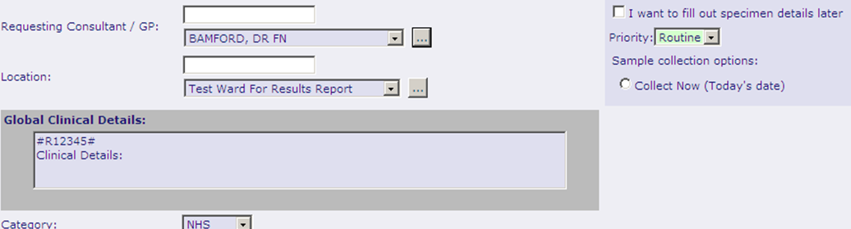
 |  | YELLOW BAR-CODED LABELS
 |  | These will only be provided for research / clinical trials which:
 |  | a) require Anonymised Samples
 |  | b) involve External Organisations / Provider-Provider / non ICE users
 |  | Please ensure the Research Nurse(s) places one of these on request cards for samples sent to the laboratories that are NOT taken as part of ‘standard patient care’. This will allow laboratory staff to invoice/re-charge accordingly. LABELS WILL BE PROVIDED WITH THE DLM LAB APPROVAL LETTER
 |  |  |  | 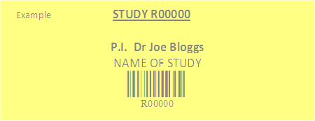
 |  | Important: If you require more labels, please ensure you quote the following at all times
 |  |  | * | R & D Pin Number |  |  | R12345
 |  |  | * | Study Title/Acronym |  |  | CHASE Study
 |  |  | * | Name of PI: |  |  | Dr A Twist
 |  |  | * | iLog Number (if applicable) |  |  | Ilog:12345
 |  |  | * | MCRF Number (if applicable) |  |  | T12/3456 SUB123
 |  |  | * | POD Number: (if applicable)
 |  |  | * | Where the labels need to be sent

c. Recruitment Delays / End of Study
Please ensure we are informed of:

        - Recruitment issues / hold-ups e.g. not enough participants or slow recruitment etc.
        - Study postponement / suspension
        - Date the study stops recruitment and/or comes to an end

- Changes to Study Protocol
If there are any changes to the protocol affecting Lab input, please ensure the DLM is notified as this may have an impact on the costs/service provided. The DLM may be required to review lab costs and/or provide revised ones. We will also require:

  - Confirmation of revised LREC approval (if applicable). This may not be necessary if there is a minor amendment
  - Confirmation that the Research Office is aware of the protocol amendment and has re-confirmed approval
  - A copy of the protocol amendment

    - REFERENCE RANGES
Internal
The reference ranges can be obtained via the following link (see User Guides) internal staff only:

http://www.cmft.nhs.uk/info-for-health-professionals/laboratory-medicine/gp-information/laboratory-user-guides.aspx

Note: Notification regarding changes to test methodologies and reference ranges will be cascaded internally

External Organisations
If these are required by external users/companies, please contact the DLM CTA.

    - ACCREDIATION CERTIFICATES / CVs
These are controlled documents and will not be provided unless the DLM has sufficient details about your study including details of the lab you require support from. If your study is already up and running, the DLM will also require the R-peak number to identify the study.

      - SERVICE LEVEL AGREEMENTS (SLAs)
The DLM has an overarching governance agreement for trials performed under the Trust R&I approval process.
However, similar agreements are in place with many of our local Trusts. ‘Local’ SLAs may be required for trial work undertaken by the DLM for external organisations not covered by these agreements. R&D (and REC) approval documents from the appropriate Trust/University will need to be provided in these cases.

- APPENDIX
a. BIOBANK
The DLM will endeavour to support your pre-analytical requirements, however if we are unable to do so, you may wish to contact the Biobank directly:

Biobank Study Support Service:

- Blood processing (serum/plasma/cells) and storage (short/long term)

- Shipping/logistics

- DNA/RNA extraction from blood and tissues.

Contact: Dr Jay Brown
Biobank Manager / HTA Licence Manager
Tel: 0161 701 1890 Mob: 07795547954
Email: jay.brown@cmft.nhs.uk
Web: http://www.manchesterbrc.org/OurFacilities/Biobank.php
GMBN:http://www.greatermanchesterbiobankingnetwork.ac.uk/

- MCRF

MCRF Study Support Service:

• Blood processing (serum/plasma/cells) and storage (short/long term)

• Shipping/logistics

• DNA/RNA extraction from blood and tissues.

Contact: Simon Gorman
Senior Research Scientist
Manchester Clinical Research Facility
T: 0161 906 7522
E: simon.gorman@mft.nhs.uk

