**Bladder & Bowel Diary**

What is a bladder & bowel diary?

A bladder & bowel diary is a detailed record of what happens with your poo and wee over a period of time, usually two consecutive days. It is important that you record as much information and detail as you can, as this will really help us when we assess you.

Why is a bladder & bowel diary important?

A bladder & bowel diary is really important as it helps us understand what your daily routine is like, and identify if there are any patterns or links which contribute to your symptoms. Sometimes, just by changing your toileting routine or drinking habits, we can see an improvement in your symptoms. The advice we give you is called “Urotherapy Advice” and is always the first step in helping you get better. Without your bladder diary, it is hard to know what the right Urotherapy advice is for you.

When do I complete it?

We recommend completing your diary as close to your urology appointment as possible, so that we can see what has been happening recently with your bladder and bowels. It is also helpful to do your diary for two consecutive days so we can see if things change from day to day, and to see if things you might have done or drank on the first day, impact on the following day. It is also ideal to choose a time when you will mostly be at home, as measuring your wee can be difficult if you are out and about! A weekend, or during a school holiday is ideal.

How do I complete it?

The diary is very straightforward to complete, and it is important you take the time to fill it out as thoroughly as possible. You will need a plastic jug with measurements down the side to measure your urine. If you wear nappies or pads, you will need to weigh them to see how much urine they contain when they are changed. To do this, weigh a clean dry nappy/pad and then deduct this amount off every wet one that you weigh, giving you the exact amount of urine.

We have separated the bladder and bowel diaries so you have enough room to complete each one in detail. You may be asked to only complete the bladder or bowel section, or you could be asked to complete both. To help you, we have included an example completed diary. If you are still unsure or have any questions, please contact the urology nurse specialists.

## Contacts

## Please do not hesitate to contact us if you have any questions about how to complete your bladder & bowel diary.

## In case of problems or advice please call:

## **Clinical Nurse Specialists RMCH**

## **Jenny Powell**

## Tel: (0161) 701 7707

## **Susan Wright**

## Tel: (0161) 701 1637

## **General queries**

## **Urology Secretaries**

## Tel: (0161) 701 1635

## **Trafford General Hospital**

## **Lower Urinary Dysfunction Service**

## Tel: (0161) 746 2944

## **Hayley Wynne**

## Tel: 07779978447 or (0161) 701 2476

**Example Bladder Diary**

It is important you completely the diary in as much detail as possible including the following information:

* Any overnight urine output e.g. pull up weight, first wee of the day
* When you have a drink and how much
* What you drink e.g. water, milk, juice (including flavour)
* How much urine is passed
* If there was any wetting, and if possible the amount passed into the nappy/pad
* If you do not wear a nappy/pad then whether underwear was:
  + **D – Damp** *(maybe requiring change of underwear)*
  + **W – Wet** *(requiring change of underwear)*
  + **S – Soaking** *(requiring full change of underwear and trousers/clothing)*
* Any additional information you think may be important e.g. exercise, coughing, sneezing, laughing
* If there was any urgency, using the below codes:

1. Did not feel the need to go to toilet, but went for other reasons e.g. about to go out
2. Could’ve waited a **significant length** of time before going to the toilet without worrying about wetting
3. Could’ve waited a **short length** of time before going to the toilet without worrying about wetting
4. Could **not wait** to go toilet, otherwise would’ve wet
5. Wet/leaked before arriving at the toilet

|  |  |  |  |  |  |  |  |  |  |  |
| --- | --- | --- | --- | --- | --- | --- | --- | --- | --- | --- |
| **Time** | **Day 1** | | | | | **Day 2** | | | | |
|  | **In (Drink)** | **Out (Wee)** | **Urgency** | **Wetting** | **Notes** | **In (Drink)** | **Out (Wee)** | **Urgency** | **Wetting** | **Notes** |
| 07:00 | Milk  200ml | 300ml pullup |  |  |  |  |  |  |  |  |
| 08:00 |  |  |  |  |  |  |  |  |  |  |
| 09:00 |  | 90ml | 5 | 30ml  pad |  |  |  |  |  |  |
| 10:00 | Water  100ml | 50ml | 2 |  |  |  |  |  |  |  |
| 11:00 |  |  |  |  |  |  |  |  |  |  |
| 12:00 |  | 80ml | 5 | 20ml  pad | Exercising |  |  |  |  |  |

**Name: Date of Birth:**

|  |  |  |  |  |  |  |  |  |  |  |
| --- | --- | --- | --- | --- | --- | --- | --- | --- | --- | --- |
| **Time** | **Day 1** | | | | | **Day 2** | | | | |
|  | **In (Drink)** | **Out (Wee)** | **Urgency** | **Wetting** | **Notes** | **In (Drink)** | **Out (Wee)** | **Urgency** | **Wetting** | **Notes** |
| 07:00 |  |  |  |  |  |  |  |  |  |  |
| 08:00 |  |  |  |  |  |  |  |  |  |  |
| 09:00 |  |  |  |  |  |  |  |  |  |  |
| 10:00 |  |  |  |  |  |  |  |  |  |  |
| 11:00 |  |  |  |  |  |  |  |  |  |  |
| 12:00 |  |  |  |  |  |  |  |  |  |  |
| 13:00 |  |  |  |  |  |  |  |  |  |  |
| 14:00 |  |  |  |  |  |  |  |  |  |  |
| 15:00 |  |  |  |  |  |  |  |  |  |  |
| 16:00 |  |  |  |  |  |  |  |  |  |  |
| 17:00 |  |  |  |  |  |  |  |  |  |  |
| 18:00 |  |  |  |  |  |  |  |  |  |  |
| 19:00 |  |  |  |  |  |  |  |  |  |  |
| 20:00 |  |  |  |  |  |  |  |  |  |  |
| 21:00 |  |  |  |  |  |  |  |  |  |  |
| 22:00 |  |  |  |  |  |  |  |  |  |  |
| 23:00 |  |  |  |  |  |  |  |  |  |  |
| 00:00 |  |  |  |  |  |  |  |  |  |  |
| 01:00 |  |  |  |  |  |  |  |  |  |  |
| 02:00 |  |  |  |  |  |  |  |  |  |  |
| 03:00 |  |  |  |  |  |  |  |  |  |  |
| 04:00 |  |  |  |  |  |  |  |  |  |  |
| 05:00 |  |  |  |  |  |  |  |  |  |  |
| 06:00 |  |  |  |  |  |  |  |  |  |  |

**Example Bowel Diary**

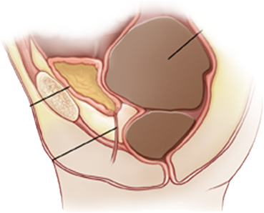Your bowels play a big part in how your bladder behaves. This is because your rectum (where your poo sits before you pass it out) is very close to your bladder. Have a little look at the image below to help you understand what your bladder and rectum looks like inside.

**Rectum** (filled with poo!)

**Bladder**

(being squished!)

**Urethra**

(where you wee from)

If your rectum has lots of poo in it, like the picture above, or if you are constipated (not had a poo for several days) it can press on your bladder. This means your bladder is squished by the rectum and has less space to expand and fill with wee, and it can also confuse the nerves and brain into think you need a wee, when actually you need a poo! The longer the poo sits in your rectum, the harder is gets and the more difficult it is to poo it out.

Constipation and problems with the bowels are one of the biggest causes of wetting, so it’s important we sort your bowels out as well as your bladder!

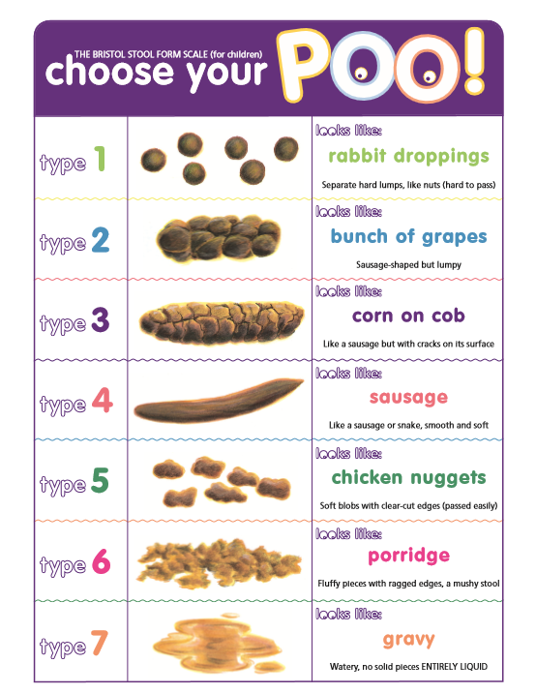Please use the below chart to help you complete your bowel diary. It is important to note the stool type as this helps us assess you and decide on the best way to manage your care.

Below is an **example** of how to complete your bowel diary. You will need to do this for approximately 7 days to give us a clear picture of what poo patterns you have!

|  |  |  |  |  |  |  |
| --- | --- | --- | --- | --- | --- | --- |
| **Day** | **Poo** | **Time** | **Type** | **Discomfort** | **Soiling** | **Notes** |
| **1** |  | 18:00 | 4 | No |  |  |
| **2** |  |  |  |  | M |  |
| **3** |  | 16:00 | 2 | Mild |  |  |
| **4** |  | 19:00 | 5 | No |  |  |
| **5** |  |  |  |  |  |  |
| **6** |  |  |  |  | S |  |
| **7** |  | 10:00 | 1 | Moderate | S | Upset passing |

**Soiling Descriptions:**

**S** – Smear

**M** – Medium (requiring change of underpants)

**L** – Large (requiring change of underpants and clothes)

**Name: Date of Birth:**

|  |  |  |  |  |  |  |
| --- | --- | --- | --- | --- | --- | --- |
| **Day** | **Poo** | **Time** | **Type** | **Discomfort** | **Soiling** | **Notes** |
| **1** |  |  |  |  |  |  |
| **2** |  |  |  |  |  |  |
| **3** |  |  |  |  |  |  |
| **4** |  |  |  |  |  |  |
| **5** |  |  |  |  |  |  |
| **6** |  |  |  |  |  |  |
| **7** |  |  |  |  |  |  |

Useful Resources

**Bladder & Bowel UK**

Offers advice and information on all bladder and bowel issues in children and young people including those with additional needs. They have a range of resources that will help parents, carers, professionals and schools cope with incontinence in children and young people.

Helpline: 0161 607 8219

Website: <https://www.bbuk.org.uk/>

**ERIC**

Bowels and bladder charity offering education, advice, support, resources for improving childhood continence.

Helpline: 0808 1699 949

Website: https://www.eric.org.uk/