Manchester Pain Centre

Pain Assessment Questionnaire for New Patients
Please add your details

Name

Address
Email address
Telephone Number
Date of Birth
Date Completed

This is a confidential questionnaire which will be used by the Pain Management Team to help understand the type of pain from which you are suffering. It enables you to give detailed information and allows us more time for discussion and explanation at your appointment. We are interested to know all about your pain so there are many questions. It may take you some time to complete this questionnaire. Please do not feel that you have to do this all at once; do a little at a time.

- Please try to answer all the questions and return the questionnaire in the free post envelope provided. You will be sent an appointment by the Booking Team in a few months’ time.

- You must complete and return this questionnaire within 3 weeks of receiving it.

- If you do not return this questionnaire you will not be offered an appointment at the Manchester Pain Service. You will be discharged from the service.

- We will offer a video consultation in the first instance. If you do not have access to the internet then please let us know immediately so alternative arrangements can be made. Please confirm your preferred Hospital for treatment and return this form in the envelope provided

- Trafford General Hospital this

- Wythenshawe Hospital this

- No preference this

- Appointment no longer required this

Contact Information
- Assistance with completing this questionnaire contact the Manchester Pain Team, on 0161 291 5442 or 3260. Appointment queries contact the Booking Team on 0161 291 5120
- How long have you had your present pain problem? ………………… years.
- How did it start? (Please √ more than one if appropriate).

Following injury No injury, sudden onset following surgery

Gradual onset

Unknown Other, please describe below

- List the parts of your body that are painful starting with the worst pain.
- What makes the pain worse?
- What makes the pain better?
- When is your pain at its best and worst?
- In the last month how often have you visited your General Practitioner (GP) for advice on your pain?

..................................................................................................................................

- How many other specialists have you seen for this pain? (Please √)

None 1-3 4 or more

- If you can remember could you please list their names, when and where you saw them.

- Please give details of tests or investigations that you have had for the pain listing the dates and hospitals if possible.

Investigations | Awaiting | Had Done
Scans
Blood tests
Nerve tests
X-rays

- Please list all medications you have been given.

Medication | Now Receiving | Effective  (Please √) |  | In the Past | Effective  (Please √)
 |  | Yes | No |  | Yes | No
Pain Killers
Include dose and how many taken each day.

Medications taken for other medical problems
Include dose and how many taken each day.

- Please list any other medical problems you have.
- To assist with treatment options please give details of your

Height ..................feet ............... inches or ..........................Meters

Weight .................Stones .......... pounds or ..........................Kilograms

- Do you smoke No Yes Amount per week

- Do you drink alcohol? No Yes Amount per week

Below are questions relating to treatments which you have received for your pain. Please give details and dates where appropriate and state if they were effective.

Treatments | Now Receiving | In The Past | Effective  (Please √)
 |  |  | Yes | No
Surgery

Injections

Psychology or Counselling

Physiotherapy

TENS

Acupuncture

Osteopath or Chiropractor

Collars, Corset etc.

Aids or Appliances:
Wheelchair, Crutches, Walking Sticks etc.

Anything else?

- What is your current situation? (Please √)

1. Employed 2. Employed on sick leave
3. Unemployed 4. Homemaker
5. Retired 6. Student
7. Voluntary work

- What is / was your job title?

- When did you stop working?

- What does your pain stop you from doing?

- Please give details of how you spend your days?

- Are you receiving or in the process of claiming any state benefits? (Please √)

None Job Seekers Allowance
Sickness Benefit Incapacity Benefit
DLA (Mobility) DLA (Care)
Working Tax Credit Employment Support Allowance
Industrial Injury Pension (Medically Retired)
Other please give details

- Are there any legal actions being taken with regards to your pain? (Please √)
None Anticipated Current Finished

- What do you believe to be the cause of your pain?

- What would you like to get from the Pain Management Clinic?

- Do you have any other comments?

PAIN QUESTIONNAIRE

Please select from the list below words that you would use to describe your pain. (Tick the appropriate column for each word).

 | None | Mild | Moderate | Severe
Throbbing
Shooting
Stabbing
Sharp
Cramping
Gnawing
Hot/Burning
Aching
Heavy
Tender
Splitting
Tiring/Exhausting
Sickening
Fearful
Punishing/Cruel

CIRCLE A NUMBER BELOW TO INDICATE THE INTENSITY OF YOUR PAIN:
E.G. 0 = NO PAIN 10 = WORST PAIN

a) Right now

No Pain | 0 | 1 | 2 | 3 | 4 | 5 | 6 | 7 | 8 | 9 | 10 | Worst Possible Pain

b) At its worst in the last month

No Pain | 0 | 1 | 2 | 3 | 4 | 5 | 6 | 7 | 8 | 9 | 10 | Worst Possible Pain

c) At its best in the last month

No Pain | 0 | 1 | 2 | 3 | 4 | 5 | 6 | 7 | 8 | 9 | 10 | Worst Possible Pain

Present Pain Index
Which of the following words explains your present pain (tick one only):

No Pain
Mild
Discomforting
Distressing
Horrible
Excruciating

PAIN DRAWING
Please mark on the drawings where you feel these sensations using these symbols.

Pain | XXXX | Cramping or Aching | ////
Numbness or ‘Pins & Needles’ | 0000 | Burning or Hot Areas | ZZZZ
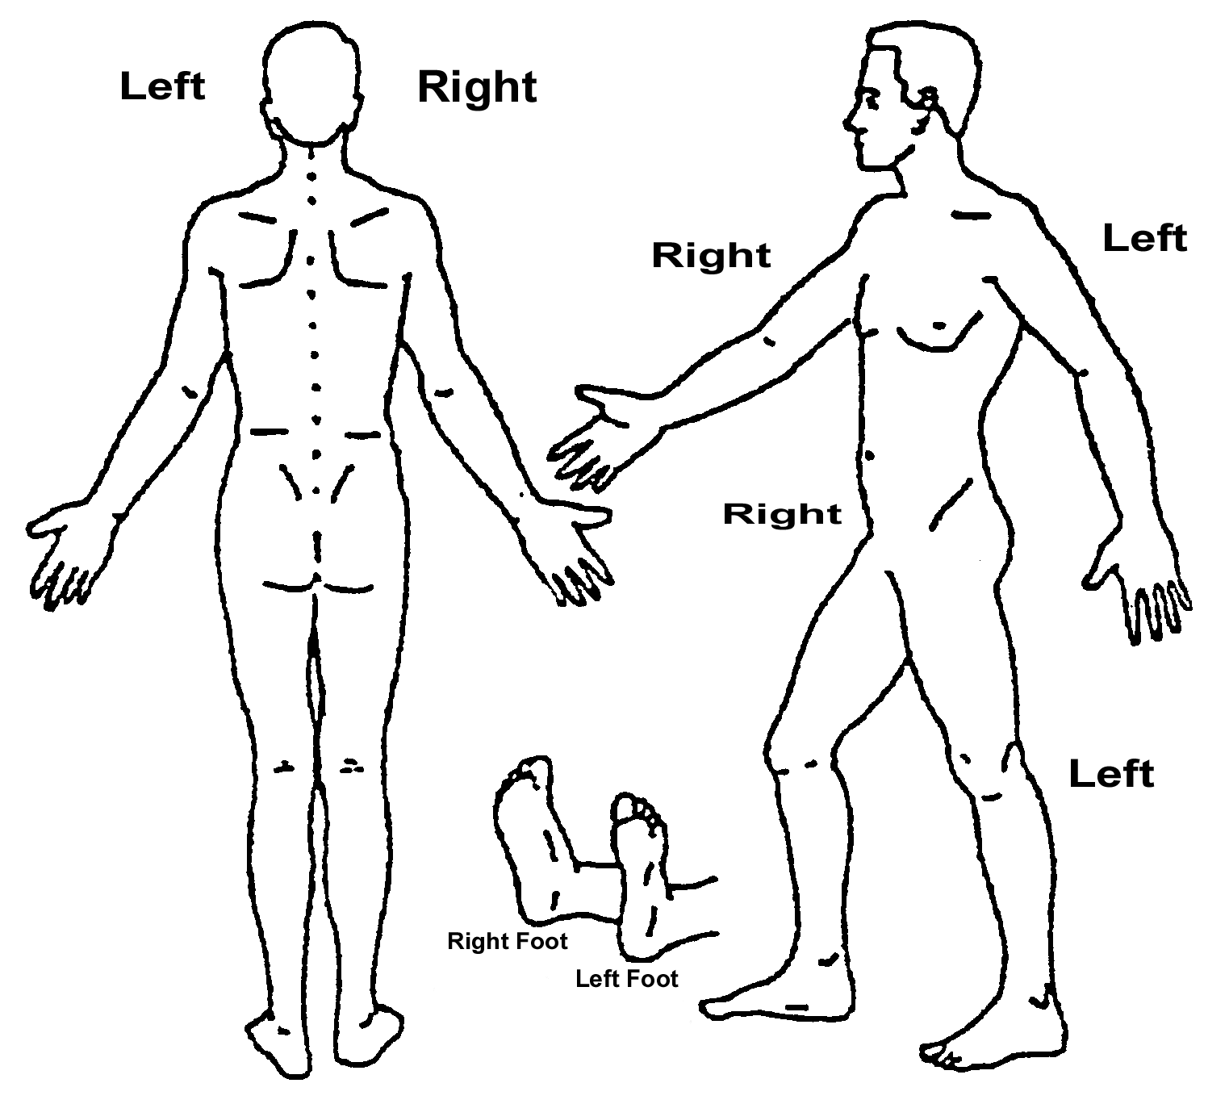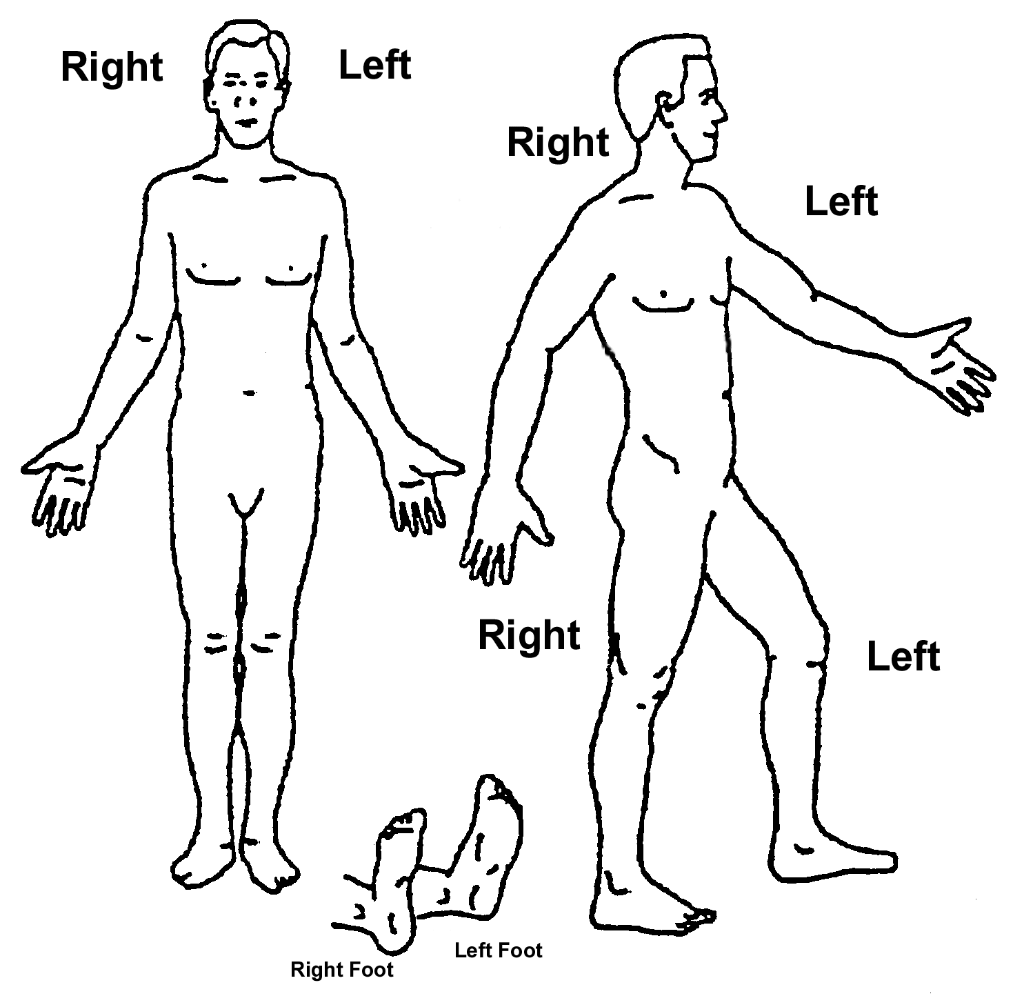
RMDQ-A

When you have pain you may find it difficult to do some of the things you normally do. This list contains some sentences that people have used to describe themselves when they have pain.

As you read the list, think of yourself today, mark the box with either 1 or 0 (true or false) whichever describes you TODAY.

Codes
1 = True 0 = False

1. | I stay at home most of the time because of my pain.
2. | I change position frequently to try and get myself comfortable.
3. | I walk more slowly than usual because of my pain.
4. | Because of my pain I am not doing any of the jobs that I usually do around the house.
5. | Because of my pain I use a handrail to get upstairs.
6. | Because of my pain I lie down to rest more often.
7. | Because of my pain I have to hold on to something to get out of an easy chair.
8. | Because of my pain I try to get other people to do things for me.
9. | I get dressed more slowly than usual because of my pain.
10. | I only stand up for short periods of time because of my pain.
11. | Because of my pain I try not to bend or kneel down.
12. | I find it difficult to get out of a chair because of my pain.
13. | I am in pain almost all of the time.
14. | I find it difficult to turn over in bed because of my pain.
15. | My appetite is not very good because of my pain.
16. | I have trouble putting on my socks/tights because of the pain.
17. | I only walk short distances because of my pain.
18. | I sleep less well because of my pain.
19. | Because of my pain I get dressed with help from someone else.
20. | I sit down for most of the day because of my pain.
21. | I avoid heavy jobs around the house because of my pain.
22. | Because of my pain I am more irritable than usual.
23. | Because of my pain I go upstairs more slowly.
24. | I stay in bed most of the time because of my pain.

CES-D
Circle the number of each statement that best describes how often you felt or behaved during the past week.
During the past week …… |  | Rarely or none of the time | Some or a little of the time | Occasionally or a moderate amount of time | Most or all of the time
 |  | (less than 1 day) | (1 to 2 days) | (3 to 4 days) | (5 to 7 days)
1. | I was bothered by things that don’t usually bother me. | 0 | 1 | 2 | 3
2. | I did not feel like eating; my appetite was poor. | 0 | 1 | 2 | 3
3. | I felt that I could not shake off the blues even with help from my family or friends. | 0 | 1 | 2 | 3
4. | I felt that I was just as good as other people. | 0 | 1 | 2 | 3
5. | I had trouble keeping my mind on what I was doing. | 0 | 1 | 2 | 3
6. | I felt depressed. | 0 | 1 | 2 | 3
7. | I felt that everything I did was an effort. | 0 | 1 | 2 | 3
8. | I felt hopeful about the future. | 0 | 1 | 2 | 3
9. | I thought my life had been a failure. | 0 | 1 | 2 | 3
10. | I felt fearful. | 0 | 1 | 2 | 3
11. | My sleep was restless. | 0 | 1 | 2 | 3
12. | I was happy. | 0 | 1 | 2 | 3
13. | I talked less than usual. | 0 | 1 | 2 | 3
14. | I felt lonely. | 0 | 1 | 2 | 3
15. | People were unfriendly. | 0 | 1 | 2 | 3
16. | I enjoyed life. | 0 | 1 | 2 | 3
17. | I had crying spells. | 0 | 1 | 2 | 3
18. | I felt sad. | 0 | 1 | 2 | 3
19. | I felt that people disliked me. | 0 | 1 | 2 | 3
20. | I could not ‘get going’ | 0 | 1 | 2 | 3

PASS

Individuals who experience pain develop different ways to respond to that pain. We would like to know what you do and what you think about when in pain. Please use the rating scale below to indicate how often you engage in each of the following thoughts or activities. Circle any number from 0 (never) to 5 (always) for each item.

Never Always

1. | I think that if my pain gets too severe it will never decrease. | 0 | 1 | 2 | 3 | 4 | 5
2. | When I feel pain I am afraid that something terrible will happen. | 0 | 1 | 2 | 3 | 4 | 5
3. | I go immediately to bed when I feel severe pain. | 0 | 1 | 2 | 3 | 4 | 5
4. | I begin trembling when engaged in an activity that increases pain. | 0 | 1 | 2 | 3 | 4 | 5
5. | I can’t think straight when in pain. | 0 | 1 | 2 | 3 | 4 | 5
6. | I will stop any activity as soon as I sense pain coming on. | 0 | 1 | 2 | 3 | 4 | 5
7. | Pain seems to cause my heart to pound or race. | 0 | 1 | 2 | 3 | 4 | 5
8. | As soon as pain comes on I take medication to reduce it. | 0 | 1 | 2 | 3 | 4 | 5
9. | When I feel pain I think that I might be seriously ill. | 0 | 1 | 2 | 3 | 4 | 5
10. | During painful episodes it is difficult for me to think of anything besides the pain. | 0 | 1 | 2 | 3 | 4 | 5
11. | I avoid important activities when I hurt. | 0 | 1 | 2 | 3 | 4 | 5
12. | When I sense pain I feel dizzy or faint. | 0 | 1 | 2 | 3 | 4 | 5
13. | Pain sensations are terrifying. | 0 | 1 | 2 | 3 | 4 | 5
14. | When I hurt I think about the pain constantly. | 0 | 1 | 2 | 3 | 4 | 5
15. | Pain makes me nauseous. | 0 | 1 | 2 | 3 | 4 | 5
16. | When pain comes on strong I think that I might become paralysed or more disabled. | 0 | 1 | 2 | 3 | 4 | 5
17. | I find it hard to concentrate when I hurt. | 0 | 1 | 2 | 3 | 4 | 5
18. | I find it difficult to calm my body down after periods of pain. | 0 | 1 | 2 | 3 | 4 | 5
19. | I worry when I am in pain. | 0 | 1 | 2 | 3 | 4 | 5
20. | I try to avoid activities that cause pain. | 0 | 1 | 2 | 3 | 4 | 5

Thank you for taking the time to complete this form.

Please make sure you have added your name & address details to the front sheet before sending it back in the pre – paid envelope.

