QUALITY MANUAL
GENOMIC DIAGNOSTICS LABORATORY

CONTENTS
1. PURPOSE 3
2. GENERAL INFORMATION 3
2.1. The Genomic Laboratories 3
2.2. GDL Documentation Hierarchy 4
2.3. The Quality Manual 4
3. QUALITY POLICY 4
4. MANAGEMENT REQUIREMENTS 6
4.1. Organization and management responsibility 6
4.1.1. Organization 6
4.1.2. Management responsibility 8
4.1.2.1. Management commitment 8
4.1.2.2. Needs of users 9
4.1.2.3. Quality policy 9
4.1.2.4. Quality objectives and planning 9
4.1.2.5. Responsibility, authority and interrelationships 9
4.1.2.6. Communication 9
4.1.2.7. Quality manager 12
4.2. Quality management system 12
4.2.1. General requirements 12
4.2.2. Documentation requirements 13
4.3. Document control 13
4.4. Service agreements 14
4.5. Examination by referral laboratories 14
4.5.1. Selecting and evaluating referral laboratories and consultants 14
4.5.2. Provision of examination results 15
4.6. External services and supplies 15
4.7. Advisory services 15
4.8. Resolution of complaints 15
4.9. Identification and control of nonconformities 15
4.10. Corrective action 16
4.11. Preventive action 16
4.12. Continual improvement 16
4.13. Control of records 16
4.14. Evaluation and audits 17
4.14.1. General 17
4.14.2. Periodic review of requests, and suitability of procedures and sample requirements 17
4.14.3. Assessment of user feedback 17
4.14.4. Staff suggestions 17
4.14.5. Internal audit 17
4.14.6. Risk management 18
4.14.7. Quality indicators 18
4.14.8. Reviews by external organisations 18
4.15. Management review 18
5. TECHNICAL REQUIREMENTS 19
5.1. Personnel 19
5.1.1. General 19
5.1.2. Personnel qualifications 19
5.1.3. Job descriptions 19
5.1.4. Personnel introduction to the organisation 19
5.1.5. Training 20
5.1.6. Competence assessment 20
5.1.7. Reviews of staff performance 20
5.1.8. Continuing education and professional development 20
5.1.9. Personnel records 20
5.2. Accommodation and environmental conditions 21
5.2.1. General 21
5.2.2. Laboratory and office facilities 21
5.2.3. Storage facilities 21
5.2.4. Staff facilities 21
5.2.5. Patient sample collection facilities 21
5.2.6. Facility maintenance and environmental conditions 21
5.2.7. Health and Safety 22
5.3. Laboratory equipment, reagents, and consumables 22
5.3.1. Equipment 22
5.3.2. Reagents and consumables 23
5.4. Pre-examination processes 23
5.4.1. General 23
5.4.2. Information for patients and users 23
5.4.3. Request form information 23
5.4.4. Primary sample collection and handling 24
5.4.5. Sample transportation 24
5.4.6. Sample reception 24
5.4.7. Pre-examination handling, preparation and storage 24
5.5. Examination processes 24
5.5.1. Selection, verification and validation of examination procedures 24
5.5.2. Biological reference intervals or clinical decision values 25
5.5.3. Documentation of examination procedures 25
5.6. Ensuring quality of examination results 25
5.6.1. General 25
5.6.2. Quality control 25
5.6.3. Interlaboratory comparisons 26
5.6.4. Comparability of examination results 26
5.7. Post-examination processes 26
5.7.1. Review of results 26
5.7.2. Storage, retention and disposal of clinical samples 26
5.8. Reporting of results 26
5.9. Release of results 27
5.10. Laboratory information management 28
5.10.1. General 28
5.10.2. Authorities and responsibilities 28
5.10.3. Information system management 28

- PURPOSE
This Quality Manual is consistent with the requirements of ISO 15189:2012 standards, clause 4.2.2.2. It fulfils two functions. Firstly it describes the Quality Management System for the benefit of the laboratory’s own management and staff, and secondly it provides information for users and for inspection/accreditation bodies.

- GENERAL INFORMATION
  - The Genomic Laboratories
The Genomic Diagnostics Laboratory (GDL) comprises two laboratory sections –Biochemical Genetics (also known as the Willink Laboratory) and the North West Genomic Laboratory Hub (NW GLH; Manchester site) which comprises of Cytogenomics, Specialised Cell Culture Services, Molecular Genetics, Molecular Haematology and Bioinformatics. The GDL is part of the Manchester Centre for Genomic Medicine (MCGM), a directorate within the St Mary’s Hospital Managed Clinical Service, which is an operational unit of the Manchester University NHS Foundation Trust.

The North West Genomic Laboratory Hub (NW GLH), which includes the NW GLH Manchester site and the NW GLH Liverpool site (based at the Liverpool Women’s NHS Foundation Trust but under the legal responsibility of the Manchester University NHS Foundation Trust from 1st August 2019), in partnership with The Christie NHS Foundation Trust, Liverpool Clinical Laboratories and Lancashire Teaching Hospital NHS Foundation Trust provides core genomic testing to the entire North West of England. This change has been brought about due to reconfiguration of genetics laboratories by NHS England in order to create a national NHS Genomic Medicine Service.

The GDL is situated on the 6th Floor of St Mary’s Hospital in Manchester. It offers testing predominantly for the North-West population, but also provides some specialised services nationally and internationally. The GDL provides services for Cytogenomics (predominantly QF-PCR and microarray tests), Molecular Genetic (including Next Generation Sequencing Panels), Specialised Haematology, Haematoncology, Biochemical Genetics (both Metabolic and Lysosomal Storage Diseases) and Newborn Screening. Tests are undertaken on a variety of different tissues including blood samples, amniotic fluid, chorionic villus, post mortem samples, urine, skin samples, and tumour samples (see the North West Genomic Laboratory Hub website here or the Manchester Centre for Genomic Medicine (MCGM) website www.mangen.co.uk for more details).

The laboratories also currently collaborate closely with an international EQA scheme provider which operates from within the Manchester Centre for Genomic Medicine: the European Research Network for Evaluation and Improvement of Screening, Diagnosis, and Treatment of Inherited Disorders of Metabolism (ERNDIM; www.erndim.org).

The full postal address is:
North West Genomics Laboratory Hub (Manchester) / Willink Biochemical Genetics Laboratory
Genomic Diagnostics Laboratory, Manchester Centre for Genomic Medicine,
6th Floor, St Mary’s Hospital, Manchester University Hospitals NHS Foundation Trust,
Oxford Road, Manchester
M13 9WL
Tel: NW GLH Manchester site: +44 (0) 161 276 6122 / +44 (0) 161 276 6553
Tel: Biochemical Genetics Lab: +44 (0) 161 701 8612
E-mail: NW GLH Manchester site: mft.genomics@nhs.net
Fax: Biochemical Genetics Lab: +44 (0) 161 701 2303

  - GDL Documentation Hierarchy
The GDL documentation is held within the laboratory quality management database (which will now be referred to as Q-Pulse).and broadly follows a 4 tier hierarchy with this Quality Manual at the pinnacle (see figure 1). The list of documents can be viewed directly from Q-Pulse. This Quality Manual describes the Quality Management System of the GDL (ISO 4.2.2.2). It is the index volume which refers to management, laboratory, clinical and quality policies. Specific quality procedures (often with the full policy) can be found in separate documents cited in this manual. The working instructions (standard operating procedures, SOPs) for technical processes are not described in this manual but can be found in Q-Pulse in the ‘Diagnostic’ subfolder (see section 4.3). These SOPs may contain the specific quality requirements, technical requirements and working instructions for the specific procedure. In addition, Q-Pulse is used to store quality records such as test validation documents, laboratory audit forms, instruction manuals and meeting minutes.
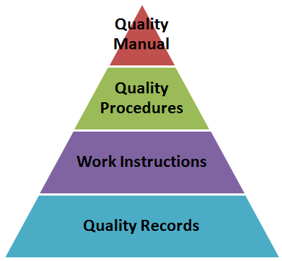
Figure 1: Hierarchy of Documentation for the Quality Management system. (Image taken from the CQE Academy website.)

  - The Quality Manual
The sections of the quality manual are arranged so that they equate with the ISO 15189:2012 Standards [DOC3046]. Under the title of each standard there is a brief description of the way in which the GDL seeks to comply with the particular standard clause and references are given to appropriate policies and/or procedures (either Trust intranet or GDL Q-Pulse procedures [in square brackets]).

Section 4 describes the management requirements (including the organisation of the GDL and its quality management system) and section 5 describes the technical requirements (including personnel, resources, pre-examination, examination and post-examination processes).

- QUALITY POLICY
The Quality Policy (ISO clauses 4.1.2.3 & 4.2.2a) of the GDL is given overleaf and published as a separate controlled document [DOC1018] displayed within the laboratory and accessible from Q-Pulse.

QUALITY POLICY
GENOMIC DIAGNOSTICS LABORATORY

The Genomic Diagnostics Laboratory (GDL) comprises two sections reflecting diverse work streams - the Biochemical Genetics section (also known as the Willink laboratory) and the North West Genomic Laboratory Hub (NW GLH; Manchester site) which comprises of Cytogenomics, Specialised Cell Culture Services, Molecular Genetics, Molecular Haematology and Bioinformatics. The GDL is part of the Manchester Centre for Genomic Medicine– a directorate within St Mary’s Hospital which, in turn, is part of Manchester University Hospitals NHS Foundation Trust.

The goal of the GDL is to provide the highest quality diagnostic service to our patients.

Commitment to Quality
It is the policy of the GDL to report the correct genetic diagnosis on the correct patient in an appropriate timeframe using reliable and accurate tests utilising the most relevant technology, and to communicate that diagnosis to the correct clinician in the most effective way.

The GDL Management is committed to:
- patient care; reporting clinically useful test results to service users
- respecting patient confidentiality
- innovation and the development of new technologies ensuring state of the art testing
- delivering efficient service workflows, meeting all agreed national and local targets
- providing laboratory staff of all grades with the appropriate knowledge, skills, competency, development and support for continued professional development (CPD) including key performance indicators such as annual appraisal, mandatory training, equality and diversity
- ensuring that all laboratory staff are familiar with the quality policy and understand what is expected from them

The GDL seeks to satisfy the UKAS ISO 15189 standards and will:
- set annual quality objectives, maintain a quality manual and complete an annual management review
- apply and promote all areas of the quality management system, including the use of documented procedures, internal audit, procurement and maintenance of equipment and other resources, as well as the health, safety and welfare of staff and visitors
- ensure the laboratory delivers the quality of service which this policy describes, within the resources available
- promote good professional practice and conduct as laid out in best practice guidelines and Trust procedures, and comply with current legislation and the requirements of NHS England
- maintain a commitment to continual quality improvement including assessment of user satisfaction, external quality assessment, and the identification of non-compliance corrective and preventive actions

Signed on behalf of the GDL:
Emma Howard, GLH Operations Scientific Director Date: 12.11.2020
- MANAGEMENT REQUIREMENTS
  - Organization and management responsibility
    - Organization
The GDL is part of the directorate of the Manchester Centre for Genomic Medicine (MCGM) within the St Mary’s hospital Managed Clinical Service, an operational unit within the Manchester University NHS Trust (ISO 4.1.1.2). The top level of the host organisation (Manchester University NHS Trust) is shown in figure 2 below.

- Board Sub-Committee Structure (from MFT Annual Report 2020-2021)
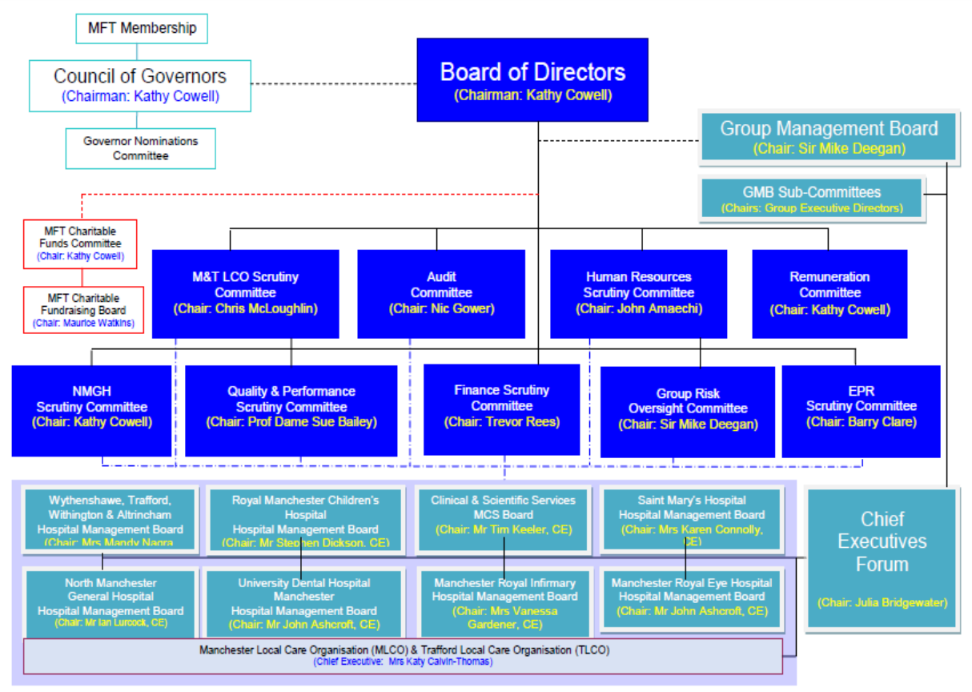

- MFT Hospital and Managed Clinical Service Organisational Structure
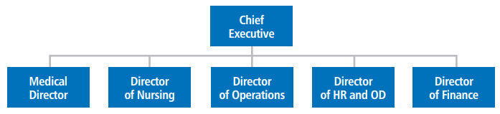

Figure 2: The Host Organisation. The Manchester University NHS Foundation Trust (MFT). There is a Board Sub-Committee Structure (A) and each Operational Unit (including the St Mary’s Hospital Managed Clinical Service) has its own organisation structure (B).

The internal organisational relationships are shown in figure 3. The Manchester Centre for Genomic Medicine and the GDL (incorporating the NW GLH Manchester site and the Willink Biochemical Genetics Laboratory) have a defined management structure.

- St Mary’s, The Manchester Centre for Genomic Medicine and the Genomic Diagnostic Laboratory management structure.

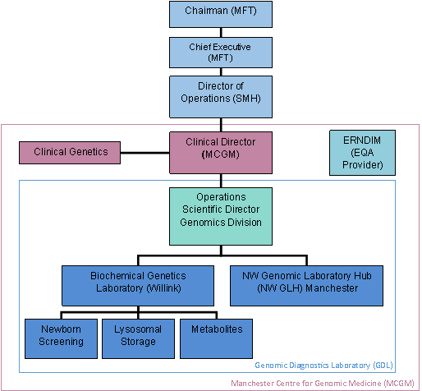

- The NW GLH management structure

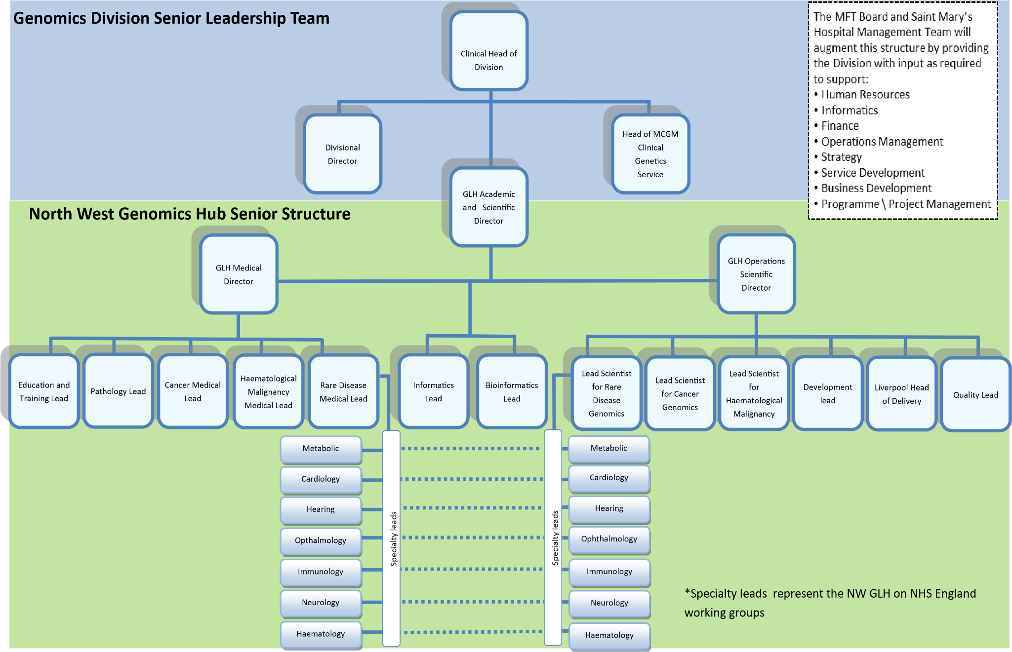

Figure 3: The relationship of (A) the Genomic Diagnostics Laboratory (GDL) to the Host Organisation and (B) the NW GLH to the Host Organisation. Manchester University NHS Foundation Trust (MFT); St Mary’s Hospital (SMH); Manchester Centre for Genomic Medicine (MCGM). Note that the GLH Operations Scientific Director also has responsibility for the Willink Laboratory and is therefore described throughout this document as the Laboratory Director.

All new staff members are required to declare any conflicts of interest prior to commencement at the Trust. Existing staff members above agenda for change Band 7 are prompted annually by the Trust to declare of any new conflicts of interests via the Learning Hub (ISO 4.1.1.3) [Trust policy CORPS 002 (ON8-2880) – Standards of Business Conduct & Hospitality Policy]. Staff members adhere to Trust and GDL requirements to maintain confidentiality [Trust policy IG006 (ON4-3437) - Confidentiality Code of Conduct and Information Disclosure Policy; DOC2051] and ensure respectful treatment of human samples (ISO 4.1.1.3) [staff induction and training].

The Director of the GDL (also the GLH Operations Scientific Director and described within this document as the Laboratory Director) is a Consultant Clinical Scientist and has the responsibility for the services provided by the GDL supported by a Senior Management Team of consultant and Principal Clinical Scientists (ISO 4.1.1.4). This is currently Dr Emma Howard. The duties and responsibilities of the Laboratory Director are documented below. These include professional, scientific, consultative or advisory, organisational, administrative and educational matters relevant to the services offered by the laboratory. The Laboratory Director can delegate duties and/or responsibilities to other qualified personnel but maintains the ultimate responsibility for the overall operation and administration of the laboratory. The deputy Laboratory Director, Simon Ramsden, takes overall responsibility in the absence of the Laboratory Director.

The Laboratory Director (and designate/s):
- Ensures the provision of clinical advice with respect to the choice of examinations, use of the service and interpretation of examination results (Senior Management Team, Scientists)
- Communicates with external agencies including accreditation and regulatory agencies (Senior Management Team or Quality Management Team as appropriate)
- Provides budget and financial management
- Ensures appropriate staff numbers (Senior Management Team including Technical Managers)
- Ensures implementation of the quality policy and manual (Quality Management Team)
- Defines, implements and monitors key performance standards and quality improvement (Senior Management Team, Quality Manager and Quality Management Team)
- Provides professional development programmes and other opportunities for staff (Training Team)
- Ensures a safe laboratory environment (Senior Management Team, Health and Safety Team)
- Selects referral laboratories and monitor quality of service (designated Clinical Scientists and Quality Management Team respectively)
- Selects and monitors laboratory suppliers (Technical Managers)
- Addresses complaints and suggestions (Quality Manager)
- Plans and directs research (Senior Management Team, Development Team)
- Ensures a contingency plan for essential services (Quality Management Team, Senior Management Team including Technical Managers)

    - Management responsibility
      - Management commitment
Laboratory management is committed to the development and implementation of the quality management system and its continual improvement as evidenced by: laboratory communication and communication processes, the quality policy, quality objectives, staff responsibilities, the appointment of a quality manager, annual management reviews, staff competency, and management of resources necessary for pre-examination, examination and post-examination activities.

      - Needs of users
Laboratory services, including appropriate advisory and interpretative services, are periodically reviewed to ensure that they meet the needs of patients and service users (ISO 4.1.2.2). Information is gathered via the use of satisfaction questionnaires (ISO 4.14.3) and in response to complaints or comments regarding the service (ISO 4.8). These can be translated into corrective or preventive actions and form the focus of objective setting and planning (ISO 4.1.2.4). Assessment of user satisfaction and complaint findings [DOC1187] forms part of the annual management review (ISO 4.15). The service profiles of the GDL can be found on the North West Genomic Laboratory Hub website here or the MCGM website at www.mangen.org.uk (which also includes a Willink Laboratory Handbook).

      - Quality policy
The Quality Policy is regularly reviewed to ensure that it recognises the Trust values (pride, respect, empathy, consideration, compassion and dignity) and Trust objectives (patient safety and clinical quality, patient and staff experience, productivity and efficiency). It is communicated to all staff through Q-Pulse [DOC1018].

4.1.2.4 Quality objectives and planning
      - Quality objectives and planning
The Director and Senior Management Team define the quality objectives within the GDL (ISO 4.1.2.4) ensuring consistency with the quality policy. This team, in conjunction with the Quality Management Team, is responsible for ensuring that objectives are measurable. The quality objectives are available to all members of staff on Q-Pulse [DOC1343]. The progress of GDL quality objectives are reviewed regularly at various management meetings. The annual management review (see 4.15 below) is used by the Senior Management Team to determine whether objectives have been successfully completed and provides an opportunity for reviewing both GDL quality objectives and the integrity of the quality management system.

      - Responsibility, authority and interrelationships
The GDL is managed by the Laboratory Director with sections led by Consultant and/or Principal Clinical Scientists (ISO 4.1.2.5). The organisation of GDL staff is represented in the organisational chart (Figure 4). All staff and their roles (including staff at the GLH Liverpool site) are documented in the Genomics Laboratory Staff (NW Region) Roles and Responsibilities document [DOC2072]. The specific roles and responsibilities of the Quality management team are described [DOC488].

      - Communication
The GDL has different methods and means for communicating with staff including meetings (summarised below), newsletters, e-bulletins, lunchtime seminars, and staff suggestions via a whiteboard and Q-Pulse register. Minutes for the majority of meetings are available on Q-Pulse. Quality Management meetings are distributed to all staff members. Dashboards are available on shared network drives.

The GDL communicates with stakeholders via the MCGM website, letters, complaints, and user satisfaction questionnaires. Stakeholders are informed of any significant changes to services.

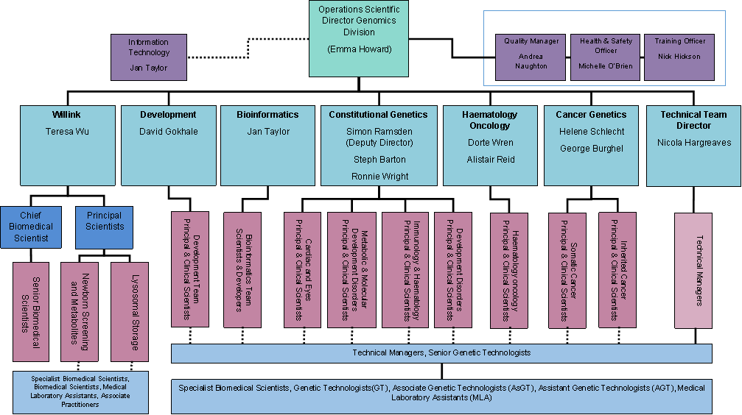
Figure 4: The organisation within the Genomic Diagnostics Laboratory.

Regular MCGM, GDL and GLH meetings include:

- The Genomic Medicine Business Group meets monthly. Its membership is as follows:
- Clinical Head of Division
- Divisional Director
- NW GLH Academic & Scientific Director
- NW GLH Operational Director
- Head of MCGM Clinical Genetics Service
- MCGM Governance Lead
- MFT Communication and HR representatives

- The North West GLH Operations Group meets monthly. Its membership is as follows:
- NW GLH Operational Director
- Liverpool Head of Service / Deputy Director
- Assistant Directorate Manager
- Section Lead Scientists / Consultant Clinical Scientists
- Team Leads / Principal Clinical Scientists
- Technical Managers
- Development Team Lead
- NW GLH Quality Lead

- The Willink Biochemical Genetics Operational Management Team meets monthly. Its membership is as follows:
- Head of Willink Biochemical Genetics
- Sectional leads and deputies
- Quality Lead for Biochemical Genetics
Notes of the meetings are circulated to members of the team and appropriate actions taken.

- The Genetic Medicine Quality & Safety Committee meets monthly. Its membership is as follows:
- MCGM Governance Lead
- SMH Clinical Effectiveness Lead
- Quality Manager of the GDL Laboratories / Representative for NW GLH Manchester
- Laboratory Representative for Biochemical Genetics
- Laboratory Representative for NW GLH Liverpool
- Quality Manager of Clinical Genetics
- Clinical Representative for Biochemical Genetics
- Clinical Research Representative
- Office Manager for Clinical Genetics
- Clinical Audit Lead
- MCGM Health & Safety Lead
- Genetic Counsellors’ Representative
Minutes of these meetings are circulated to members and appropriate actions taken. Minutes are also made available to members and are held by the PA to the Clinical Lead.

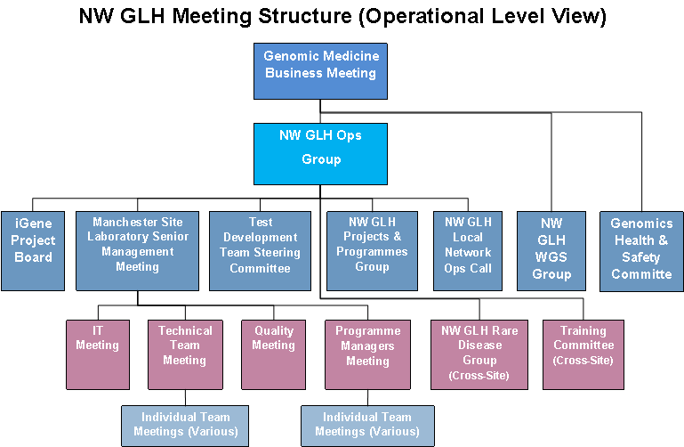

- The GDL Quality Management Team meets monthly. Its membership is:
- Quality Manager
- Quality Leads
- Education &Training Lead
- Incident Lead
- Document Control Lead
- Health & Safety Lead
- Audit Lead
- EQA Lead
- Change Control Lead
- IT Lead
- Technical Director/Manager (Equipment & Risk Lead)
Notes of the meetings are circulated to members of the team and appropriate actions taken. Minutes are made available to all members of staff via Q-Pulse [DOC1172].

In addition, all Willink staff members meet monthly [DOC729]. Due to the large size of the other laboratory areas the Technical Team Leads meets every month and includes the Technical Team Managers and Senior Genetic Technologist Team Leads [DOC2068]. Specific Technical Team and Clinical Scientist Team meetings are held on a regular basis and minutes are made available to all members of staff via Q-Pulse.

      - Quality manager
There is an appointed Quality Manager (ISO 4.1.2.7) who works with Senior Management and the Quality Team to ensure that quality management system processes are established, implemented, and maintained. They report directly to the Laboratory Director on the performance and effectiveness of the quality management system and any need for improvement. The Quality Manager also promotes of the awareness of the needs and requirements of service users by providing guidance to staff in seminars and meetings and through the means of user satisfaction surveys, suggestions and complaints.

The current post-holder is Dr Andrea Naughton. There are currently four Quality Leads who can deputise for the Quality Manager: Josie Innes (Cytogenomics), Emma Miles (Constitutional Genomics), Sarah Waller (Cancer Genomics) and Rob Gibson (Biochemical Genetics). All aspects of quality are supported by teams of staff. The organisation of the Quality Management Team is shown in figure 5 below.

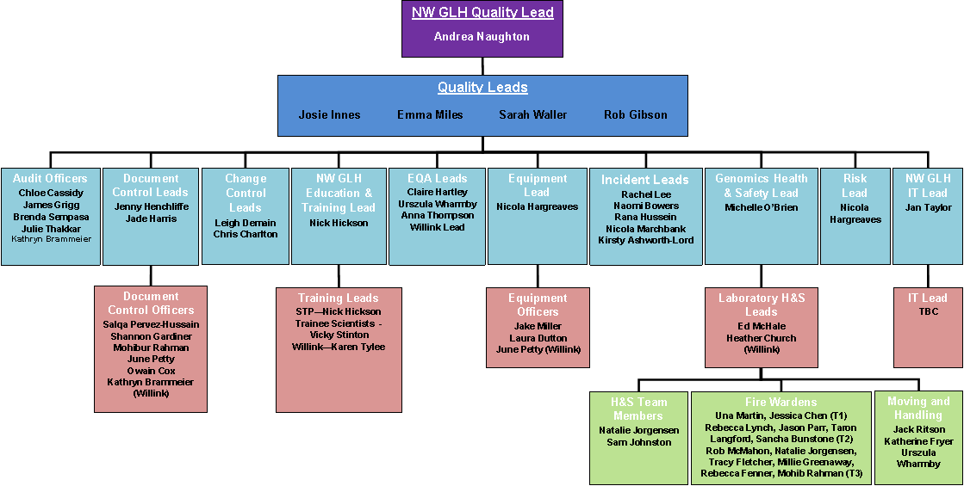Figure 5: Organisation of the Quality Management Team.

  - Quality management system
    - General requirements
The components and relationships within the Quality management system (ISO 4.2) are described in section 4 and 5 of this Quality Manual. The roles and responsibilities of laboratory quality management in ensuring compliance with the ISO standards are defined below:

Role | Responsibility
Laboratory Director | Overseeing compliance with ISO 4 & 5
Consultant Clinical Scientists | Deputising for Director of Lab responsibilities
Principal Clinical Scientists / Section Leads | Ensuring compliance with ISO 5.4 to 5.9
Quality Manager  (also NW GLH Quality Lead) | Implementing, maintaining and reporting on function and effectiveness of the Quality Management System (including liaising with inspection bodies) ISO 4 & 5
Quality Lead | Deputising for Quality Manager, ensuring compliance with ISO 4 & 5 (particularly ISO 4.9-4.12 and 5.6.3)
Training Lead | Ensuring compliance with ISO 5.1
Incident Lead | Ensuring compliance with ISO 4.9-4.11
Document Control Lead | Ensuring compliance with ISO 4.2.2
Health & Safety Lead | Ensuring compliance with ISO 5.1.4
Audit Lead | Ensuring compliance with ISO 4.14
EQA Lead | Ensuring compliance with ISO 5.6.3
Change Control Lead | Ensuring compliance with ISO 4.12
IT Lead | Ensuring compliance with ISO 5.10
Technical Director (Risk Lead) and Managers (Equipment Lead) | Ensuring compliance with ISO 4.14.6, 4.6, 5.3

Table 1: Roles within the Quality Management system.

The Quality Management Team meets to discuss the strategy of the quality management system and to monitor, evaluate and improve the effectiveness of the quality management system.

    - Documentation requirements
The GDL has controlled regularly reviewed documents on Q-Pulse pertaining to a quality policy [DOC1018], quality objectives [DOC1343], quality manual [DOC1191] and the annual management review [DOC1020]. This quality manual describes the scope of the quality management system and fulfils the requirement of ISO 4.2.2.2.

  - Document control
GDL documents are controlled using Q-Pulse (ISO 4.3) [DOC845, DOC842, DOC843, and DOC846]. The GDL has designated staff responsible for ensuring document control [DOC1196]. They have specific areas of responsibility and report formally via Quality Management team meetings. Documents are regularly reviewed, updated and approved for use by authorised personnel prior to use [MP 000 135]. Version control is in place with only documents used from an active register. Obsolete documents are retained. Documents are organised in Q-Pulse depending on the nature of the document as shown below.

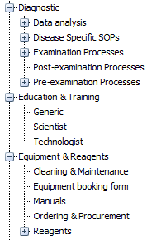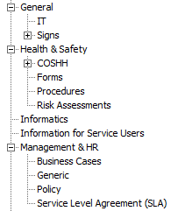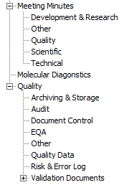

Trust documents can be accessed by all staff through the intranet. A separate document control process exists for documents relating to MFT policies (Trust policy CG001 (ON8-2524) Document Control Policy).

Standard operating procedures should be strictly followed and failure to do so may be regarded as misconduct and could incur disciplinary action. Staff have a duty to raise any discordance between a procedure and its documentation via the Q-Pulse quality management system and to complete any critical document changes promptly.

  - Service agreements
Each request for testing is considered an agreement with the service user. The requirements of the service user are indicated on the MCGM (www.mangen.org.uk) website and North West Genomic Laboratory Hub (https://mft.nhs.uk/nwglh/) website. Specific instructions given on some referral forms export forms and handbooks [DOC1134].

Under certain circumstances specific contracts for medical laboratory services are put in place [DOC1192]. These service level agreement contracts are documented on Q-Pulse [Management & HR>Service Level Agreement (SLA)]. There is also an agreement between the NW GLH Manchester and Liverpool sites for service processes [DOC5634].

Any new services are designed, developed and validated appropriately [DOC2063]. GDL staff are appropriately trained (ISO 5.1.5) and deemed competent (ISO 5.16) in the skills and expertise necessary for examination processes.

  - Examination by referral laboratories
    - Selecting and evaluating referral laboratories and consultants
The GDL periodically sends samples to external laboratories, mainly for Molecular Genetics or Biochemical Genetics tests not available at the GDL. Samples are exported on behalf of external and internal (Clinical Genetics) referrers. For Biochemical Genetics tests, a list of referral laboratories is maintained in the standard operating procedure [DOC2166]. From October 2018, Molecular Genetics specialist tests in England are delivered by specific referral centres (Genomic Laboratory Hubs, listed here). Centres providing molecular testing outside England are listed separately [QF 000 006]. This standard (ISO 4.5.1) is met by the laboratory document on the evaluation, selection, and monitoring of referral laboratories [QP 000 008]. All exported samples are recorded on the appropriate LIMS database. There are laboratory procedures in place for sending (exporting) samples to referral laboratories [DOC2166, LP 000 007, LP100 007, LP130 009, LP160 035, MP000 072]. The periodic monitoring of referral laboratories is documented [DOC3082, QF 000 006].

    - Provision of examination results
Biochemical Genetics reports received from referral laboratories on exported samples are copied onto the database and the original report sent out to the clinician (although some labs also send a copy of the report directly to the clinician). Genomics reports are sent direct to the clinician and a copy requested to be sent to the GDL for reference (via the export letter).

  - External services and supplies
The GDL has a documented procedure for the selection and purchasing of equipment, reagents and consumables [DOC475]. There is also a procedure for ordering supplies and consumables [DOC2106]. A list of approved suppliers to the GDL can be found on Q-Pulse Suppliers Module and is periodically reviewed. The GDL records any problems with equipment as nonconformities in the Q-Pulse Asset register and any problems with reagents, consumables and services as GDL nonconformities.

  - Advisory services
The GDL has a documented policy for advisory services [DOC2077]. The MCGM and NW GLH websites offer general information on the use of services, sample types and requirements (www.mangen.org.uk and https://mft.nhs.uk/nwglh/). They also provide the means by which the GDL can be contacted for further advice. The laboratory procedures for reporting results (ISO 5.8 & 5.9) ensure that appropriate clinical advice and interpretation is included in the written report. Further clinical advice and report interpretation can be communicated by telephone. Clinical advice and interpretation is only given by appropriately trained scientific staff. It is available during routine working hours, Monday – Friday (except for Bank Holidays, Christmas Day, and Boxing Day).

  - Resolution of complaints
The GDL has a system by which complaints are recorded on Q-Pulse, processed, and monitored until resolved (ISO 4.8). User feedback is also recorded on Q-Pulse. Any user suggestions through feedback from user survey or personal communication are considered. User surveys provide a means to assess the clinical relevance of all genetic investigations performed within the GDL and the reliability of interpretive reports in conjunction with users. The document DOC1187 meets this standard. The GDL participates in the evaluation of clinical effectiveness, audit, and risk management activities within MFT via the Directorate Quality & Safety Group.

  - Identification and control of nonconformities
Procedures are in place to ensure that nonconformities are managed effectively (ISO 4.9). The Quality Management team via the Incident Leads are responsible for managing nonconformities [DOC1508]. They ensure that actions are appropriately assigned and completed within an established timeframe. The document DOC1006 describes how the GDL meets this standard.

  - Corrective action
All nonconformities originating in the GDL are investigated and appropriate corrective actions implemented (ISO 4.10). Corrective actions are identified through errors and incidents, complaints and audit nonconformities and managed via the Q-Pulse non-conformance module [DOC1006]. The root cause is determined for any nonconformity and procedures are in place for when a full root cause analysis is required [DOC1008].

As part of continual improvement, all GDL nonconformities are reviewed by the Incident Leads 3-6 months following reporting to ensure that all corrective actions have been completed and to check for further instances of the nonconformity and error trends. Any trends and concerns are raised at Quality Management Team meetings.

  - Preventive action
Preventive actions are identified through audit nonconformities, staff and user suggestions, survey feedback and external quality control scheme feedback and managed via the Q-Pulse non-conformance module [DOC1006]. Preventive actions are implemented where appropriate (ISO 4.11) and the root cause of potential nonconformities determined.

  - Continual improvement
Quality improvement is an essential role for all staff at all levels of the service to ensure the GDL delivers a high-quality service (ISO 4.12). Improvement suggestions and ideas are welcomed and encouraged from all. Quality improvement can be proactive – new ideas about different ways of working, achieving increased efficiency for example. Quality improvement can also be reactive as results of scheduled internal audits, review of adverse incidents (reported to the Trust), incident reports (reported on Q-Pulse), user feedback/complaints as well as external quality assessment (accreditation and EQA schemes). Improvement suggestions are discussed and developed in team meetings (including the quality team) and include discussion of remedial action, corrective action, preventative action, root cause analyses and improvement processes. Continued quality improvement monitoring includes scheduling of audits (new audits as a result of non-conformance or repeat audits to monitor for improvement) and a 3-6 month review of non-conformances. Staff suggestions for improvement can be recorded via the Q-Pulse database. The results of the quality improvement programme form a part of the development, training and education of all staff. Continual improvement is discussed and actioned in Quality Management Team meetings; minutes of which are documented, circulated to participating staff and available to all staff via Q-Pulse. The GDL Quality Objectives are also available to all staff [DOC1343]. Analysis of the data collected forms part of the annual review (also distributed to all staff via Q-Pulse; ISO 4.15).

  - Control of records
The GDL has procedures to meet the requirements for controlling process records and quality records (ISO 4.13). The details of all documents, their storage and retention are documented [DOC1279 and DOC846]. The laboratory complies with current legislation, regulations and guidelines determining the timescales for storage of such records (NHS & RCPath). Obsolete examination process records are available on Q-Pulse to reconstruct the process of any examination.

  - Evaluation and audits
    - General
The GDL has established a procedure for evaluations and audits including pre-examination, examination and post-examination procedures and the quality management system (ISO 4.14.1) [DOC1288]. The record of internal audit includes the activities, audited areas or items, any nonconformity or deficiencies found, with recommendations and time scales for corrective and preventative action. Full details of evaluations, the audit schedule and completed audits are recorded via Q-Pulse. The results of internal audit are regularly evaluated, and the decisions taken documented monitored, reviewed, and acted upon by the Quality Management Team in order to continually improve the effectiveness of the quality management system. Internal audits and evaluations are discussed in the annual management review.

    - Periodic review of requests, and suitability of procedures and sample requirements
The NW GLH services and tests are now regulated by NHS England as Cancer and Rare Disease Test Directories (here). The tests given in these directories are peer reviewed annually (detailed here). The Willink senior management periodically review the examinations provided by the Willink Biochemical Genetics laboratory in their Operational Management Team meetings. There is also periodic audit of the quality, packaging, and transport of samples to the GDL.

    - Assessment of user feedback
The assessment of user feedback is done through user feedback, complaints and via the use of satisfaction questionnaires (ISO 4.14.3) [DOC1187]. All user complaints and feedback are recorded in the non-conformance module of Q-Pulse. The results of user satisfaction surveys are recorded on Q-Pulse within the audit module (2015 onwards). This ensures that all feedback is recorded and reviewed, and any appropriate actions taken.

    - Staff suggestions
There is an informal staff suggestions whiteboard as well as a module on Q-Pulse where suggestions can be raised. These are evaluated by senior members of staff, implemented as appropriate and the outcome communicated to the individual who made the suggestion.

    - Internal audit
Audits are conducted against agreed criteria including the relevant ISO 15189:2012 standards. The internal audit of pre-examination, examination and post-examination processes is planned and scheduled on a yearly basis through the Audit Module of the Q-Pulse database. Examination, Vertical and Horizontal audits are conducted following the laboratory policy and procedures available on the Q-Pulse database [DOC1288, DOC1509, MP000 043]. The results of all internal audits are evaluated by the Audit Lead and/or Quality Manager who ensure that corrective and preventative actions are undertaken in a timely fashion and communicated to all members of staff via Laboratory meetings and e-mail. All details of the audit, an audit check list (if appropriate), nonconformities, and the corrective and preventative actions are recorded on Q-Pulse. A number of staff members are appropriately trained in the procedure of internal audit [QF 000 002].

    - Risk management
The GDL evaluates the impact of work processes and potential failures on examination results as part of examination process validation/verification prior to use as a diagnostic service [DOC2063, DOC2010]. When potential failures or risks are identified following the implementation of a service the issue is raised as a non-conformance and appropriate actions are undertaken to eliminate the risk (points 4.10-4.12).

There are also Trust procedures for reporting of non-conformances and for recording risks [Trust policy RM001 (ON6-2802), DOC5705]. These use a web-based risk register (Ulysses) to document, control, action and escalate risk. The Trust requires the completion of a general risk assessment for the laboratory [DOC2931]. The GDL also carries out risk assessments for equipment and laboratory processes [DOC466].

    - Quality indicators
Key quality indicators are recorded and monitored [DOC1017]. These include mandatory annual appraisal and training conformance, completion of document/audit/non-conformance activities, error analysis, staff/user suggestions/complaints, and EQA. Quality indicators are reviewed in the Quality Management Team meeting. There are requirements to provide Patient Level Contract Monitoring (PLCM) data to NHS England for the assessment of laboratory activity and turnaround times (here).

    - Reviews by external organisations
The GDL is accredited by external assessment and is currently fully UKAS accredited under reference 9865 [DOC4165, DOC2252, DOC3096, DOC4157, DOC5323]. External accreditation assessment is recorded as an audit on Q-Pulse and all assessment findings recorded as non-conformances.

  - Management review
The Quality Team and Management representatives produce an annual management review (AMR; ISO 4.15) [DOC1020]. The Quality Manager, Senior Managers and Trust Directorate representatives participate in an AMR meeting. The AMR includes the following items of information:
- A report from the Laboratory Director
- Reports from key laboratory sections with reference to major changes in organisation and management, resources (including staffing) and processes
- Report from the Quality Team including a review of laboratory performance for the year against key performance indicators (ISO 4.14.7) and a review of annual objectives (ISO 4.1.2.4)
- A review of the quality policy (ISO 4.1.2.3)
- Assessment of user feedback/complaints (ISO 4.14.3) and staff suggestions (ISO 4.14.4)
- Review of internal audit (ISO 4.14.5)
- Review of risk management (ISO 4.14.6)
- Review of accreditation by external organisations (ISO 4.14.8) and of external quality assessment (ISO 5.6.3) [QF 000 004, DOC3090] GenQA, UKNEQAS, EMQN, ERNDIM and CDC.
- The status of preventive, corrective and improvement actions (ISO 4.9) and continual improvement
- Review of the minutes and matters arising from the previous annual management review meeting.
Records are kept and key objectives for subsequent years defined and plans formulated for their implementation. Both the AMR and AMR meeting minutes are available to all members of staff on Q-Pulse [DOC1020].

- TECHNICAL REQUIREMENTS
  - Personnel
    - General
Procedures exist for the following areas of personnel management (ISO 5.1.1) and are available to all members of staff either through the host organisation (via the Trust intranet site https://intranet.mft.nhs.uk/dashboard) or within the GDL via the Q-Pulse database as appropriate. Personnel organisation is shown in figure 4.

    - Personnel qualifications
All staff members are suitably qualified to take up their position at the GDL with appropriate education, training, experience, and skill. Documented evidence of staff qualifications is stored in staff personnel files. All staff employed at Clinical Scientist grades are HCPC state registered. Trained Genetic Technologists are directed towards the voluntary state registration register. Staff recruitment takes place via the Trust Recruitment office and their procedures.

    - Job descriptions
Each member of staff has a job description and contract of employment with MFT. These comply with current legislation and provide clear terms and conditions of service. Staffing includes individuals with specific roles such as technical management, quality management, training and education, and health and safety [DOC2072].

    - Personnel introduction to the organisation
All new staff members are required to undertake induction (ISO 5.1.4). All new staff members attend an induction programme provided by the Trust on their first day of employment. Additionally, they undertake a specific induction to the laboratory [DOC772, DOC775, DOC968, DOC2854, MF 000 062]. Induction and mandatory training specific to the section and position in which they will be working is also given using the appropriate documents (logbooks) which are available in Q-Pulse. A record of the areas of induction undertaken is kept in the personal records of each member of staff.

    - Training
Appropriate training is provided for all staff which includes training of specific work processes, health and safety requirements, quality management system, information management system, ethics, and confidentiality [E&T000 019]. Staff should not work unsupervised until they have been formally deemed competent on any given procedure, process, or task. Training and education needs for all trained staff (ISO 5.1.5) are identified through annual appraisal (ISO 5.1.7). Once trained and deemed competent, all individual staff have responsibility for the output and quality of their own work.

The GDL has a Training Lead to develop policies and procedures, provide an oversight of training needs, to organise training within the laboratory. The current post holder is Nick Hickson. There are regular GDL and Genetic Medicine seminars with internal and external speakers presenting diagnostic, research, journal article appraisal and technical workshops. All staff are invited to attend.

    - Competence assessment
Once trained, all staff members are assessed by various means to ensure competency [DOC840]. This can be facilitated by direct observation, verbal assessment, review of training, assessment of EQA scheme performance, and assessment of problem-solving skill. Continued competency is assessed at annual appraisal.

    - Reviews of staff performance
Each member of staff has an annual appraisal with their line manager to ensure continued competency, review staff performance (ISO 5.1.7), set individual objectives and identify learning needs. This uses the Trust appraisal documentation and guidance which is available on the Trust intranet (a toolkit is provided and accessed from here to the Learning Hub). The Trust provides training for all staff undergoing review and those conducting the review. The appraisal process includes the review of Trust/departmental/team objectives, job description, personal objectives and development plan, and training and development needs. A copy of the completed appraisal documentation, which includes an agreed personal development plan, is placed in the staff member’s personal file. The Trust maintains a record of appraisal dates for all staff and monitors compliance.

    - Continuing education and professional development
Learning needs are identified at annual appraisal. There are Trust education courses as part of organisational development and training found on the Learning Hub (https://learninghub.mft.nhs.uk/login/index.php), laboratory seminars and other opportunities available for staff to enable continued education and professional development.

    - Personnel records
Each member of staff has a personal file to which they are entitled to see on request (ISO 5.1.9). The files contain:
- personal details
- employment details
- a record of staff induction and orientation
- relevant education and professional qualifications
- record/certificate of registration, if relevant/not available elsewhere
- accident record
- a record of annual appraisal and personal development plan
- record of disciplinary action [Trust policies, HR 006 (ON11-4388), HR/ME/004 (ON3-2518), HR/ME/005 (ON3-2583)]
- record of competency (held on Q-Pulse and/or in paper format by staff)
The staff member is sent an electronic copy of their job description and contract on commencement of employment which is held centrally by MFT Workforce Planning Department. Records of absence are managed via Absence Manager an automated telephone/electronic system which is managed by the staff member’s line manager and held electronically by MFT Workforce Planning Department (From October 2019). An occupational health record is held by the Occupational Health Department within the Trust. A record of attendance at fire lectures is held by MFT Workforce & Organisational Development Department.

Each member of staff has a Training & Development Portfolio which they are required to keep up to date with information and data relating to their personal professional development (courses and scientific conferences attended) which can also be held on the Q-Pulse. Clinical Scientists hold a CPD Training Record and/or are registered for the Royal College of Pathologists CPD Scheme.

  - Accommodation and environmental conditions
    - General
The Manchester Centre for Genomic Medicine occupies the 6th floor of the MFT major hospital building. It is designated as part of St Mary’s Hospital [DOC24]. Access to the department is restricted via swipe cards.
Specimens are delivered to the Manchester Centre for Genomic Laboratory Sample Reception (samples for all laboratories) or via a pneumatic pod system to the genomics pre-analytical laboratory [DOC1329, DOC1330].

    - Laboratory and office facilities
Access to the GDL is restricted which ensures safety, quality, and confidentiality. Suitable facilities (space, equipment, consumables, safety equipment (PPE), computer facilities, and environmental conditions including lighting, water, and waste disposal) are provided for staff to allow for the correct performance of all examinations [DOC473].

    - Storage facilities
Facilities exist within the laboratory for storage of materials in accordance with national legislation (ISO 5.2.3), including process and quality records [DOC1279], clinical material [DOC1464], hazardous substances [DOC2022], reagents [DOC2025] and waste material for disposal [DOC2064].

    - Staff facilities
Suitable facilities are provided for staff welfare including secure locker or drawer space, sufficient toilet and shower facilities, basic catering facilities with a staff room and access to the hospital cafeteria, cafes and shops [DOC473].

    - Patient sample collection facilities
The GDL does not offer facilities for patient sample collection.

    - Facility maintenance and environmental conditions
The Trust holds a contract with Sodexo to provide building and environment maintenance, cleaning, and some equipment maintenance and service. Curatorship and stock control ensures that laboratory areas and equipment are clean and operational [DOC2031, DOC2108]. Temperature monitoring is in place in critical areas such as freezers and refrigerators [DOC638]. Pre- and post- analytical laboratories and office areas are clearly separated. Cell culture laboratory areas are clearly defined.

    - Health and Safety
The GDL provides a safe working environment for staff in accordance with current legislation [DOC2021, Trust ON2-2604]. The Manchester Centre for Genomic Medicine has a Health and Safety Lead, George Burghel. Each laboratory within the GDL has an appointed Health and Safety Lead who works with the Health and Safety Committee to ensure that all areas of this standard are met.

All staff are given information about the Health and Safety procedures within the laboratory during their induction [DOC2854, MF 000 062, DOC504]. Any issues relating to Health and Safety are discussed in Quality Team Meetings and in regular team meetings. Model rules exist for visitors to the department [DOC1420] outlining relevant Health and Safety matters.

All laboratory procedure documents include any relevant risk assessments [DOC2931]. CoSHH documentation (individual assessment checklist forms) is available on Q-Pulse for chemicals used in the GDL [DOC2014, DOC2325].

  - Laboratory equipment, reagents, and consumables
    - Equipment
The GDL has equipment which is sufficient and appropriate to provide the laboratory service (ISO 5.3.1). There is a document that details the policy and procedures for the selection, procurement, purchase, management, and maintenance of equipment [DOC2107]. Equipment is validated or verified before use [DOC3125]. Individual protocols detail with the correct day-to-day use and maintenance of equipment; these are drawn up in line with manufacturer’s recommendations. Equipment is operated only by trained staff.

Information about equipment suppliers, a record of laboratory assets (equipment) and any records of equipment service, maintenance, and calibration (as appropriate) are stored in the Equipment and Assets module of the Q-Pulse database. The Q-Pulse Equipment and Assets module also has the facility to record equipment breakdowns. Whenever equipment is found to be defective, it is taken out of service and clearly labelled until it has been replaced and verified or repaired and accepted back into use [DOC3125]. Adverse incidents involving equipment are reported via the non-conformance module on Q-Pulse and if appropriate the equipment is placed on the risk register. Items of equipment are either serviced, repaired, or calibrated by Sodexo or are contracted to external sources following decontamination [LP 000 240].

Where appropriate, equipment is calibrated for use according to manufacturer’s recommendations by external contractors and if use of the equipment affects the examination result calibration is carried out to ISO standards [DOC3172]. All calibrations are recorded in the equipment record on Q-Pulse. There is no point-of-care testing carried out within the GDL.

    - Reagents and consumables
The GDL operates a system for the management [DOC3386, DOC2025] and regular monitoring of stock of reagents and consumables to ensure sufficient supply is available to maintain the service (ISO 5.3.2) [DOC2108]. Stock levels are replaced based on both usage and the likely time taken for replacement orders to be delivered to prevent deterioration [DOC2106]. Acceptance testing is carried out as appropriate [DOC3387]. A list of all chemicals is available including identity, manufacturer details, COSHH Q-Pulse number, and acceptance for use [COSHH Project]. All procedures are risk assessed before any processing begins and this includes evaluation of any new chemicals assessed for their COSHH regulations prior to any order being placed. Suppliers are evaluated as part of the procurement process. A Health and Safety Officer will advise on whether waste chemicals can be disposed of safely using means available to the laboratory or whether specialist removal is required [DOC2064]. Adverse incidents involving reagents, consumables or suppliers are reported via the non-conformance module on Q-Pulse. Audit trails of all kits, reagents and working solutions are retained.

  - Pre-examination processes
    - General
Documented procedures are in place for all pre-examination processes.

    - Information for patients and users
Information for patients and users (ISO 5.4.2) is available via the MCGM website (www.mangen.org.uk) and NW GLH website (https://mft.nhs.uk/nwglh/). Information held on the websites includes the location, contact details and business hours for the GDL, types of tests offered (including turnaround times) and sample requirements (container type, quantity, transport, acceptance policy). Price lists are available on request [DOC2017, DOC2157, DOC2289, MP000 021].

    - Request form information
Requests for most examinations (ISO 5.4.3) are made using an appropriate referral form [DOC4900, LF160 001, DOC512, LF 000 149]. Information is provided to enable their completion. Specific forms are required for stratified medicine services [DOC4145], exports [LF 000 141] and for other specific requests.

Request forms are available directly from the website (www.mangen.org.uk or https://mft.nhs.uk/nwglh/) and are version controlled via Q-Pulse. The following information is requested from the user:
- the necessary information required for unique and unequivocal patient identification (can include name, date of birth, NHS or hospital number, gender)
- date specimen taken (and time, but only if appropriate to the test)
- type of specimen
- clinical reason for the request and investigation requested as well as clinical details that may influence the examination performance and/or interpretation of results
- full consultant and referring centre details
- other information when appropriately required (consent, high infection risk, gestation and date of delivery).

Space is available on the referral form for the laboratory to include a unique laboratory accession number, the date of arrival in the laboratory, indication of priority status, and any pre-examination processes required (depending on the specimen). The date of arrival of a sample request in the laboratory is recorded in the relevant laboratory information management system.

Users are encouraged to complete the request forms fully. Incomplete information is requested where necessary by telephone (urgent cases) or letter. Where there is a verbal request for testing, confirmation in writing is required (email or completed referral form). Procedures exist for dealing with incomplete information that may affect onward processing of samples [DOC1563].

    - Primary sample collection and handling
Information concerning specimen collection and handling (ISO 5.4.4) is available on the reverse of referral forms or via the website (www.mangen.org.uk and https://mft.nhs.uk/nwglh/). The laboratory is not directly involved in specimen collection for any of its sample types. Informed consent is inferred by a written request for testing (usually as a referral form) from a clinician.

    - Sample transportation
The MCGM website (www.mangen.org.uk) and NW GLH website (https://mft.nhs.uk/nwglh/) contains model rules and detailed information for the packaging and transportation of specimens to the GDL to ensure specimens arrive safely with the integrity of the sample maintained (ISO 5.4.5) [EO 000 033, DOC1419].

    - Sample reception
Specimens for GDL are received and handled appropriately (ISO 5.4.6) [LP000 019, LP160 005]. Specimens are delivered to the 6th floor sample reception close to the Lift and Stairs in Core Lift Junction 6 in Saint Mary’s Hospital. Alternatively, samples are received via the pneumatic pod system to the pre-analytical laboratory. Samples for Biochemical Genetics tests are transferred prior to unpacking to the Willink specimen reception area [DOC4868]. Sample referrals are date and time stamped at receipt and the urgent samples dealt with promptly.

The specimen and referral form are checked for quality and continuity and are rejected if the specimen is suboptimal or when specimen and form are not sufficiently linked [DOC1563, LP000 026].
Leaking samples and high-risk samples are treated appropriately [DOC1417, DOC2044]. Suitably qualified Duty Scientist staff ensure that samples are appropriate for testing [DOC4826-4829, DOC4868]. Any sample transfers are checked and transfer containers labelled appropriately to ensure traceability to the original primary sample.

    - Pre-examination handling, preparation and storage
GDL samples are stored appropriately prior to preparation and testing [DOC1464, DOC1459]. Procedures are in place to ensure the continued suitability of samples for testing including time limits for requesting additional tests on a stored primary sample [DOC1464].

  - Examination processes
    - Selection, verification and validation of examination procedures
All new examination procedures are verified or validated prior to introduction (ISO 5.5.1) [DOC2063, DOC2010, DOC4060]. Verification is achieved by acceptance of manufacturers’ data and by in-house confirmation of performance characteristics. Validation is achieved by a more robust methodology to extensively examine the procedure performance characteristics. Performance characteristics can include measurement trueness, accuracy and precision (repeatability and intermediate precision), measurement uncertainty, analytical specificity/sensitivity, interfering substances, limits, measuring interval, and diagnostic specificity/sensitivity. Measurement uncertainty is determined to ensure robustness of quantitative values output for patient results.

Copies of validation information are kept on Q-Pulse or a GDL shared network and some paper copies. Any significant changes to examination procedures are revalidated and reported to relevant users prior to implementation. Users are asked for their views regarding examination procedures via user surveys (ISO 4.15).

    - Biological reference intervals or clinical decision values
For quantitative (and some semi-quantitative) tests biological reference intervals or clinical decision values are determined based upon test validation and quoted in the standard operating procedure. Where appropriate, reference intervals are quoted on the patient report. reference intervals or clinical decision values are reassessed regularly.

    - Documentation of examination procedures
Procedures are available for the conduct of all examinations within the GDL and are located on the Q-Pulse database in the relevant diagnostic section of the document register and are available to all staff. These procedures are reviewed regularly by examination and vertical audit and changed in the light of objectives and new methods as appropriate.

Templates are available for general documents [DOC842] and for examination procedures [DOC2739, DOC2889]. Examination procedure templates include provision for the addition of information on the purpose, principle, performance characteristics, sample types, equipment & reagents, internal quality control, risk assessment & COSHH, measurement uncertainty and calibration requirements, reference intervals & interferences (where appropriate), data analysis & interpretation and procedural steps.

  - Ensuring quality of examination results
    - General
Clinical Scientists and senior technologists ensure that the appropriate processes are developed, validated and implemented by all staff. Staff members are trained in the use of documented procedures. Procedures are available for the use and acceptance of internal quality control systems for all genetic laboratory examinations for which such control systems are required [DOC1564].

    - Quality control
Laboratory tests are IQC risk assessed [QP 000 003, MP 000 085]. IQC measurements and results are recorded, regularly evaluated and any subsequent corrective and/or preventive actions recorded.

Examination procedures use internal assay standards, reference materials, assay controls, positive/negative controls and blanks, as appropriate, to ensure quality of patient results. Internal quality control measures are indicated in individual examination procedures. In certain high-risk circumstances, to ensure accuracy of the result, duplicate samples are analysed or analytical results are confirmed using either a different methodology or the same methodology on a different subsample of the primary sample. The quality and accuracy of analytical data is ensured by analysis, reporting and authorisation procedures.

    - Interlaboratory comparisons
The GDL has a procedure for the participation in interlaboratory comparisons and the evaluation of performance (ISO 5.6.3) [DOC1564, DOC697]. The GDL participates in External Quality Assessment Schemes organised by GenQA, UKNEQAS, EMQN, ECFN, ERNDIM and CDC (ISO 4.14.8). Where there are no specific schemes available the GDL will participate in generic technical schemes or exchange of samples with other laboratories. A record of performance is kept in several locations (electronically stored on Q-Pulse [QF 000 004, DOC2062], on secure account Genetics servers and on the EQA scheme organiser websites). EQA activity is communicated to all staff at laboratory meetings (see 4.1.2.6) and via the Quality Notice boards in Rooms L6.CV.062, L6.CV.107 and L6.CV.290. Point deductions and poor performance are recorded as non-conformances in Q-Pulse and are appropriately investigated. The summary of EQA performance allows for trend analysis.

    - Comparability of examination results
All examination procedures are carried out on a single site and individual tests generally use the same samples, equipment and methods for all patients. Where differences exist, these variations are incorporated into test validation. Comparability testing is performed on identical pieces of equipment which are used interchangeably when required [DOC4815].

  - Post-examination processes
    - Review of results
All analytical data (including duplicate or confirmatory testing) is analysed independently by two appropriately trained staff members, the second being a registered clinical scientist. Internal quality measurements are reviewed as appropriate. Concordance of analytical data ensures accurate results. All examination results are authorised before release by appropriately trained staff [DOC2077].

    - Storage, retention and disposal of clinical samples
The GDL has procedures to meet the requirements for the control of clinical material (ISO 5.7.2). There is a GDL procedure for the storage, retention and disposal of biological materials [DOC1464] which conforms to the recommendations of the Royal College of Pathologists [MP000 057]. Other documentation refers to procedures for leaking samples [DOC1417], high risk samples [DOC2044], solid tissues samples in line with HTA recommendations [DOC2367] and for the return of tissue block samples [LP 000 142].

  - Reporting of results
The GDL has defined reporting procedures for the reporting of results (ISO 5.8) [DOC2066, MP 000 014, DOC463]. Laboratory reports are currently created through 3 separate LIMS with reports through each following a specific electronic format. They are produced using either (i) the Molecular Genetics laboratory database or (ii) the iGene database (Cytogenomic tests) or (iii) APEX (Biochemical Genetics tests). The iGene LIMS is being developed for the reporting of both Cytogenomic and Molecular Genetics results.

The GDL aims to achieve national NHS England guidelines for the reporting time for all examinations, where such guidelines exist (none exist for Biochemical Genetics tests). Where applicable the laboratory turnaround times reflect the clinical needs of the user. Turnaround times are monitored and reviewed at laboratory team and quality meetings and action plans introduced if reporting times are not being met. NW GLH target turnaround times are published on the website (https://mft.nhs.uk/nwglh/). NW GLH reporting times are collected and reported monthly to NHS England.

If a laboratory report is delayed, the course of action taken will be dependent on the urgency of the report and the extent of the delay. If appropriate, the requesting clinician will be informed of the delay with an estimated timeframe for when the result will be available. If the delay would impact on critical clinical management decisions, senior staff will decide whether the sample should be immediately sent to another laboratory for testing. If a service is expected to be unavailable for a prolonged period of time, business contingencies may be triggered appropriately by senior management [DOC2809].

Reports are clear, unambiguous and conform to requirements of professional best practice and the requirement of approved standards (ISO 5.8.3). Reports include the following information:
- Identification of the test or examination and measurement procedure (where appropriate)
- Identification of the GDL including contact details
- Name and contact details of the service user and any other referrer to whom a copy of the report is to be sent
- Date of sample collection/receipt and date of report
- Clear reporting of examination results using appropriate nomenclature and/or units
- Reference intervals, clinical decision values or comparison to control values if appropriate
- Interpretation of the results
- Cautionary comments or explanatory notes
- Whether the test is part of a research programme or if not an ISO 15189 accredited test

When required, reports will include comments regarding:
- Test specifications and limitations
- Sample quality which may/has compromised the quality of results
- Sample suitability, particularly with respect to rejected sample
- Critical results and reference ranges
- Whether tests have been repeated or confirmed using an alternative methodology
Such comments can form part of the report template or as report ‘notes’ added when specifically required.

  - Release of results
There are strict criteria regarding who can release results and to whom (ISO 5.9) [DOC2065]. Reports are released to service users by email but also by post or telephone [DOC2065]. Policies [DOC2805, DOC2806] are in place to ensure that reports are handled and transmitted confidentially. There is an approved system for the automated selection and reporting of results for Biochemical Genetics tests through NPEX. All reports are authorised prior to release. Occasionally amended reports are issued to the service user following defined criteria (ISO 5.9) [DOC2048].

  - Laboratory information management
    - General
The GDL utilises a number of laboratory data management systems and software applications which generate a large amount of data. The policies and procedures are documented [DOC3115]. Data is stored on allocated MFT server space. There are procedures in place which conform to accreditations standards (ISO 5.10) to ensure the security, access, confidentiality [DOC2051] and data protection [Trust IG003 (ON4-2498), HR/DPA/001 (ON3-2601)], back-up of data, and the storage, archive and retrieval of data [DOC3115]. All PCs in the Trust are password protected and all staff member have their own log in password. Other software applications are also password protected to ensure patient security. Access to electronic patient information (LIMS) is restricted and separate security levels set for enabling patient data entry, general access to data, changing or acceptance of examination results, reporting results and authorising reports.

    - Authorities and responsibilities
Staff members are allocated defined levels of access to LIMS as appropriate to their laboratory role and grade. Staff members may be permitted to access LIMS and enter patient data and information, where others are permitted to change or report patient data or examination results or permitted to authorise and release results and reports.

    - Information system management
There is a documented policy and procedure for information management [DOC3115]. Patient confidentiality is maintained at all times [DOC2051]. Laboratory data management systems and software applications used for the collection, processing, recording, reporting, storage and retrieval of examination data are appropriately verified or validated for use including ensuring information is accurately reproduced. Documented procedures are available for the day-to-day use of GDL LIMS systems [DOC4201, DOC4193, LP 000 107, DOC1499, DOC3225]. Staff members are appropriately trained in their use. Systems are password protected and safeguarded against unauthorised access, breach of confidentiality and tampering or loss of information. All non-conformances associated with data systems and software are recorded on Q-Pulse and investigated appropriately.

There are documented contingency plans in place to ensure continuing service provision to service users [DOC2809].

Genomics Quality Assessment (part of UK NEQAS)
United Kingdom National External Quality Assessment Schemes: (a) Molecular Genetics, (b) Leucocyte Immunophenotyping, (c) Blood Coagulation, (d) Histocompatability & Immunogenetics and (e) Haematology
European Molecular Genetics Quality Network
European Research Network for evaluation and improvement of screening, Diagnosis, and treatment of Inherited disorders of Metabolism
Centres for Disease Control

