­

**Information for Patients**

**Children’s Neuropsychology Assessment**

***Outpatient Appointment***



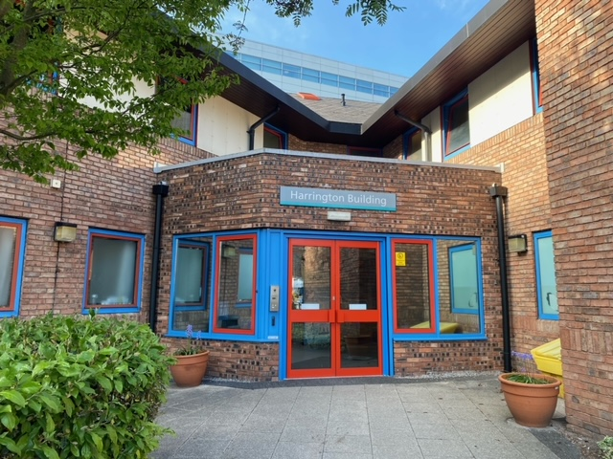

**Coming to the Harrington Building**

You will come into the reception area when you get to the Harrington building. The receptionist will let us know that you are here.



Your clinician will come to meet you. You will go upstairs to one of our rooms.

**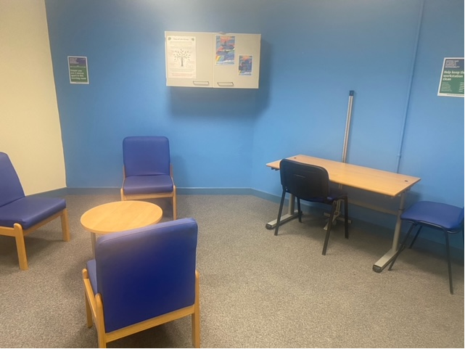**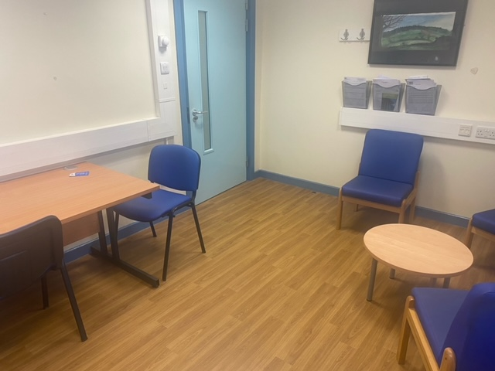

Your clinician will ask you and your parent/carer some questions about how you are doing at school, what you are good at and enjoy, and anything you might find hard.



**What will I have to do?**

We will do different puzzles and quizzes. It is usually best if parents/carers leave so you won’t be distracted.

* 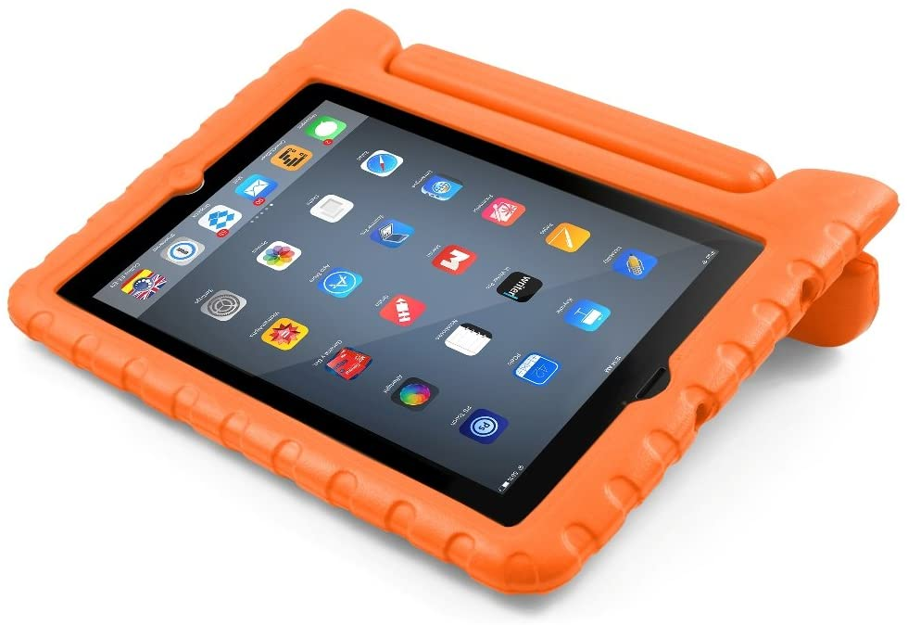Some of these will be on an Ipad.
* Some will be using a pen and paper



* Some of them will be building with blocks.



* Some activities will involve words
* Some will be pictures.

**How long does it take?**

The assessment can take a few hours BUT you can have breaks.

You might have more than one appointment.



Some children really enjoy these.

**What do the puzzles & quizzes do?**

They measure different areas of your thinking.

This includes language, solving problems (with pictures and words), memory, concentration and thinking speed.



You cannot lose or win, you just need to try!

****

**Why am I having this assessment?**

There are different reasons children and young people do these puzzles and quizzes. Some reasons are:

* To help understand what you are good at
* To help understand what is difficult for you
* So we can know how to help you with anything you find difficult at school and at home.
* This might also help us understand how a medical condition might be affecting you.



**What will happen after?**

We will look at all of the tests you have completed and then write a letter to your parents/carers with the results. You and your parents/carers can discuss your results in more detail with us in person or on the phone.

If you have any questions, ask your grown up. Or you can write questions down to ask the clinician.



communication-1293317_960_7200161 701 4512

envelope-35392_960_720

paediatric.psychosocial@mft.nhs.uk

www-1632431_960_720

<https://mft.nhs.uk/rmch/services/camhs/young-people/paediatric-psychosocial-service>

**Information for parents:**

What should I bring?

It is helpful if you can bring:

Any recent school and/or therapy reports.

Glasses and/or hearing aids if appropriate

A snack and drink for your child.