Manchester Newborn Screening Laboratory - User Survey 2021

Introduction

The user survey was first rolled out in 2018 and has been distributed each year to gain feedback from users to help improve the NBS laboratory service. (There was no user survey for 2020 due to reduced staffing levels across the NHS during the COVID pandemic.) The 2021 user survey was developed using Google forms and was distributed to users of the Manchester Newborn Screening laboratory to receive feedback for 2021. The 2021 user survey consists of 9 questions which would take an estimated 5 minutes for someone to complete. The link to the survey was emailed to midwives, health visitors, child health departments, QA team and responses were collated over a two-month period.

Results

The survey was available from 2nd December 2021 until February 2022. The last response was submitted on 20th Jan 2022.
Question 1 - To which staff group do you belong?

We received 31 responses from a variety of staff groups. The majority (35 % of respondents) of people who responded to the survey were members of staff who work for child health records department (11 staff). The smallest staff group to respond were members of staff who work for antenatal and newborn screening team and administration 3.2 % (1 member of staff in both categories).
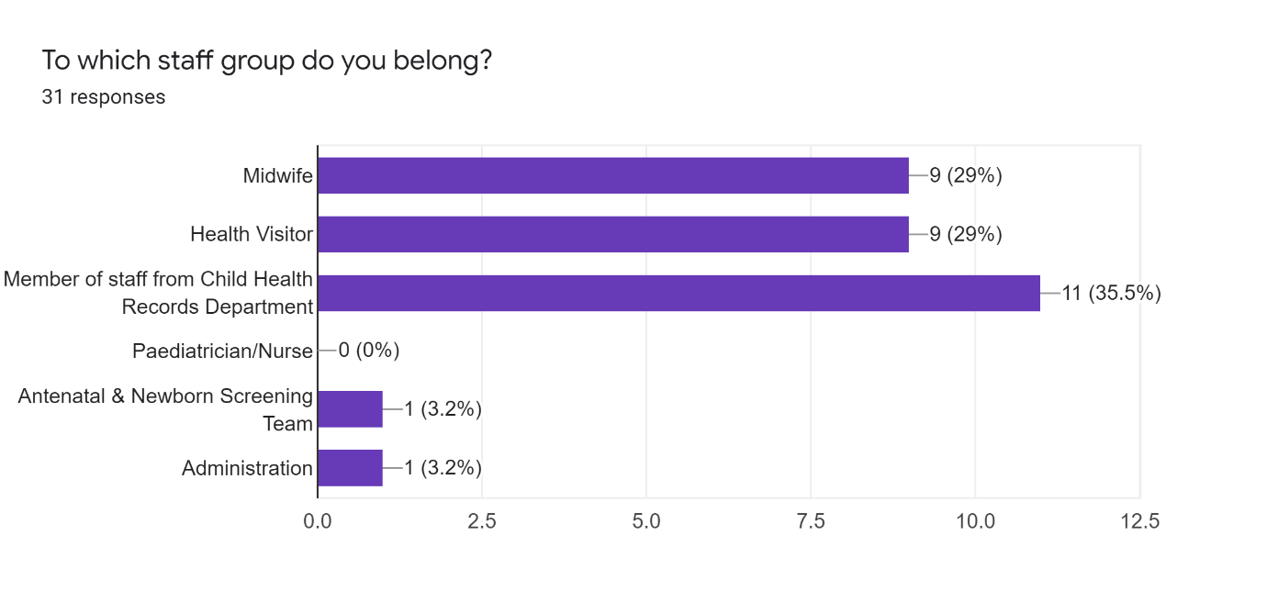
Questions 2-7
Users were asked whether they agreed or disagreed with a number of statements relating to different aspects of the laboratory. Each question was rated from 1-5. Where 1 was strongly disagree and 5 was strongly agree.

Question 2 - Enquiries are resolved in a timely manner by laboratory staff
29 people selected agree or strongly agree to the statement ‘Enquiries resolved in a timely manner by laboratory staff’. Only two people selected neither agree/nor disagree.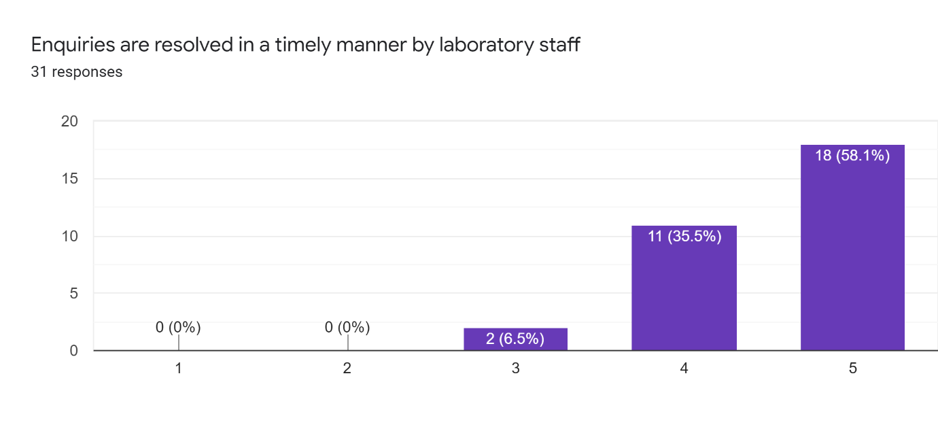

Question 3 - Staff are friendly and helpful
29 people selected agree or strongly agree to the statement ‘Staff are friendly and helpful’. Only two people selected neither agree/nor disagree.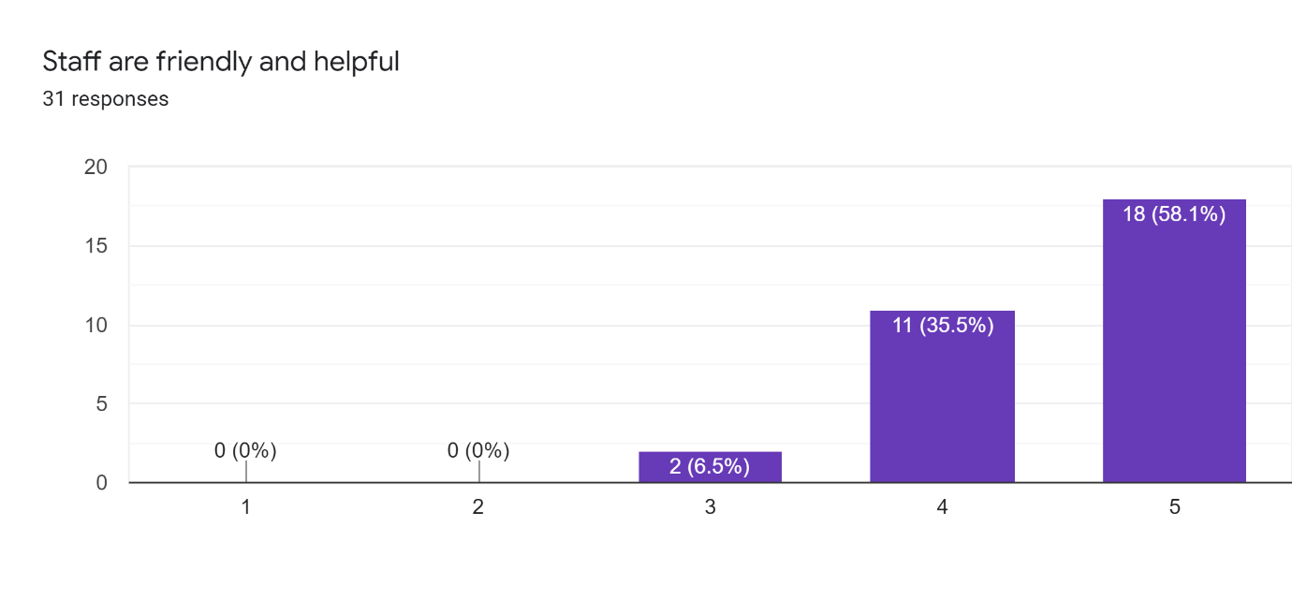

Question 4 - I am satisfied with the quality of professional advice that I receive from the laboratory
28 people selected agree or strongly agree to the statement ‘I am satisfied with the quality of professional advice that I receive from the laboratory’. Three people selected neither agree/nor disagree.
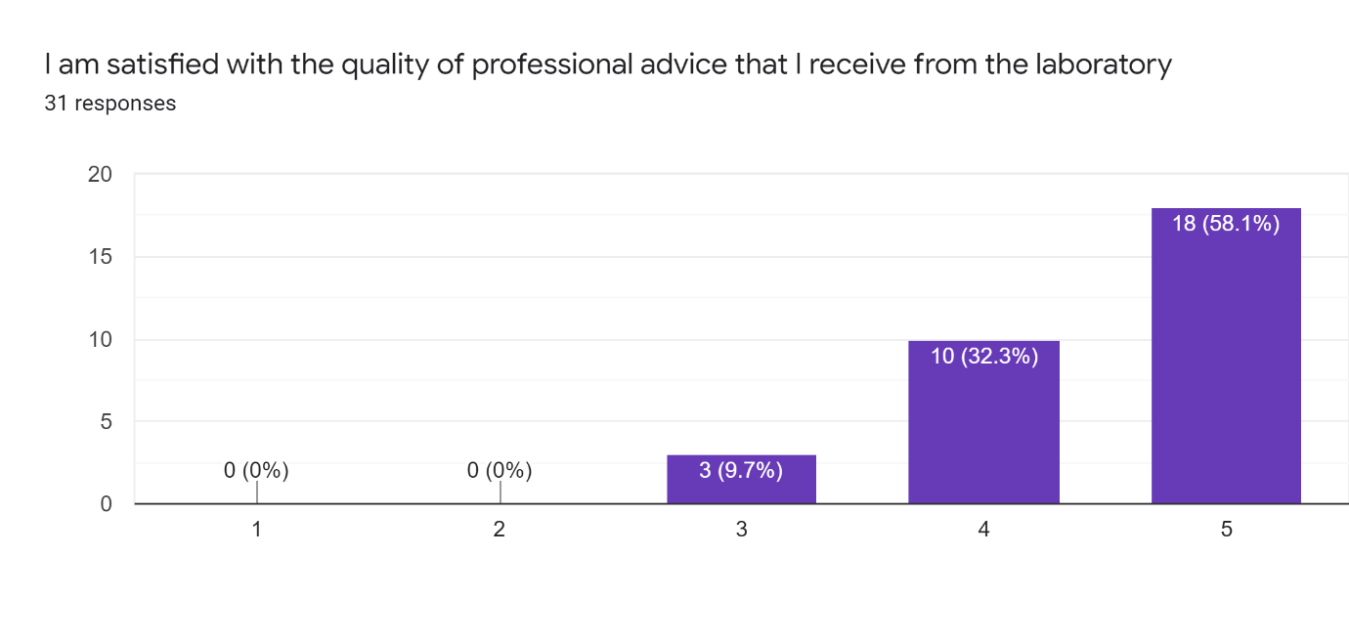

Question 5 - Any actions required following a positive newborn screening result are communicated clearly and promptly
24 people selected agree or strongly agree to the statement ‘Any actions required following a positive newborn screening result are communicated clearly and promptly’. Three people selected neither agree/nor disagree and one person selected slightly disagree.
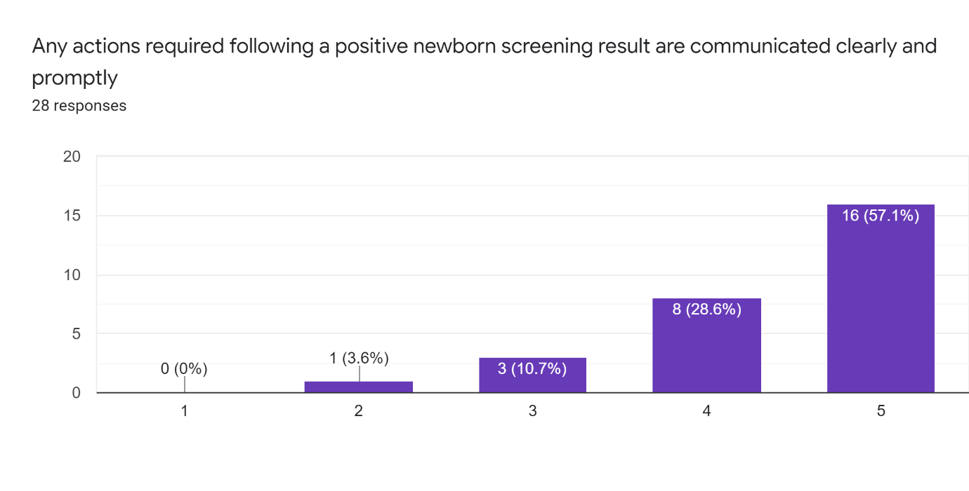

Question 6 – Reasons for repeat sample requests are clear
26 people selected agree or strongly agree to the statement ‘Reasons for repeat sample requests are clear’. 5 people selected neither agree/disagree.
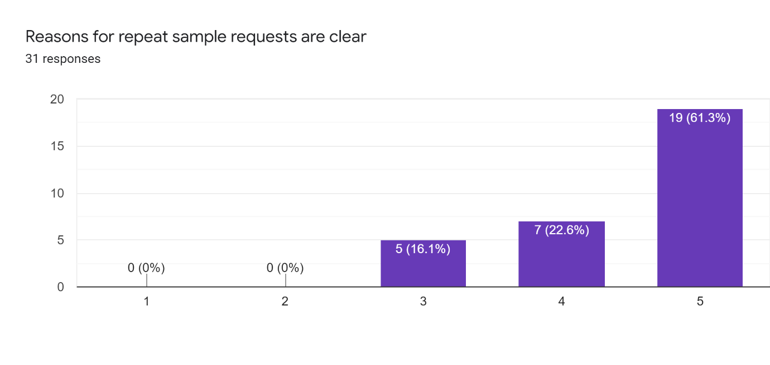
Question 7 - The newborn screening laboratory effectively communicates any changes to guidelines and policies
26 people selected agree or strongly agree to the statement ‘The newborn screening laboratory effectively communicates any changes to guidelines and policies’. 4 people selected neither agree/disagree.
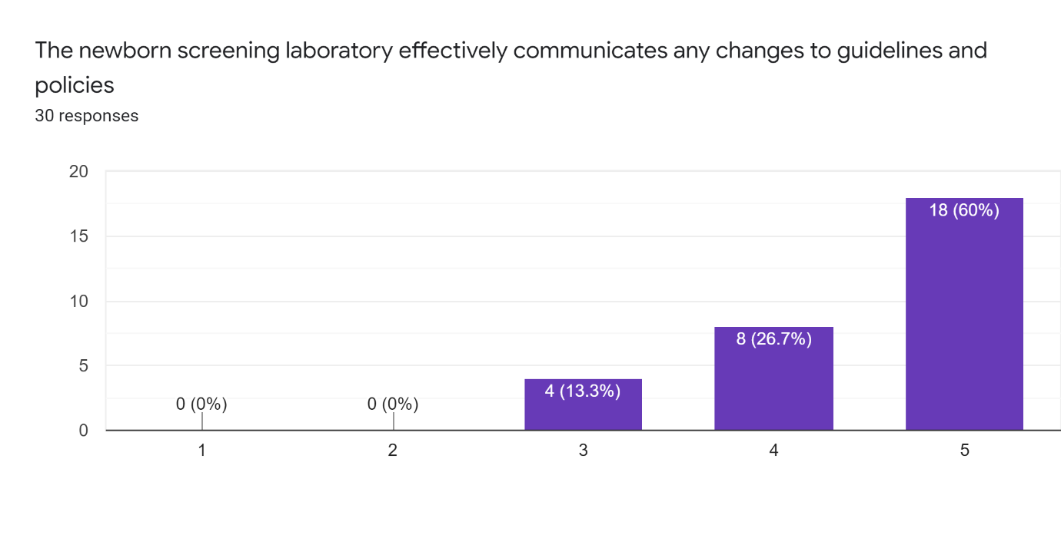

Question 8 - Overall, how would you rate the service provided by the Manchester Newborn Screening laboratory?
This question was answered on a scale of 1 to 5 with 1 = poor and 5= Excellent.
26 people selected 5 or 4 (excellent or good) to the statement ‘Overall, how would you rate the service provided by the Manchester Newborn Screening laboratory?
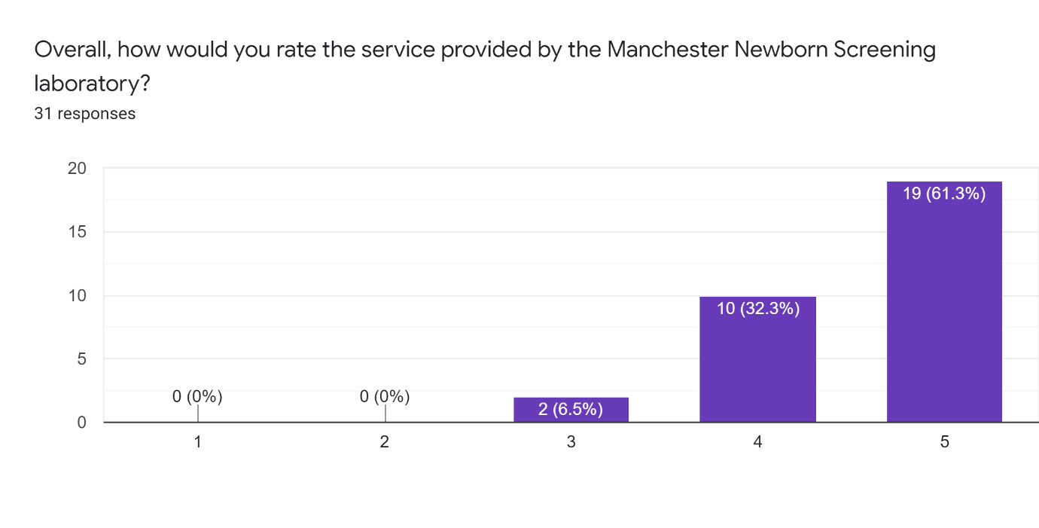

Question 9 - Do you have any other comments, questions or concerns?
The following comments were written in the survey:
- ‘The lab does appear to be taking longer to update received samples and outcomes, possibly to do with staff shortages as in many other areas’. Member of the Antenatal & Newborn Screening Team.
- ‘Friendly and helpful staff, always respond quickly’. Member of staff from Child Health Records Department.
- ‘As stated by my selections Neera, Pat and team are always friendly and helpful and are an asset to your service. Member of staff from Child Health Records Department.
- ‘No concerns’. Administration staff.
- ‘Why do you not send a full report of 10 results on 1 report as this would help us when sending a report to the GP? Member of staff from Child Health Records Department.

Conclusions
Much of the feedback received by the lab was positive. There were several neutral responses where number 3 was selected (‘neither agree nor disagree to this statement’). As the survey did not allow n/a answers, it is possible that people selected a neutral response instead of leaving the answer blank. There was one response to the survey that was negative. This was in response to the statement ‘Any actions required following a positive newborn screening result are communicated clearly and promptly.’ The person who responded with this was a midwife who selected number 4, which would equate to ‘disagree’ with this statement. Unfortunately, the midwife who responded did not elaborate in the comments section of the survey to explain why they disagreed with this statement. Without understanding the reasons why actions following a positive newborn screening result are not communicated clearly and promptly the NBS cannot improve the current positive referral system.

The staff group with the most responses to this survey were from child health records department (11 responses). We also had 9 responses from midwives, who are responsible for collecting the majority of blood spot samples (approximately 55,000 blood spot samples per year). There were 9 responses from health visitors. Health visitors are responsible for collecting some repeat samples and samples from babies who have moved into the area from inside or outside the UK. In some areas, health visitors are also responsible for communicating the newborn blood spot screening results to parents.

One of the comments from a member of staff from Child Health Records Department asked, ‘Why do you not send a full report of 10 results on 1 report as this would help us when sending a report to the GP?’ If a sample is found to be normal for all conditions without any re-testing, then all 10 conditions are reported out at the same time in one report. On occasion if a sample requires further testing, then we may issue a pending code for one condition but report the other 9 to avoid any delays and to ensure unnecessary repeat samples are not collected. Unfortunately, in September and October 2021 this pending code was used for the majority of samples as there were delays in issuing the SCID result. Testing for SCID in the Manchester NBS laboratory had to be suspended to a technical issue. All blood spot cards from Manchester were couriered to other NBS laboratories in England to test for SCID testing. As a SCID result was not available for up to a week a decision was made by the lab to not hold back any NBS results (and ensure the Failsafe was kept up to date). An initial report would have been issued with 9 results with the SCID result pending. Once SCID testing was complete, a report containing all 10 results would be issued. As some child health departments forward the newborn blood spot screening reports directly to GPs, this would have meant increased work for those areas. The suspension of SCID testing in Manchester was an exceptional circumstance. It is extremely unlikely that there would be such disruption to NBS testing on this scale in the future.

One of the comments from a member of the Antenatal & Newborn Screening Team stated that ‘The lab does appear to taking longer to update received samples and outcomes, possibly to do with staff shortages as in many other areas’. Manchester NBS lab report two files to the newborn failsafe system each morning, one is a list of cards received and the other is a list of results reported the previous day. The results file is also sent to the relevant Child Health departments. The Manchester NBS lab has only delayed the reporting of results by more than one day on one occasion in 2021. This was in September 2021 when SCID testing was suspended in Manchester and NBS results were delayed for four days. There have been occasions when results have been delayed (usually due to an assay failure in the lab) but this would only add one working day onto the turn-around-time. Recently a new protocol has been implemented and the NBS laboratory will inform NBS service users if there will be any expected delays results. Previously child health departments would only be informed of delays if the lab did not report for at least two days.

Two members of staff at child health were very complementary about the NBS administration team stating that the admin team are always friendly, helpful and an asset to the NBS service. Overall, the 2021 user survey rated that the overall service provided by the NBS lab as either good or excellent and gave similar results to those received in 2019.

