Information for Referrers:
Changes to NW GLH Process for Sensitive Disposal/Return of Potentially Remaining Sample for Early Stage Pregnancy Loss (<24 Weeks) Following Genetic Testing

The Human Tissue Authority (HTA), Royal College of Nursing, and the Royal College of Obstetricians and Gynaecologists state that a patient has up to 12 weeks to decide how they would prefer tissue from pregnancy loss to be disposed i.e., burial or cremation as part of a sensitive disposal policy arranged with the help of the referring hospital, or by incineration. Although, under the Human Tissue Act, consent is not required for the disposal of pregnancy remains (<24-week pregnancy loss), the particularly sensitive nature of this tissue means that the wishes of the woman, and her understanding of the disposal options open to her, are of paramount importance and should be respected and acted upon.
Early-stage pregnancy loss tissue samples sent to the North West Genomic Laboratory Hub (NW GLH) undergo DNA extraction prior to testing. Where possible, DNA extraction will exhaust the entire sample that has been received by the laboratory and there is no sample remaining. Occasionally, excess tissue is sent to us, and there is a small amount of remaining sample which is stored until after testing is completed. Currently, the NW GLH policy for disposal of any remaining sample where the women’s wishes were not provided to the laboratory are region dependent, as follows:
- Liverpool & Merseyside Hospital Trusts – If the remaining tissue sample is extra embryonic in origin it is incinerated by the laboratory. Remaining tissue that is identifiable as fetal is returned to the referring centre.
- Manchester Hospital Trusts – Any remaining tissue samples are returned to the referring centre.
Managing different regional policies with a policy to return any remaining tissue samples (regardless of whether they are fetal or not) is no longer practical or sustainable. Therefore, we have taken the decision to sensitively incinerate any remaining samples that are not identifiable as fetal in origin unless the woman wishes otherwise.
This new policy will come into effect on 1st November 2022.

To both inform the laboratory of the woman’s wishes and provide the patient with relevant information so she can make a choice, we have prepared a Genetic Testing Record of Discussion and Consent form. The form also allows the referrer to provide the laboratory with contact information in cases where there is remaining sample to be returned for cremation/burial/private arrangements.
It is vital that we are given a return address on this form.
The record of discussion and consent form should be completed and accompany a fully completed NW GLH referral form and an appropriate patient sample. The forms are available from the NWGLH website https://mft.nhs.uk/nwglh/

The following flow diagram illustrates the sample process as defined in the new policy for pregnancy loss tissue samples remaining after testing.

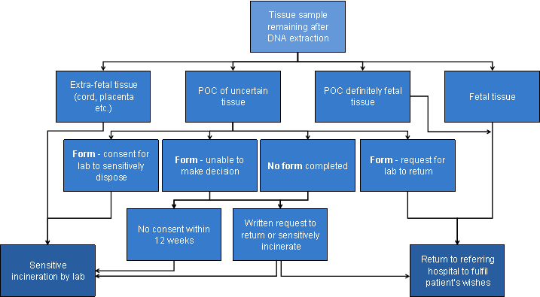

- Remaining tissue samples that are definitively extra-fetal in origin (cord, placenta, or membrane) will be sensitively disposed of by incineration arranged by the laboratory (not with general clinical waste).
- Remaining tissue from products of conception of uncertain tissue (where distinction between fetal, extra-fetal and maternal tissue is not possible), the woman can choose either for the laboratory to arrange for sensitive disposal by incineration or for the sample to be returned for cremation/burial/private arrangements. If the remaining sample is requested to be returned, we will return it to the contact address given on the record of discussion and consent form approximately 12 weeks after receipt. Samples will be returned by inter-hospital transport where possible or by courier.
  - If the woman cannot make a decision at the time and decides at a later date to request that any remaining sample is returned for cremation/burial/private arrangements, you must inform the laboratory in writing within 12-weeks from when the test request was made by sending the laboratory a new record of discussion and consent form.
  - If the woman cannot make a decision at the time of referral and no further notification/consent is received to the laboratory within 12 weeks OR if no consent form is received at all, any remaining products of conception of uncertain tissue will be sensitively incinerated by the laboratory.
- Remaining identifiable fetal tissue (including that identified within products of conception) will be returned to the referring hospital to fulfil patient wishes approximately 12 weeks after receipt regardless of whether a record of discussion and consent for was received.

It is important for patients to be aware that both sensitive incineration and cremation is communal and there will be no separate ashes afterwards. If a patient would like any tissue to be disposed of separately, they should be guided to request the return of any remaining tissue for cremation and discuss their options with the referrer.
Please refer to our tissue sample acceptance guidance (within the relevant pages of our website (https://mft.nhs.uk/nwglh/) which advises on the amount of tissue to send to the laboratory minimising the requirement for sample return.
If you have any questions regarding our policy for disposal of tissue samples, please contact the laboratory.

References:
HTA Guidance on the disposal of pregnancy remains following pregnancy loss or termination (March 2015).
Royal College of Nursing Managing the disposal of pregnancy remains (December 2018; previous version ‘Sensitive disposal of all fetal remains’ 2007).
RCOG Good Practice No.5 Disposal following pregnancy loss before 24 weeks of gestation (January 2005).

