This text is from
Manchester University
NHS Foundation Trust

Why we sent you this text

This is an important text from a part of Manchester University NHS Foundation Trust called the XXXXXXXXXXX department.

We know you are waiting for an appointment.

We have a list of everyone who is waiting for an appointment.

We need to check if everyone on
our list still needs an appointment.
What you need to do now

You need to tell us if you still need an appointment.

Type or copy and paste this link into a search engine like google on your phone or laptop.

XXXXXXXXXXX

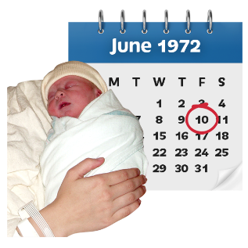
You will need to use
- the date you were born
- this pin number
XXXXXXXXXXX.

If you already have a date
for your appointment

If you already have a date for your appointment you must go to your appointment on this date.
Thanks, from Manchester University NHS Foundation Trust.

The full version of this document is called
“1st text.”

This letter is from
Manchester University

NHS Foundation Trust

This letter was sent on: XXXXXXXXXX

NHS number:

Patient ID:

Waiting List ID:

Hello XXXX

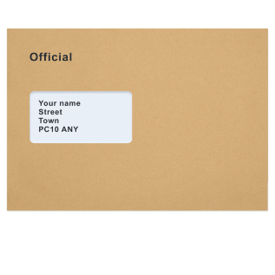
Why we sent you this letter

We know you are waiting for an appointment with XXXXXXXXXXX
or someone who works with them.
Your appointment will be in a part of Manchester University NHS Foundation Trust called the XXXXXXXXXXX department.

We have a list of everyone who is waiting for an appointment.

We need to check if everyone on
our list still needs an appointment.

What you need to do now

You need to tell us if you still need an appointment.

You need to click on this link to fill in an online form that asks if you still need an appointment

XXXXXXXXXXX

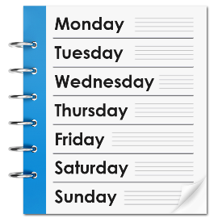
Fill in this online form within 14 days from the date this letter was sent.

This letter was sent on XXXXXXXXXXX

Go to this website if you need this letter in large print or a different language

https://mft.nhs.uk/waiting-list-review-patient-letters/
Contact us

Call this number if you want to talk to someone about this letter
XXXXXXXXXXX
or send us an email to us at this address

XXXXXXXXXXX

If you already have a date
for your appointment

If you already have a date for your appointment you must go to your appointment on this date.
If you are waiting for more
than 1 appointment

If you are waiting for more than 1 appointment you will be on more
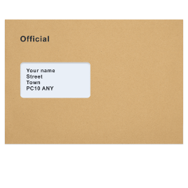
than 1 waiting list.

If you are on more than 1 list, you might get more than 1 of these letters.

You must reply to each letter and
do what we ask you to do.
Thanks, from Manchester University NHS Foundation Trust.

INSERT SIGNATURES

The full version of this document is called
“1st electronic letter.”

[

This letter is from
Manchester University
NHS Foundation Trust
This letter was sent on: XXXXXXXXX

Your address: 13 XXXXXXX XXXX XXX XXX XXX
Our address: XXXXXXX XXXX XXX XXX XXX

Telephone number:

NHS number:

Patient ID:

Waiting List ID:

Hello XXXX

Why we sent you this letter
We know you are waiting for an appointment with XXXXXXXXXXX or someone who works for them.

Your appointemnt will be in a part of
XXXXXXXXXXX hospital called the XXXXXXXXXXX department.

We have a list of everyone who is waiting for an appointment.

We need to check if everyone on
our list still needs an appointment.

What you need to do now

You need to tell us if you still need an appointment.

You need to click on this link to fill in an online form that asks if you still need an appointment

XXXXXXXXXXX

Fill in this online form within 14 days from the date this letter was sent.

This letter was sent on XXXXXXXXXXX

If you can’t fill in the online form,
you can fill in the paper form that comes with this letter instead.

Go to this website if you need this letter in large print or a different language

https://mft.nhs.uk/waiting-list-review-patient-letters/
Contact us

Call this number if you want to talk to someone about this letter
XXXXXXXXXXX
or send us an email to us at this address

XXXXXXXXXXX

If you already have a date
for your appointment
If you already have a date for your appointment you must go to your appointment on this date.

If you are waiting for more
than 1 appointment

If you are waiting for more than 1 appointment you will be on more
than 1 waiting list.

If you are on more than 1 list, you might get more than 1 of these letters.

You must reply to each letter.

Thanks, from Manchester University NHS Foundation Trust.

INSERT SIGNATURES

The full version of this document is called
“1st paper letter.”

This form is from
Manchester University
NHS Foundation Trust
Our address: XXXXXXX XXXX XXX XXX XXX
This form is for: XXXXXXXXXXX

Hello XXXX
Why we sent you this form

We have a list of everyone who is waiting for an appointment.
We need to check if everyone on
our list still needs an appointment.

What you need to do now
You need to fill in this form to tell us if
you still need an appointment.

How to fill in this form

- Write your answers in the boxes under each question.
- Tick the box next to the answer you want to choose.
Your questions start here

Please tick the box next to the answer you want to choose.

I still need an appointment
and I want to stay on the waiting list.

I don’t need an appointment anymore
and I want to be taken off the waiting list.

If you do not need an appointment and want to be taken off the waiting list,
please tell us why.

I don’t have symptoms anymore.

I don’t need an appointment anymore.
I have moved house and I get care from a different NHS hospital now.

I had care from a different NHS hospital.

I had emergency care.
I had care from a private hospital.

If you said you still want an appointment and want to stay on the waiting list, can you travel to a different place to get care?

No.
Yes.

If you said yes, how far from Manchester can you travel to get an appointment to talk to a doctor or get care?

In Manchester, 0 to 20 miles away.

Leeds, Sheffield, or Liverpool, 20 to 50 miles away.

Birmingham, Derby, or Hull, 50 to 100 miles away.

Newcastle, Cambridge, or Bristol, 100 to 200 miles away

London, Exeter, or Norwich, more than 200 miles away.

[

How to send us this form

When you have filled in this form,
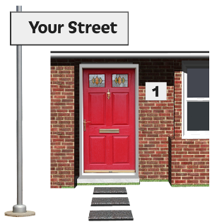
put it in the envelope that came with this letter. You don’t need a stamp.
Post the envelope to our address:

XXXXXXX XXXX XXX XXX XXX

Please don’t fill in this part of the form.
This will be filled in for you.

Name: XXXXXXX

NHS number: XXXXXXX

Speciality: XXXXXXX

Waiting list ID: XXXXXXX

This letter is from
Manchester University
NHS Foundation Trust

This letter was sent on: XXXXXXXXXX

NHS number:

Patient ID:

Waiting List ID:

Hello XXXX

Why we sent you this letter

We already sent you a letter to ask if
you still need an appointment in a part of XXXXXXXXXXX hospital called the XXXXXXXXXXX service.

We have a list of everyone who is waiting for an appointment.

We need to check if everyone on
our list still needs an appointment.

You haven’t told us if you still need an appointment.

Why we check who is waiting for an appointment

We check if everyone on our list still needs an appointment, so we know who does not need one anymore.
There are lots of reasons why you might not need an appointment anymore.

Some people move house and get care from a different hospital.

If you don’t tell us if you still need an appointment, we might have to
- take you off our list.

- discharge you to your doctor’s surgery. Discharge means we won’t care for you anymore.

You will need to go to your doctor’s surgery for care if we discharge you.

If we do this, we will send a letter to you and your doctor.

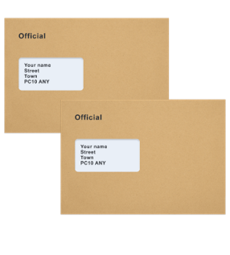
What you need to do now

You need to contact us within 14 days from the date this letter was sent.

This letter was sent on XXXXXXXXXXX
You need to tell us if you still want an appointment.

Click on this link to fill in the online form.
XXXXXXXXXXX
Contact us

If you find it hard to fill in the online form,
call this number
XXXXXXXXXXX

or send us an email to us at this address

XXXXXXXXXXX
Go to this website if you need this letter in large print or a different language
https://mft.nhs.uk/waiting-list-review-patient-letters/

Thanks, from Manchester University NHS Foundation Trust.

INSERT SIGNATURES

The full version of this document is called
“2nd electronic letter with embedded link in digital form.”

This letter is from
Manchester University
NHS Foundation Trust
This letter was sent on: XXXXXXXXX

Your address: 13 XXXXXXX XXXX XXX XXX XXX
Our address: XXXXXXX XXXX XXX XXX XXX

Telephone number:

NHS number:

Patient ID:

Waiting List ID:

Hello XXXX

Why we sent you this letter

We already sent you a letter to ask if
you still need an appointment in a part of XXXXXXXXXXX hospital called the XXXXXXXXXXX service.

We have a list of everyone who is waiting for an appointment.

We need to check if everyone on
our list still needs an appointment.
You haven’t told us if you still need an appointment.

Why we check who is waiting for an appointment

We check if everyone on our list still needs an appointment so we can

- make sure people who need an appointment can get one.
- take anyone off our list who does not need an appointment anymore.
There are lots of reasons why you might not need an appointment anymore.

If you don’t tell us if you still need an appointment, we might have to
- take you off our list.
- discharge you to your doctor’s surgery. Discharge means we will not care for you anymore.

You will need to go to your doctor’s surgery for care if we discharge you.

If we do this, we will send a letter to you and your doctor.

What you need to do now

You need to contact us within 14 days from the date this letter was sent.

This letter was sent on XXXXXXXXXXX

You need to tell us if you still want an appointment.

Use this link to fill in the online form.
XXXXXXXXXXX

If you can’t go online to fill in the form, you should contact us.

Contact us

Call this number if you want to talk to someone about this letter
XXXXXXXXXXX
or send an email to us at this address

XXXXXXXXXXX

Go to this website if you need this letter in large print or a different language
https://mft.nhs.uk/waiting-list-review-patient-letters/

If you already have a date
for your appointment

If you already have a date for your appointment you must go to your appointment on this date.

Thanks, from Manchester University NHS Foundation Trust.

INSERT SIGNATURES

This is the second paper letter that we
have sent to you

The full version of this document is called
“2nd paper letter – reminder letter.”

This letter is from
Manchester University
NHS Foundation Trust
This letter was sent on: XXXXXXXXX

Your address: 13 XXXXXXX XXXX XXX XXX XXX
Our address: XXXXXXX XXXX XXX XXX XXX

Telephone number:

NHS number:

Patient ID:

Waiting List ID:

Hello XXXX

Why we sent you this letter

You told us you don’t need an appointment anymore in a part of
Manchester University Hopsital NHS Foundation Trust called the XXXXXXXXXXX service.

You told us you want to be discharged to your doctor’s surgery. Disharged means we won’t care for you anymore.
What we have done
We have
- taken you off the waiting list for this
appointment.
- told your doctor about your decision.

If you don’t agree with what we have done

If you think any information in this letter
is wrong, or you don’t agree with what we have done you can contact us.
Contact us

Call this number if you want to talk to someone about this letter
XXXXXXXXXXX

or send an email to us at this address

XXXXXXXXXXX

Contact us within 28 days.

Thanks, from Manchester University NHS Foundation Trust.

INSERT SERVICE AND SITE

This letter tells you
that you have been discharged
to your doctor’s surgery.

The full version of this document is called
“Discharge letter to patient – following wish to be removed from the waiting list.”

This letter is from
Manchester University
NHS Foundation Trust
This letter was sent on: XXXXXXXXX

Your address: 13 XXXXXXX XXXX XXX XXX XXX
Our address: XXXXXXX XXXX XXX XXX XXX

Telephone number:

NHS number:

Patient ID:

Waiting List ID:

Hello XXXX

Why we sent you this letter

You haven’t told us if you still need an appointment in a part of Manchester University Hopsital NHS Foundation Trust called the XXXXXXXXXXX service.

We have a list of everyone who is waiting for an appointment.
We need to check if everyone on
our list still needs an appointment.
It’s most important that we talk to people who are meant to be seen first
for an appoinment.

Why we check who is waiting for an appointment

We check if everyone on our list still needs an appointment so the time everyone has to wait is as short as possible.

What we have done

We have taken you off the waiting list for an appointment.
We did this because you did not contact us after we sent you 2 letters about your appointment with the service called XXXXXXXXXXX.

If you don’t agree with what we have done

If you think any information in this letter
is wrong, or you don’t agree with what we have done you can contact us.
Contact us

Call this number if you want to talk to someone in the XXXXXXXXXXX
department about this letter
XXXXXXXXXXX
Thanks, from Manchester University NHS Foundation Trust.

INSERT SERVICE AND SITE

This letter tells you
that you have been taken off the waiting list
for an appointment.

The full version of this document is called
“Discharge letter to patient – no response from patient.”

This text is from
Manchester University
NHS Foundation Trust
Why we sent you this text

You told us you want to stay on the waiting list for an appointment for XXXXXXXXXXX
at Manchester University NHS Foundation Trust.

We might need to contact you again when we next check if everyone on our list needs an appointment.

MyMFT
We have a new app called MyMFT. MyMFT stands for My Manchester University Trust.

You can use MyMFT to look at information about your healthcare.

How to use MyMFT
To use MyMFT you need to
- search for MyMFT into the app store on your phone or laptop.
- download MyMFT and create an account with us.
- search for ‘Mychart’ when you are in the app to get information about your healthcare.

This letter is from
Manchester University
NHS Foundation Trust
This letter was sent on: XXXXXXXXX

Your address: 13 XXXXXXX XXXX XXX XXX XXX
Our address: XXXXXXX XXXX XXX XXX XXX

Telephone number:

NHS number:

Patient ID:

Waiting List ID:

Hello XXXX

Why we sent you this letter

You told us you want to stay on the waiting list for an appointment for XXXXXXXXXXX
at Manchester University NHS Foundation Trust.

We know you have waited a long time for your appointment, we are sorry.

It’s most important that we talk to people who are meant to be seen first
for an appoinment.

We have a list of everyone who is waiting for an appointment.

We need to check if everyone on
our list still needs an appointment.

Why we check who is waiting for an appointment
We check if everyone on our list still needs an appointment so the time everyone has to wait is as short as possible.

MyMFT
We have a new app called MyMFT. MyMFT stands for My Manchester University Trust.

You can use MyMFT to look at information about your healthcare.

How to use MyMFT

To use MyMFT you need to
- search for MyMFT into the app store on your phone or laptop.
- download MyMFT and create an account with us.
- search for ‘Mychart’ when you are in the app to get information about your healthcare.

You can talk to us on MyMFT whilst you wait for your appointment.
Go to this website to find out more about MyMFT
https://mft.nhs.uk/the-trust/mymft/.
Thanks, from Manchester University NHS Foundation Trust.

INSERT SERVICE AND SITE

The full version of this document is called
“Remain on waiting list letter to patient.”

