NW GLH Liverpool Quality Manual

Table of Contents
Joint Laboratory Quality Manual…………………………………………………………………………….. 1
1 General Information ……………………………………………………………………………………..3
1.1 Departmental Information ………………………………………………………………………….3
1.2 The Quality Manual ………………………………………………………………………………….4
2 Quality Policy ………………………………………………………………………………………………6
3 Organisation, responsibilities and authorities ………………………………………………………..7
4 Management Requirements ……………………………………………………………………………17
4.1 Organisation and management responsibility …………………………………………………..17
4.2 Quality Management System ………………………………………………………………………18
4.3 Document control ………………………………………………………………………………….18
4.4 Service Agreements ………………………………………………………………………………..18
4.5 Examination by referral laboratories …………………………………………………………….19
4.6 External services and supplies ……………………………………………………………………19
4.7 Advisory services ………………………………………………………………………………….19
4.8 Resolution of complaints ………………………………………………………………………….20
4.9 Identification and control of nonconformities …………………………………………………..20
4.10 Corrective action …………………………………………………………………………………20
4.11 Preventive action ………………………………………………………………………………..20
4.12 Continual improvement ……………………………………………………………………….20
4.13 Control of records ……………………………………………………………………………….20
4.14 Evaluation and audits …………………………………………………………………………..20
4.15 Management Review …………………………………………………………………………….22
5 Technical Requirements ………………………………………………………………………………..23
5.1 Personnel ……………………………………………………………………………………………23
5.2 Accommodation and environmental ……………………………………………………………..24
5.3 Laboratory equipment, reagents and consumables …………………………………………….25
5.4 Pre-examination Processes ………………………………………………………………………..27
5.5 Examination procedures …………………………………………………………………………..28
5.6 Ensuring the quality of examination results …………………………………………………….29
5.7 Post-examination Processes ……………………………………………………………………….30
5.8 Reporting results …………………………………………………………………………………..30
5.9 Release of results (4.7, 5.8, 5.9) ……………………………………………………………………..30
5.10 Information Management (5.10) ………………………………………………………………….31
6 Validation …………………………………………………………………………………………………32

General Information

Laboratory Information
The genetics laboratory based at Liverpool Women’s NHS foundation Trust (LWH) forms part of the North West Genomics Laboratory Hub (NW GLH), managed by Manchester Centre for Genomic Medicine (MCGM), a directorate within St Mary’s Hospital Managed Clinical Service and an operational unit of the Manchester University NHS Foundation Trust (MFT). This allows the collaboration and combining of specialist knowledge from experts across the North West, with laboratories from The Christie NHS Foundation Trust, Liverpool Clinical Laboratories and Lancashire Teaching Hospital NHS Foundation Trust also joining the hub as local delivery partners.

This change has been brought about due to national reconfiguration of genetics laboratories by NHS England in order to create a national NHS genomic medicine service. The laboratory based at Liverpool Women’s NHS Foundation Trust officially came under the management of MFT on 1st August 2019. The name of the genetics laboratory based at LWH was changed from The Cheshire and Merseyside Regional Genetics Laboratory to North West Genomics Laboratory Hub – Liverpool Site (NWGLH – Liverpool Site) and the legal entity (legal entity: 4.1.1.2) has transferred to Manchester Foundation Trust (MFT); UKAS were informed and the process of the change in legal entity was successfully completed in August 2021.

A process of change has since been implemented and the two laboratories are currently working to align.

The postal address is:- | North West Genomics Laboratory Hub – Liverpool Site  Manchester Centre for Genomic Medicine  Liverpool Women’s NHS Foundation Trust  Crown St  Liverpool L8 7SS

Information on the services provided and contact telephone numbers is available and on the hospital website (https://mft.nhs.uk/nwglh).

The North West Genomics Laboratory Hub – Liverpool Site is situated on the second floor of Liverpool Women’s Hospital and comprises of a combined Cytogenetics and Molecular Genetics Laboratory. The laboratory is divided into rare disease, cancer and technical streams to deliver core and specialist genomic testing services as defined in the NHS England National Test Directories for rare disease and cancer. DNA banking is available for patients where no testing is currently available or for future testing.

Cancer testing is considered core service and is delivered from the hub for the North West region. Rare disease is subdivided into core and specialised services; specialised rare disease services are offered as part of the NHS Genomic Medicine Service on a national basis whereby Genetics Laboratory Hubs in England are responsible for specific specialist test groups (https://www.england.nhs.uk/genomics/) for a designated geography (which can vary depending on the speciality). The test directory originated from an NHS Directory of Genetic Disorders/Genes previously established and validated via gene dossiers by the UK Genetic Testing Network (UKGTN).

The laboratory is a designated specialist Cytogenetics testing centre for the Haematological Oncology Service (NICE IOG).

The Quality Manual
This Quality Manual describes the Quality Management System of the North West Genomics Laboratory Hub – Liverpool Site. Throughout the text there are references to ISO 15189:2012 Standards (in brackets) and to relevant information and documents written in fulfillment of these standards.

This Quality Manual fulfills two functions. It describes the Quality Management System for the benefit of the laboratory’s own management and staff, and it provides information for users and for inspection/accreditation bodies.

This Quality Manual can be regarded as the index volume to separate volumes of management, laboratory, clinical and quality procedures. The sections of the Quality Manual are arranged so that they equate with the ISO 15189:2012 Standards (see table below). Under the title of each standard there is a brief description of the way in which the Genetics Laboratory seeks to comply with the particular standard and references are given to appropriate documents.

The various clauses of the standard should be seen to relate to each other
Section in the  Quality Manual | Section of ISO 15189 Standard
4 | Management Requirements
4.1 | Organisation and Management Responsibility
4.2 | Quality Management System
4.3 | Document Control
4.4 | Service Agreements
4.5 | Examination by referral laboratories
4.6 | External services and suppliers
4.7 | Advisory services
4.8 | Resolution of Complaints
4.9 | Identification and control of nonconformities
4.10 | Corrective action
4.11 | Preventive action
4.12 | Continual improvement
4.13 | Control of records
4.14 | Evaluation and audits
4.15 | Management review
5 | Technical Requirements
5.1 | Personnel
5.2 | Accommodation and environmental conditions
5.3 | Laboratory equipment, reagents and consumables
5.4 | Pre-examination processes
5.5 | Examination processes
5.6 | Ensuring quality of examination results
5.7 | Post Examination processes
5.8 | Reporting of results
5.9 | Release of results
5.10 | Laboratory information management

Quality Policy
The NWGLH – Liverpool Site, part of the Manchester Centre for Genomic Medicine (a directorate within St Mary’s Hospital which, in turn, is part of Manchester University Hospitals NHS Foundation Trust) provides a wide range of genetic testing services to the Northwest region, including the Isle of Man and North Wales. The laboratory also receives both national and international referrals for a number of specialist services.

The laboratory is committed to providing a high-quality service that considers and aims to meet the needs and requirements of its users.

It is our policy to report the correct genetic diagnosis on the correct patient in an appropriate timeframe using reliable and accurate tests utilising the most relevant technology, and to communicate that diagnosis to the correct clinician in the most effective way.

The NWGLH Management is committed to:
- patient care; reporting clinically useful test results to service users
- respecting patient confidentiality
- innovation and the development of new technologies ensuring state of the art testing
- delivering efficient service workflows, meeting all agreed national and local targets
- providing laboratory staff of all grades with the appropriate knowledge, skills, competency, development and support for continued professional development (CPD) including key performance indicators such as annual appraisal, mandatory training, equality and diversity
- ensuring that all laboratory staff are familiar with the quality policy and understand what is expected from them

The NWGLH seeks to satisfy the UKAS ISO 15189 standards and will:
- set annual quality objectives, maintain a quality manual and complete an annual management review
- apply and promote all areas of the quality management system, including the use of documented procedures, internal audit, procurement and maintenance of equipment and other resources, as well as the health, safety and welfare of staff and visitors
- ensure the laboratory delivers the quality of service which this policy describes, within the resources available
- promote good professional practice and conduct as laid out in best practice guidelines and Trust procedures, and comply with current legislation and the requirements of NHS England
- maintain a commitment to continual quality improvement including assessment of user satisfaction, external quality assessment, and the identification of non-compliance corrective and preventive actions

Signed on behalf of the NWGLH Liverpool Site
Emma Howard, GLH Operations Scientific Director Date: 11.10.2021

Organisation, responsibilities and authorities
The North West Genomics Laboratory Hub (NW GLH) is managed by Manchester Centre for Genomic Medicine (MCGM), a directorate within St Mary’s Hospital Managed Clinical Service and an operational unit of the Manchester University NHS Foundation Trust (MFT).

3.1 The Host Organisation (MFT)

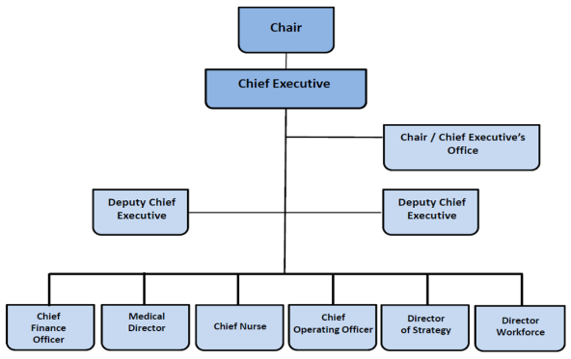
The MFT Host Organisation

3.2 Relationship to the Host Organisation
The Liverpool site forms part of the NWGLH managed by MCGM which has a defined management structure that feeds into the host organisation management as shown below:
- St Mary’s, MCGM and the NWGLH management structure.

Chairman (MFT)
NW Genomic Laboratory Hub (NW GLH) Manchester/
Biochemical (Willink) Laboratory
ERNDIM (EQA Provider)
Operations Scientific Director Genomics Division
Clinical Genetics
Chief Executive (MFT)
Director of Operations (SMH)
Clinical Director (MCGM)
NW Genomic Laboratory Hub (NW GLH) Liverpool
North West GLH
Manchester Centre for Genomic Medicine (MCGM)
With delivery partners
• Liverpool Clinical Laboratories
• Christie NHS Foundation Trust
• Lancashire Teaching Hospitals NHS Foundation Trust

- The NW GLH senior management structure
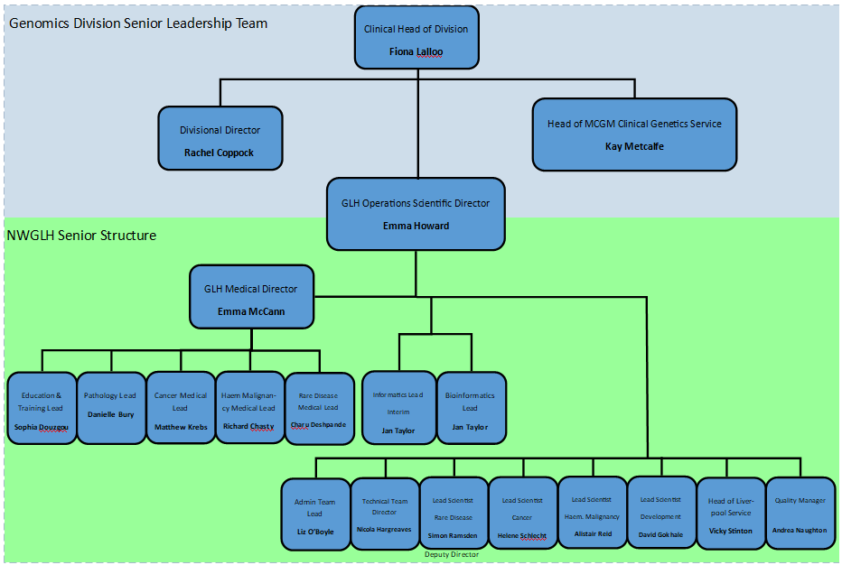

3.3 Organisation and responsibilities within the NWGLH – Liverpool Site.
The laboratory has a strong management structure which feeds into the Head of service and is led by the Scientific Operational Director who provides general management and strategic support.

The Scientific Operational Director (Laboratory Director – Organisational Responsibilities 4.1.1.4)
for the North West Genomics Laboratory Hub is Dr Emma Howard who is ultimately responsible for the following issues where relevant:
- Professional
- Scientific
- Consultative/advisory
- Organisational
- Administrative
- Educational

The Laboratory Director can delegate duties and/or responsibilities to other qualified personnel but maintains the ultimate responsibility for the overall operation and administration of the laboratory. The Deputy Laboratory Director, Simon Ramsden, takes overall responsibility in the absence of the Laboratory Director.

On a day-to-day basis, at the Liverpool Site, the requirements of 4.1.1.4 are assumed by the Head of Laboratory service; the responsibilities are described within the job description and DOC5647 Quality Team Roles, which also details the delegation of these responsibilities, as per the organisational plans below.

The NWGLH – Liverpool Site Laboratory is divided into:
- Technical
- Rare Disease
- Cancer

Rare Disease and Cancer (formerly germline and acquired) teams are headed by a Scientific Programme Manager, and the Technical Team is headed by a Technical Programme Manager who report to the Head of the Service. Cross professional cover is provided by these key members of staff. Teams are then broken down into further functional sections of Rare Disease, Cancer and Technical which are headed by Principal Clinical Scientists and Senior Technical Leads (please see organograms below; exact staff number, post/vacancy number and grade is not included in the organograms but a complete staff structure list is maintained for payroll purposes by the Laboratory Director and Finance and is accessible as required). A staff list of staff in post on the Liverpool site and their area of work and responsibilities is maintained on Q-Pulse (DOC5252 Staff List).

The GLH Quality Manager, based on the Manchester site of the NWGLH, is responsible for overseeing the implementation, development, and maintenance of all quality management activities across both sites. The Quality Manager oversees the quality management system and integration of this system into the trust governance and risk management systems.

The day-to-day running of the quality management system on the Liverpool site is delegated to the Deputy Quality Manager with the support of the Quality Leads/Team. For full quality team organogram see DOC5647 Quality Team Roles.

NW-GLH Liverpool Site Management Structure

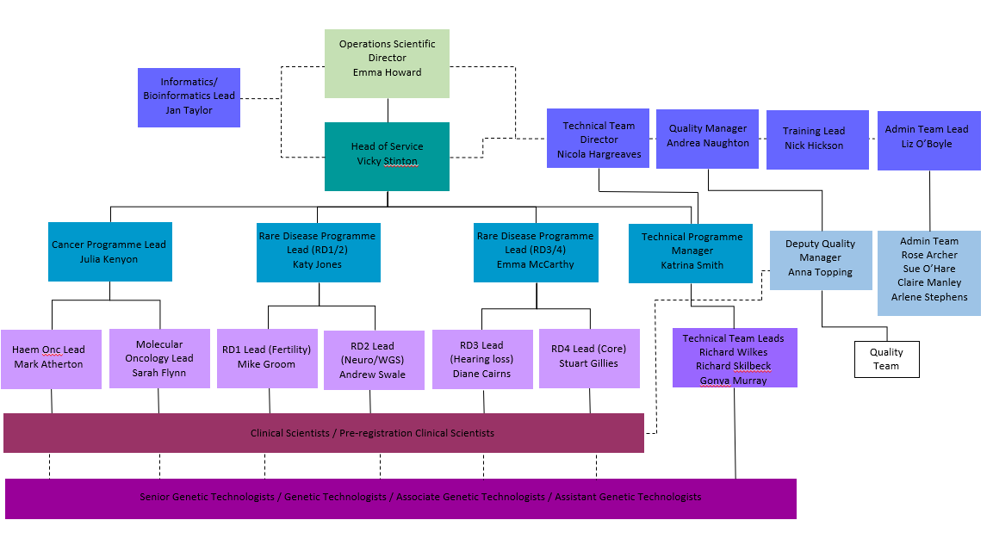

*NW-GLH Liverpool Site Technical Team Structure Breakdown

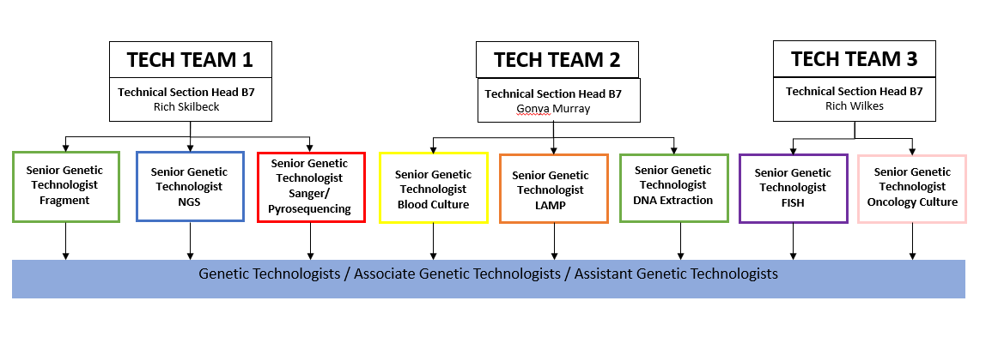

3.4 Departmental Committees and meetings (4.1.2.6 Communication) =
The NWGLH has different methods and means for communicating with staff including meetings, newsletters, lunchtime seminars/education sessions, communication boards and staff suggestions. Meeting minutes are stored in the relevant folders on the Genetics Labs shared drive.

The NWGLH communicates with stakeholders via the NWGLH website, letters, complaints, and user satisfaction questionnaires. Stakeholders are informed of any significant changes to services.

Regular MCGM and GLH meetings, local team level to senior cross site level, are summarised and documented in DOC4969 NWGLH Meeting Structure & Diagram.

Management Requirements

Organisation and management responsibility
4.1.1 Organisation
The organisation and management of the North West Genomics Laboratory Hub – Liverpool Site are detailed in section 3 of this quality manual.

All new staff members are required to declare any conflicts of interest prior to commencement at the Trust. Existing staff members above agenda for change Band 7 are prompted annually by the Trust to declare of any new conflicts of interests via the Learning Hub (Standards of Business Conduct & Hospitality Policy). Staff members adhere to Trust requirements to maintain confidentiality [Trust policy IG006 (ON4-3437) - Confidentiality Code of Conduct and Information Disclosure Policy; DOC2051] and ensure respectful treatment of human samples [staff induction and training].

4.1.2 Management responsibility

4.1.2.1 Management commitment
Laboratory management is committed to the development and implementation of the quality management system and its continual improvement as evidenced by: laboratory communication and communication processes, the quality policy, quality objectives, staff responsibilities, the appointment of a quality manager, annual management reviews, staff competency, and management of resources necessary for pre-examination, examination and post-examination activities.

4.1.2.2 Needs of users
Laboratory services, including appropriate advisory and interpretative services, are periodically reviewed to ensure that they meet the needs of patients and service users. Information is gathered via the use of satisfaction questionnaires, user meetings/forums and various regular multi-disciplinary team meetings, and in response to complaints or comments regarding the service. These can be translated into corrective or preventive actions and form the focus of objective setting and planning. Assessment of user satisfaction and complaint findings forms part of the annual management review.

4.1.2.3 Quality policy
The Quality policy of the North West Genomics Laboratory Hub – Liverpool Site is detailed in section 2 of this quality manual and available in DOC5321.

4.1.2.4 Quality objectives and planning
The Scientific Operations Director, Head of Service, Deputy/Quality Manager define the quality objectives of the laboratory and are responsible for ensuring that plans are made to meet these objectives. The management review (4.15) that is undertaken on an annual basis determines whether the objectives have been successfully completed and provides an opportunity for revising such objectives and plans and the functioning of the quality management system. The management reviews can be found on Q-Pulse.

4.1.2.5 Responsibility, authority and interrelationships
Detailed above in section 3.3.

4.1.2.6 Communication
Detailed above in section 3.4.

4.1.2.7 Quality Manager
There is an appointed Quality Manager (GLH – Dr Andrea Naughton) and Deputy Quality Manager (Liverpool site – Anna Topping) who work with Senior Management and the Quality Team to ensure that quality management system processes are established, implemented, and maintained. They report directly to the Scientific Operations Director on the performance and effectiveness of the quality management system and any need for improvement.

Quality Management System
4.2.1 General Requirements
The components and relationships within the quality management system are described in section 4 and 5 of this Quality Manual. The roles, responsibilities and interactions of laboratory quality management in ensuring compliance with the ISO standards are defined in DOC5647 Quality Team Roles. The Quality Management Team meet monthly to monitor, evaluate and improve the effectiveness of the quality management system.

4.2.2 Documentation Requirements
The quality management system documentation consists of the below which are all available on Q-Pulse:
- DOC5321 Quality Policy NWGLH Liverpool
- Quality objectives agreed and documented in the annual management review (DOC5310)
- A quality manual.
- A copy of ISO 15189 is accessible on Q-Pulse and in hard copy.
- All other laboratory procedures, documents, and forms are controlled and reviewed on Q-Pulse

4.2.2.2 Quality manual
This requirement is fulfilled by the production of this Quality Manual which contains/references DOC5321 Quality Policy NWGLH Liverpool. Revisions to the Quality Manual are distributed to all staff to acknowledge on Q-Pulse.

Document control
NWGLH documents are controlled by Q-Pulse as detailed in DOC845 Procedure for the Preparation and Control of Documents. NWGLH Liverpool site onboarded to Manchester site’s Q-Pulse server in December 2020. Prior to the transfer, Liverpool site document control had been operated and managed by iPassport electronic quality management system, since 2008. Ongoing access to all document control history and legacy data is still accessible in iPassport via two read only licenses. Liverpool site document control policy (GEN3435/DOC5306) has been made obsolete and is superseded by DOC845. There are designated staff responsible for ensuring document control (DOC1196).

Trust documents can be accessed by all staff through the intranet.

Service Agreements
Each request for testing is considered an agreement with the service user. The requirements of the service user are indicated on the North West Genomic Laboratory Hub (https://mft.nhs.uk/nwglh/) website.

Under certain circumstances specific contracts for medical laboratory services are put in place [DOC1192 Policy for developing and maintaining service level agreements for medical laboratory services]. There is also an agreement between the NW GLH Manchester and Liverpool sites for service processes [DOC5634 Agreement for service processes across Liverpool and Manchester sites].

Any new services are designed, developed and validated appropriately. Staff are appropriately trained (ISO 5.1.5) and deemed competent (ISO 5.16) in the skills and expertise necessary for examination processes.

Examination by referral laboratories
4.5.1 Selecting and evaluating referral laboratories and consultants
This standard is met by the laboratory document DOC5460 Evaluation, selection, and monitoring of referral laboratories. All exported samples are recorded on the LIMS database and follow the DOC5641 Sample export procedure. A list of referral laboratories is maintained (DOC5572).

4.5.2 Provision of examination results
Referral laboratories or hubs, external to the NWGLH, are expected as normal practice, to send the report directly back to the requesting consultant with a copy sent to the referral laboratory. The laboratory does not alter the report in any way and does not send out a report but logs receipt of the report on StarLIMs.

External services and supplies
This requirement is fulfilled by:
DOC5651 Selection and management of suppliers
DOC5374 Laboratory equipment management procedure
DOC5414 Ordering Procedure – Genetics Labs

All licensed service providers are assessed annually using the DOC5134 Supplier Contract – Service provision, Consumables and Third Party Agreements including Maintenance Contracts’ form.

The purchasing of equipment and services for the laboratory is managed by the equipment leads. They ensure compliance with legislation, availability of service contracts and continued provision of spare parts etc. Assessment and selection of new equipment is carried out by senior and principal members of the department, in consultation with the Technical Programme Manager. Whenever possible, new equipment is trialed by the department/hub and tested prior to selection and purchasing to ensure the equipment meets the specifications. Trust business cases are developed to justify the purchase of major equipment and assist the procurement process.
A list of selected and approved suppliers is available on the shared drive.

All information relating to equipment is kept on the shared drive. This includes records of registration (DOC5133 Equipment inventory registration form) maintenance, service and repair, instrument failure (DOC5132 Equipment Failure Form & Procedure) and corrective action and potential replacement time/cost. An inventory of all equipment that includes name of manufacturer, serial number, date of purchase and a record of contracted maintenance is maintained on the shared drive.

Advisory services
The NW GLH website offers general information on the use of services, sample types and requirements (https://mft.nhs.uk/nwglh/), and contact details for the laboratory for advice and enquiries.

The laboratory procedures for reporting results ensure that appropriate clinical advice and interpretation is included in the written report. Further clinical advice and report interpretation can be communicated by telephone as per DOC5147/DOC5003. Clinical advice and interpretation is only given by appropriately trained scientific staff.

Resolution of complaints
The standard is fulfilled by DOC5308 Assessment of complaints, compliments, and user feedback. All formal complaints are referenced and discussed at local quality meetings and Quality & Safety Committee meeting. Complaints and outcomes are summarised in the annual management review.

Identification and control of nonconformities
Procedures are in place to ensure that nonconformities are managed effectively. Root cause analysis is carried out on all incidents and non-conformities to aim to reduce risks and improve procedures. The laboratory has an annual audit schedule to monitor effectiveness of areas of service, policy changes, new techniques etc. and to suggest changes when appropriate, to improve the overall service to patients and service users. Staff are encouraged to continually look for areas where the service can be improved.

The requirement is fulfilled using the following policies and forms:
DOC5648: Laboratory incident reporting policy
DOC5317: Laboratory Audit and Continual Improvement Procedures
DOC5311: Quality Improvement form
DOC5312: Non-conformance report

Corrective action
This requirement is fulfilled by
DOC5648: Laboratory incident reporting policy
DOC5317: Laboratory Audit and Continual Improvement Procedures

Preventive action
This requirement is fulfilled by
DOC5648: Laboratory incident reporting policy
DOC5317: Laboratory Audit and Continual Improvement Procedures

Continual improvement
This requirement is fulfilled by
DOC5317: Laboratory Audit and Continual Improvement Procedures

Control of records
NWGLH Liverpool has procedures to meet the requirements for controlling process records and quality records. This standard is fulfilled by the following documents:
DOC5649 Genetics Record Control
DOC5461 Cytogenetics Record Control Policy
DOC5580 Molecular Genetics Record Control policy

Evaluation and audits
4.14.1 General
This requirement is fulfilled by DOC5317 Laboratory Audit and Continual Improvement Procedures.

4.14.2 Periodic review of requests, and suitability of procedures and sample requirements
The NWGLH services and tests are now regulated by NHS England as Cancer and Rare Disease Test Directories (here). The tests given in these directories are peer reviewed annually (detailed here).

Each request is reviewed by the relevant Duty Scientist/Lead Scientist for the disease to ensure that the appropriate analysis is carried out based on the clinical information provided and test directory criteria fulfilled.

Sample requirements are reviewed as documented procedures are reviewed. Sample types and sample acceptance criteria are reviewed and the information available on the NWGLH website for access to all clinical users.

4.14.3 Assessment of user feedback
The assessment of user feedback is done through user feedback, complaints/compliments and via the use of user satisfaction surveys. User comments are recorded, reviewed and acted upon where appropriate. See also sections 4.7 and 4.8.
This standard is fulfilled by procedures:
DOC5314 User Satisfaction Policy
DOC5317 Laboratory Audit and Continual Improvement Procedure
DOC5308 Assessment of Complaints, Compliments and User Feedback Procedure

4.14.4 Staff suggestions
NWGLH encourages all staff to make suggestions for the improvement of any aspect of the laboratory service.
Suggestions can be made -
- directly to line managers either privately or at team meetings
- suggestion box located in tearoom which is checked prior to operational meetings by senior team
- staff suggestion excel sheet located centrally on the shared drive

Decisions and outcomes from the staff suggestions are fed back to all staff at relevant meetings or via email. All suggestions made throughout the year are compiled and presented in the Annual Management Review.

4.14.5 Internal Audit
The laboratory plans a schedule of audits annually to ensure compliance with ISO15189 standard and the requirements of the departments’ policies and procedures. The audit schedule aims to provide assurance that agreed procedures have been implemented, are effective and have been maintained.
The requirements of this clause are fulfilled by the following procedures:
DOC5317 Laboratory Audit and Continual Improvement Procedure

4.14.6 Risk Management
NWGLH evaluates the impact of work processes and potential failures affecting patient safety; where failures or risks are identified they are recorded and managed as an incident/non-conformance in Q-Pulse and appropriate actions undertaken to eliminate/mitigate the risk (see 4.10-4.12).

There are also Trust procedures for reporting of incidents/non-conformances and for recording risks (DOC5705 MCGM risk register management policy and procedure). These use a web-based risk register (Ulysses) to document, control, action and escalate risk.

Risk assessments are carried out for laboratory processes and a general risk assessment for the laboratory is available DOC5043 Genetics Department Generic Risk Assessment.

4.14.7 Quality Indicators
Key quality indicators are recorded and monitored as per DOC5325 Performance Monitoring to evaluate performance throughout critical aspects of pre-examination, examination, post-examination and quality management. Indicators are presented and reviewed at monthly quality meetings and form part of the annual management review.

There are requirements to provide Patient Level Contract Monitoring (PLCM) data to NHS England for the assessment of laboratory activity and turnaround times (here).

4.14.8 Reviews by external organisations
NWGLH Liverpool is accredited by external assessment by the United Kingdom Accreditation Service (UKAS) conforming to the requirements for quality and competence for medical laboratories (ISO 15189:2012) and is currently fully UKAS accredited under reference 9322 (DOC2252 UKAS ISO 15189 Accreditation Certificate).

Assessment plans, findings and reports are stored in the relevant inspection folders on the shared drive Quality Management System folder.

Further details can be found in:
DOC5317 Laboratory Audit and Continual Improvement Procedures
DOC4165 UKAS accreditation process

Management Review
The Quality Management and Senior Team conduct an annual review and produce a report. It considers the items detailed in the agenda template DOC5309 Annual Management Review Template.

In addition to the full annual review report, regular quality and service-related meetings (see 3.4) are held throughout the year to monitor and evaluate workload, turnaround times, staffing, non-compliances/incidents against performance indictors to ensure quality and safety of services and patient care (both local and cross site meetings).

4.15.2 Review Input
The Annual Management Review Template is structured to include information and evaluation of the required elements into the final report (DOC5310) as defined by standard 4.15.2 points a) to o). Annual objectives and improvement outcomes are reviewed and new objectives for the upcoming year are defined with plans formulated for their implementation and measurable outcome.

4.15.3 Review activities
In addition to the full annual review report, quarterly trend analysis of key performance indicators in line with DOC5325 Performance monitoring is undertaken and reported at the Quality Meeting. Trust incidents raised on Ulysses are also monitored and discussed monthly and the Joint Quality & Safety Committee Meeting.

The quality and appropriateness of the laboratory’s contribution to patient care is evaluated by the senior management team monthly at the Senior Operational Meeting.

4.15.4 Review output

Full review report is available on Q-Pulse DOC5310 Annual Management Review.

Technical Requirements

Personnel

5.1.1 General
The laboratory uses relevant Trust policies and procedures issued by the Trust and HR/Recruitment Office for staff recruitment and selection, and for grievance and staff disciplinary matters.

5.1.2 Professional Qualifications
Required qualifications are documented in the person specification of the job description for each role. All staff are suitably qualified to take up their position with appropriate education, experience and skill. Documented evidence of staff qualifications is stored in staff personnel files. All staff employed at Clinical Scientist grades are HCPC registered. Trained Genetic Technologists are directed towards the voluntary state registration register

Ongoing registration with relevant professional body is reviewed annually at PDR.

5.1.3 Job descriptions
Each member of staff has a job description and contract of employment. These comply with current legislation and provide terms and conditions of service.

Generic job descriptions are held in the HR folder centrally on the shared drive and more specific job descriptions held in personal files.

5.1.4 Personnel introduction to the organisational environment
All staff participate in the Trust induction programme, which is evidenced on ESR. In addition, the laboratory has its own induction procedures and forms which are held on Q-Pulse:
DOC5113 Induction Policy
DOC5106 Local Induction checklist
DOC5107 Induction checklist (first day)
DOC5108 Genetic Laboratories Health & Safety Induction Document

5.1.5 Training
There is a training programme for all members of staff outlined in the DOC5111 Genetics Laboratory Training Policy. Training is provided for all staff which includes training of specific work processes, health & safety requirements, quality management system, information management system, ethics and confidentiality. Staff should not work unsupervised until they have been formally deemed competent on any given procedure, task or process. Training and education needs of trained staff are identified through annual appraisal.

The NWGLH has an Education & Training Lead providing oversight and organisation of training needs across the sites.

Training is organised into the following areas and covered by separate local training policies:

- DOC5114 Clinical Scientist training policy. This covers departmental training for State Registered Clinical Scientists, trainee Scientists (both STP and Route 2), and Higher Specialist Training for Scientists (HSST).
- DOC5118 Genetic Technologist training policy. This outlines current training arrangements for Healthcare Science Associates / Practitioners /Senior Practitioners.
- DOC5056 Scientific administration officer training policy. This outlines training specific to the administration team.

5.1.6 Competence assessment
The laboratory process for assessing and monitoring ongoing competency is outlined in a separate policy (DOC5112 Laboratory Competency Policy) and details the requirements necessary to fulfil ISO 15189 standards. It describes laboratory policy and procedure for competency assessment and re-assessment.

This will cover a broad range of laboratory techniques, analytical workflows and management duties to assess the competency of staff to perform tasks relating to their role, safely and to an acceptable standard. Competency to perform a task or function is assessed following satisfactory completion of training. In addition, continued competency or performance is monitored through day to day activities which may include examination of work records or witness examination audits and is reviewed annually at appraisal. Reassessment and/or retraining may also take place if indicated by a non-compliance or incident, or if the individual has not performed the task for over 6 months due to long term absence (i.e sickness/maternity).

5.1.7 Reviews of staff performance
Each member of staff has an annual appraisal with their line manager to ensure continued competency, review staff performance, set individual objectives and identify learning needs. This uses the Trust appraisal documentation and guidance which is available on the Trust intranet. A copy of the completed appraisal documentation, which includes an agreed personal development plan, is returned to staff to store electronically in staff folders on the shared drive or hard copy in a personal file.

The Trust maintains a record of appraisal dates for all staff and monitors compliance (>90%).

5.1.8 Continuing education and professional development
All senior staff above Band 8b take part in the RCPath CPD scheme. All other scientific and technical staff take part in an internally organised CPD scheme.

There are Trust education courses as part of organisational development and training found on the Learning Hub (https://learninghub.mft.nhs.uk/login/index.php), laboratory seminars/weekly education sessions and other opportunities available for staff to enable continued education and professional development. The laboratory maintains a training budget including support for attendance at meetings and conferences. Participation in national meetings is encouraged, and feedback from these meetings is presented at cross site education sessions.

The laboratory is accredited by the National school of Healthcare Science in partnership with the Workforce Development sub-committee of the ACGS as a training centre for Clinical Scientists and Practitioners.

5.1.9 Personnel Records
Records of educational/professional qualifications, training and competence for staff are maintained, and accessible as needed, in staff personal folders, HR folders and training/competence folders on the shared drive. Additionally, hard copy personal staff folders are held in the admin office.

Accommodation and environmental
5.2.1 General
The NWGLH – Liverpool Site is located on the second floor of the Jeffcoate wing of the Liverpool Women’s NHS Foundation Trust Hospital. Separate office and laboratory space is provided with defined areas. The laboratory site operates under the legal entity of Manchester NHS Foundation Trust with a SLA in place for estates and facilities.

5.2.2 Laboratory and office facilities
Access to the department is limited to authorised staff only using proximity cards. Access to laboratory information systems which contain patient information are controlled using usernames and passwords and appropriate access/permission levels.

Safety facilities are regularly tested:
- Fire alarms; weekly
- Fire extinguishers; annually
- Power systems; monthly

5.2.3 Facilities for storage
Specimens and reagents are stored in defined areas within the laboratory working areas as not to contaminate each other. There are dedicated storage facilities for acids and solvents. The cultured cell bank is housed offsite at Liverpool Clinical Laboratories.
Patient records/ laboratory documentation are kept in secure cabinets or offices and/or scanned to the laboratory databases. Secure offsite document storage to maintain retention of records for appropriate timescales is provided by Restore.
Please also refer to - DOC5319 Clinical Material Control, DOC5649 Genetics Record Control Policy, DOC5480 Health & Safety Local Rules, DOC5479 Waste Disposal Procedure.

5.2.4 Staff Facilities
Suitable facilities are available for staff within the laboratories including male and female toilets, secure locker space, and a rest room with basic catering facilities.

5.2.5 Patient sample collection facilities
Not applicable to the laboratory.

5.2.6 Facility maintenance and environmental conditions
The laboratories provide a safe working environment in accordance with current legislation. The laboratory is maintained by Liverpool Women’s NHS Foundation Trust Estates department and is covered by a SLA. All office areas are cleaned daily by the Trust Facilities Department and the laboratory areas are cleaned by laboratory staff. Please also refer to DOC5040: Cleaning and Decontamination Policy.
Many areas are kept at optimal temperature using air conditioning units. Furthermore, laboratory staff monitor room temperature and humidity where required to ensure quality of examinations. Temperature dependent equipment and areas are monitored by Contronics monitoring system. Regular Health & Safety audits are carried out by the Health & Safety lead.

Laboratory equipment, reagents and consumables
5.3.1 Equipment
5.3.1.1 General
The purchasing of equipment and services is managed by the equipment leads. They ensure compliance with legislation, availability of service contracts and continued provision of spare parts etc.

Assessment and selection of new equipment is carried out by senior and principal members of the department, in consultation with the Technical Programme Manager. Whenever possible, new equipment is trialed and tested prior to selection and purchasing to ensure the equipment meets the specifications.

Trust business cases are developed to justify the purchase of major equipment and assist the procurement process.

A list of selected and approved suppliers is available on the shared drive.

All information relating to equipment is kept on the shared drive. This includes records of maintenance, service and repair, instrument failure and corrective action and potential replacement time/cost. An inventory of all equipment that includes name of manufacturer, serial number, date of purchase and a record of contracted maintenance is maintained on the shared drive.

Majority of decontamination of equipment is carried out by the service provider and an EBDS certificate is provided and stored on the shared drive. Any decontamination carried out by the department prior to servicing is recorded using forms available on Q-Pulse and completed copies are stored on the shared drive.

5.3.1.2 Equipment acceptance testing
This requirement is fulfilled by DOC5374 Laboratory Equipment Management Procedures, DOC5133 Equipment Inventory registration form and DOC5366 Validation and Verification Policy.

5.3.1.3 Equipment Instructions for use
This requirement is fulfilled by the DOC5374 Laboratory Equipment Management Procedures. Instructions for use may be incorporated into specific assay protocols or be available as an external document available in Q-Pulse.

5.3.1.4 Equipment calibration and metrological traceability
This requirement is fulfilled by DOC5374 Laboratory Equipment Management Procedures and DOC5377 Uncertainty of Measurement Policy

5.3.1.5 Equipment maintenance and repair
This requirement is fulfilled by DOC5374 Laboratory Equipment Management Procedures.

5.3.1.6 Equipment adverse incident reporting
When appropriate, adverse incidents relating to equipment are reported to the manufacturer and Medicines and Healthcare Products Regulatory Agency (MHRA) as appropriate.
This requirement is fulfilled by DOC5374 Laboratory Equipment Management Procedures and DOC5371 Incident Reporting Procedure.

5.3.1.7 Equipment records
This requirement is fulfilled by the DOC5374 Laboratory Equipment Management Procedures and DOC5133 Equipment Inventory registration form.

5.3.2 Reagents and consumables
5.3.2.1 General
5.3.2.2 Reagents and consumables – Reception and storage
This requirement is fulfilled by the:
- DOC5416: Receipt and Distribution of Stock to Genetics Laboratories
- DOC5646: Receipt of Laboratory Consumables and Acceptance of Use

Specimens and reagents are stored in defined areas within the laboratory working areas. There are dedicated storage facilities for acids and solvents, and a separate secure store external to the main buildings.

The entire department is protected by an alarm with a direct link to the LWH Hospital ‘Front of House’. Details are provided in the following procedures:
- DOC5319: Clinical Control Policy
- DOC5650: Moving of Chemical Stocks and Waste Procedure
- DOC5479: Waste Disposal Procedure

      - Reagents and consumables – Acceptance testing
This requirement is fulfilled by DOC5416: Receipt and Distribution of Stock to Genetics Laboratories and DOC5646: Receipt of Laboratory Consumables and Acceptance of Use
.
5.3.2.4 Reagents and consumables – Inventory management
This requirement is fulfilled by the: DOC5646: Receipt of Laboratory Consumables and Acceptance of Use and DOC5414 Ordering procedure – Genetics Labs.

5.3.2.5 Reagents and consumables – Instructions for use
This requirement is fulfilled by the DOC5646: Receipt of Laboratory Consumables and Acceptance of Use.

5.3.2.6 Reagents and consumables – Adverse incident reporting
Incidents relating to reagents and consumables are reported to the manufacturer and Medicines and Healthcare Products Regulatory Agency (MHRA) as appropriate.
This requirement is fulfilled by DOC5646: Receipt of Laboratory Consumables and Acceptance of Use and DOC5371 Incident Reporting Procedure.

5.3.2.7 Reagents and consumables - records
This requirement is fulfilled by the DOC5646: Receipt of Laboratory Consumables and Acceptance of Use.

Pre-examination Processes
5.4.1 General
All pre-examination processes are documented and are available to all staff via the Q-Pulse document module.

5.4.2 Information for users and patients
Information is available on the NWGLH website https://mft.nhs.uk/nwglh for 5.4.2 a) to n) as applicable/appropriate.

5.4.3 Request form
Requests for examinations are made using appropriate referral forms directly available on the NWGLH website to users, and are version controlled on Q-Pulse.

Where a verbal request for testing is received, confirmation in writing is required and this is stated on the NWGLH website and Duty Scientist SOPs DOC5188, DOC5956 and DOC5014.

5.4.4 Primary Sample collection and handling
5.4.4.1 General
The laboratory is not directly involved in the collection of specimens but offers sample type, volume and collection & transportation guidance, available on the NWGLH website.
Informed consent is inferred by a written request for testing (usually as a referral form) from a clinician; consent information is available on the NWGLH website.

5.4.4.2 Instructions for pre-collection activities
Pre-collection activities are specified on the NWGLH website under general requirements tab (sample requirements and sample acceptance criteria). Sample requirements and factors known to affect examination/interpretation are also stated on GLH referral form, also available on the website under Documents and Forms (Test request Forms e.g. DOC4900 Rare Disease referral form)

5.4.4.3 Instructions for collection activities
This standard is fulfilled by DOC5370 Sample Collection & Transportation Guidance and DOC5048 Buccal cell sampling (Cheek scrapes) for Molecular Genetic testing.

5.4.5 Specimen transportation
The laboratories do not control or manage the transport of specimens, however transport and packaging guidance is provided on the NWGLH website and guidance by DOC5370 Sample Collection & Transportation Guidance.

5.4.6 Sample reception
This standard is fulfilled by:
- DOC5400 Genetics Specimen Reception
- DOC5178 Cyto Specimen Transport and Reception procedure
- DOC5464 Specimen reception and booking in procedure

5.4.7 Pre-examination handling, preparation and storage
The laboratory has relevant procedures for pre-examination sample handling and appropriate facilities for securing samples that avoids deterioration, loss or damage. Primary sample handling and storage is further described in DOC5319 Clinical Material Control Policy

Examination procedures
5.5.1 Selection, verification, and validation of examination procedures
5.5.1.1 General
Technology used for specific examination procedures is dictated by NHSE Test Directories for rare disease and cancer; therefore, the laboratory does not have a process of selection of examination procedures. The requirements of the rest of the clause are documented in DOC5366 Validation and Verification Policy and DOC5318 Change Management Procedure.

5.5.1.2 Verification of examination procedures
Equipment, C.E./UKCA marked products and kits and associated procedures are verified by the laboratory before being introduced into routine use.
Verification documentation is held on Q-Pulse (transferred from iPassport). Prior to this electronic system, hardcopies are kept in Room 2806. Data and progress files are also stored in S:\Genetic Labs\Quality management\validation & verification.

5.5.1.3 Validation of examination procedures
The laboratory validates examination procedures derived from the following sources:
- Non-standards method
- Laboratory designed or developed method
- Standard methods used outside their intended scope
- Validated methods which have subsequently been modified

Validation documentation is held on Q-Pulse (transferred from iPassport). Prior to this electronic system, hardcopies are kept in Room 2806. Data and progress files are also stored in S:\Genetic Labs\Quality management\validation & verification.

5.5.1.4 Measurement of uncertainty of measured quantity values
Overarching guidance is provided in the documents DOC5376 Uncertainty of Measurement Procedure and DOC5377 Uncertainty of Measurement Policy.

The NWGLH – Liverpool Site accepts the principle and requirement for measurement of uncertainty within our scope of practice. This has been considered for all processes within the laboratory, see appendix A of and DOC5377 Uncertainty of Measurement Policy.

5.5.2 Biological reference intervals or clinical decision values
Clinical decision values are within specific diseases profiles and relevant protocols where applicable.

5.5.3 Documentation of Examination procedures
All examination procedures are carried out in accordance with the examination specific SOPs and policy documents. A full record of these is kept on the Q-Pulse database and legacy data available on iPassport. All procedures and policies are reviewed regularly and are under full document control (a cross NWGLH site policy for document control was implemented May 2022; DOC845 Procedure for the preparation and control of documents). Prior to May 2022, examination procedures were previously written following the Liverpool site DOC5306 Document Control Policy which met the requirements of this clause; this has been superseded by DOC845 and relevant document templates (DOC842/2739)

Ensuring the quality of examination results
5.6.1 General
All procedures, pre and post examination, are carried out by trained staff who follow pre-defined procedures that are available on Q-Pulse. The laboratory will not fabricate any results.

5.6.2 Quality Control
5.6.2.1 General
The laboratory has defined a variety of procedures to guarantee the quality of reports to service users and ensure patient safety, including audit and regular competency assessment.

5.6.2.2 Quality control materials
Examination procedures use appropriate controls to ensure quality of patient results. Internal quality control results are recorded and monitored. This standard is fulfilled by DOC5202 Internal quality control policy.

5.6.2.3 Quality control data
In addition to DOC5202 Internal Quality Control, various assay protocols and/or disease profiles may contain relevant instruction regarding acceptable data quality, e.g. DOC5642 Chromosome analysis and karyotyping procedure for chromosome QA score, DOC5397 Fluorescent DNA Sequencing protocol for sequencing trace scores. This standard is further fulfilled by DOC5324 Fails Procedure for recording and investigating sample processing failures.

5.6.3 Interlaboratory comparisons
5.6.3.1 Participation
The laboratory has a procedure for the participation in interlaboratory comparisons and participates in recognised EQA schemes organised by GenQA, EMQN and NEQAS, relevant to the services provided.

5.6.3.2 Alternative approaches
Where there are no specific schemes available the laboratory will participate in generic technical schemes or exchange of samples with other laboratories where appropriate.

5.6.3.3 Analysis of interlaboratory comparison samples
This standard is fulfilled by procedure: DOC5322 External Quality Assurance Policy

5.6.3.4 Evaluation of laboratory performance
The laboratory will conduct a formal review of their EQA performance as results are returned via DOC5307 EQA review form and annually during the Annual Management Review. EQA activity is communicated to all staff at laboratory meetings, Quality meetings and/or team huddles. The laboratory will implement changes to improve their performance where indicated.

5.6.4 Comparability of examination results
All examination procedures are carried out on a single site and individual tests generally use the same samples, equipment and methods for all patients. Where differences exist, these variations are incorporated into test validation. Comparability testing is performed on identical pieces of equipment which are used interchangeably when required (DOC5374 Laboratory equipment management procedures).

Post-examination Processes

5.7.1 Review of results
This standard is fulfilled by procedure:
DOC5003 Cytogenetics checking, reporting & authorizing procedure
DOC5147 (Molecular) Checking and Reporting Results Policy

5.7.2 Storage, retention and disposal of clinical samples
This standard is fulfilled by the following documents:
DOC5319 Clinical Material Control
DOC5187 Receipt, disposal and return of solid tissue relating to pregnancy loss
DOC5410 DNA Storage Inventory
DOC5477 RCPath Guidance document; The retention and storage of pathological records and specimens

Reporting results
5.8.1 General
NWGLH – Liverpool Site endeavors to report results in a manner that is accurate, clear and unambiguous and in accordance with DOC5003 Cytogenetics checking, reporting & authorizing procedure and DOC5147 (Molecular) Checking and Reporting Results Policy.

The format of the report is defined in the Laboratory Information Management System, StarLIMS.
Reports can be in an electronic format, paper format or both. Electronic reports are reported as pdfs via secure email or onto the HODS database according to the above reporting policies.

5.8.2 Report attributes & 5.8.3 Report content
Report templates and statements have been designed to fulfill the criteria for these clauses.

Release of results (4.7, 5.8, 5.9)
5.9.1 General
This standard is fulfilled by procedure:
DOC5003 Cytogenetics checking, reporting & authorizing procedure
DOC5147 (Molecular) Checking and Reporting Results Policy

5.9.2 Automated selection and reporting of results
This clause is not applicable to NWGLH – Liverpool Site.

However, DPYD reporting of normal results is a semi-automated process using a LIMS query to collate patient records with a n/n final result and mailmerge function to populate a normal report template. Reports generated are checked and authorised by a competent clinical scientist prior to distribution by admin staff. To fulfill 5.9.2 a) and b) the procedure is documented in DOC6006 DPYD normal reports procedure and follows relevant change control and trial period (CC20008).

5.9.3 Revised reports
Occasionally, amended reports are issued to service users following defined criteria in relevant sections of the reporting policies (DOC5003/5147).

Information Management
5.10.1 General
NWGLH- Liverpool site uses a number of data management systems and software applications. There are documented procedures in place to ensure data security, access, back-up of data, storage, archive and retrieval (overarching policy DOC5191 Data Management & Storage Policy). All PCs in the Trust are password protected and all staff member have their own log in password. Other software applications are also password protected to ensure patient security.

Confidentiality of patient information is maintained at all times; in addition to the data management policy, all staff undertake mandatory Trust Information Governance training and DOC2051 Confidentiality Policy documents local procedures.

5.10.2 Authorities and responsibilities
The StarLIMS Administrators (LIMS Forum members) are jointly responsible for maintaining the system and as such have administrator rights in conjunction with the software provider StarLIMS UK.

An authority for access to data and various data analysis is controlled by the permissions system linked to individual login usernames and passwords, as appropriate to their laboratory role and grade.

5.10.3 Information system management
Laboratory data management systems and software applications used for the collection, processing, recording, reporting, storage and retrieval of examination data will be appropriately verified or validated for use including ensuring information is accurately reproduced.

Changes to information systems are managed through change management procedure (DOC5318) where necessary.

Documented procedures are available for the day-to-day use of StarLIMS [DOC5599], and other information management systems/softwares such as Cytovision (DOC5190), Alamut (DOC5002) and Congenica (DOC3210/DOC5805). Staff members are appropriately trained in their use. All non-conformances associated with data systems and software are recorded on Q-Pulse and investigated appropriately.

Trust Policies on IM&T and Information Governance can be found on the MFT and LWH trust intranets.

In addition, the information activities of the laboratory must abide by the following legislation:
- Data Protection Act
- Regulation of Investigatory Powers Act
- Computer Misuse Act
- Freedom of Information Act

The information technology requirement and data storage is provided in part by Liverpool Women’s NHS Foundation Trust and Manchester Foundation Trust (access via VPN); however, processes are ongoing to transfer genetics databases from LWH servers to MFT following the laboratory merger.

The servers are fully virtualized UCS Mini Blade chassis and are located in the LWH Trust Data Centre. The centre is only accessible to authorised Trust IT and Estates staff. The centre is environmentally controlled and temperature monitored to ensure the integrity of data and information on the servers. All Trust servers are backed up nightly and copied over to a failover site in at AIMES Tier 3 Data centre, ensuring the safety of all Trust data in the event of an incident onsite.

The Liverpool Women’s NHS Foundation Trust IT Department is accredited to the below standards:
Cyber essentials plus
ISO27001
ISO9001
ISO22301
The department has a contingency plan, DOC5421 Business Continuity Plan, to maintain services in the event of failure or prolonged downtimes.

Validation
This document does not require validation.

