**COUNCIL OF GOVERNORS – 2023**

Neeraj Bhardwaj



Sheila Otty

**LEAD GOVERNOR**

Aysha Ahmad

Charles Kwaku-Odoi

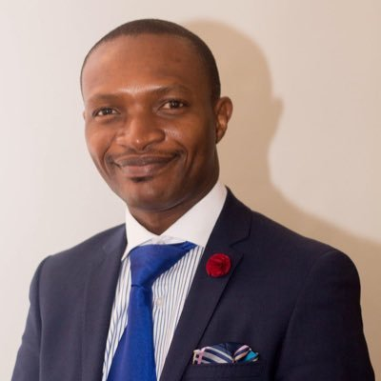

Lois Dobson

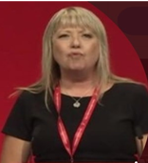

Rohina Ghafoor

Manchester BME

Network

GM Integrated

Care Board

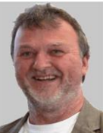

Manchester University

Esther Akinwunmi

Geraldine Thompson



**Other Clinical**

Eunice Onwuamaegbu



**Nursing & Midwifery**



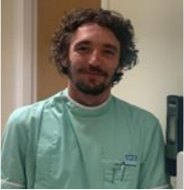

**Non-Clinical & Support**

**Medical & Dental**

**STAFF GOVERNORS**

Christine Turner



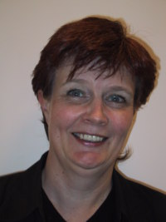



**Rest of England & Wales**



**Trafford**

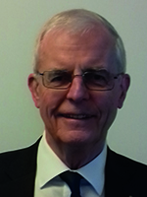

**Eastern Cheshire**



**Rest of Greater Manchester**





**PUBLIC GOVERNORS**

**Manchester**

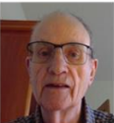

Picture

Awaited



Michael Kelly

Lead Governor – Michael Kelly

Helen Burgess

Vacant

Syed Nayyer Abidi

Gill Hoad-Reddick

Ivan Benett

Lisa Johnson

Picture

Awaited

Vacant

Vacan





Vacant

Colin Owen

Volunteer Services

Youth Forum

Richard Harvey

Paul Gibson

Harold Myers

Chris Templar

Nazir Choonara

Caribbean & African

Health Network

Manchester City

Council

Julie Reid

**NOMINATED GOVERNORS**

Trafford Council

Anne-Marie Glenny

Ann Balfour

Jerome Cook



Karen Scott

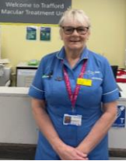

Constance Chen

Manisha Kumar

Mike Cordingley