­

**Royal Manchester Children’s Hospital**

**Information for Patients**

**Healthy Eating Following a Burn Injury**

This booklet is intended to inform families of children with a burn injury about nutrition during hospitalisation and after they return home. Your child needs adequate nutrition to grow and develop. Having a burn injury can increase the need for good nutrition. The size and depth of the burn injury will influence the amount of additional nutrition your child may need. A diet which is high in calories and protein:

* Supports the immune system to decrease the risk of infection
* Helps wound healing
* Maintains muscle mass
* Minimises weight loss and provides energy to support rehabilitation

**Healthy Eating for Burns**

**How are nutritional needs calculated?**

For a child with a burn injury the dietitian and medical team decide how much fluid, calories and protein your child needs based on his/her weight, height, age, burn size and any previous dietary issues. Vitamins and minerals\* are also important for wound healing and preventing infection.

|  |  |
| --- | --- |
| **Vitamin/Mineral** | **Function** |
| Vitamin C, Copper and Zinc | Help burns to heal |
| Vitamin E, C and Selenium | Help to reduce the bodies stress response after an injury |
| Vitamin C,D and Zinc | Help to prevent and treat infections |
| Vitamin D | Healthy Bones |

\*See Food sources of vitamins and minerals

**How are nutrition needs met whilst in hospital?**

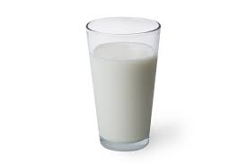Healing from a burn injury requires more calories and protein than any other type of injury. In hospital the dietitian and ward staff make sure that your child is getting enough nutrition to help with wound healing.

The nursing staff will assess your child’s height and weight and ability to eat adequate nutrition on admission.

In the hospital your child will be encouraged to drink milk as this contains protein, fat and calories. Water and Juice do not contain protein and will therefore not be offered as main drinks. Special milkshakes may also be offered to encourage your child to have enough nutrition to heal. High Protein foods such as meat, fish, eggs, pulses, milk yogurt, cheese and nuts should be included in meals and snacks.

If your child is unable to meet all of their nutritional needs, they will be referred to the Burns Dietitian. The Dietitian will assess and calculate nutritional requirements and will provide a plan to increase nutritional intake as necessary.

This may include:

* Extra Foods/ Snacks on the ward
* Nutritional Supplements: High Energy /High Protein Milkshakes or Juices
* Tube feeding: If your child cannot manage to take enough nutrition a soft flexible tube maybe inserted to deliver a liquid formula containing all the nutrients needed for healing. Tube feeding can deliver all or part of your child’s nutritional requirements and continue as long as necessary.

As burns heal children will gradually need less nutrition and you can monitor your child’s nutritional status by watching his/her weight, growth, wound healing and energy levels. Take your child to regular medical appointments where growth can be monitored. You may be asked to complete a food diary so the dietitian can monitor dietary intake.

**What should your child eat after discharge from hospital?**

Remember your child now requires fewer calories than when he/she was in hospital. If your child’s burn wounds are still open, his/her diet should still include extra protein, vitamins and minerals. As your child continues to heal, his/her nutrition needs will be like they were before the injury.

At the hospital your child was encouraged to follow a high calorie, high protein diet, possibly with nutritional supplements. After discharging you might notice their appetite may have increased. At home you need to focus on a balanced diet; including lean meats, wholegrains, vegetables, fruits and dairy foods. Try to limit foods with little nutritional value such as sugary drinks, desserts, sweets, crisps and sweet biscuits.

A child with a burn injury needs a balanced and varied diet, including foods rich in vitamins and minerals this will help your child heal and maintain a healthy weight.

Your child may also need extra vitamins and minerals. All children from 6 months -5 years (unless on formula milk or nutritional supplements require healthy vitamin drops (Vitamins A, C & D) or Abidec (Vitamins A, B, C, D). See Food Sources of vitamins and minerals

Body text. Leave one line (12 pica) between the main heading and the body text.

Text should be justified on the **left.**

**Tips for a good meal routine at home**

* Offer your child small, frequent meals and snacks.
* Prepare balanced meals containing all 5 food groups: fruits, vegetables, starchy carbohydrates, protein and dairy- as per the Eatwell Guide.
* Offer your child water/milk between meals- sugary drinks offer little nutritional value.
* Try to eat together as a family.

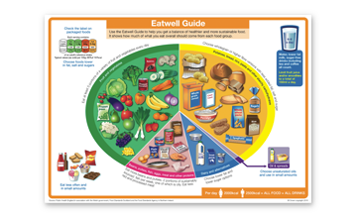

**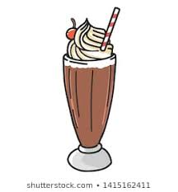Recipe ideas**

**Milk Shake (485 kcals, 14g protein)**

1 banana

2 tablespoon peanut butter

2table spoon milk shake powder/syrup

½ cup whole milk

**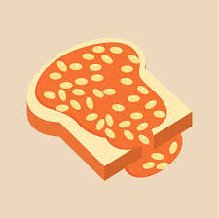**

**Beans on Toast with Cheese (550 kcal, 24g protein)**

2 slices toast

Butter or margarine

200g beans

30g grated cheese

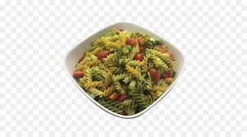

**Tuna Pasta (475 kcal, 25g protein)**

150g Cooked Pasta

½ Tin of Tuna mixed with Mayonnaise

Grated Carrot/Sweetcorn

**Food sources of Vitamin and Minerals**

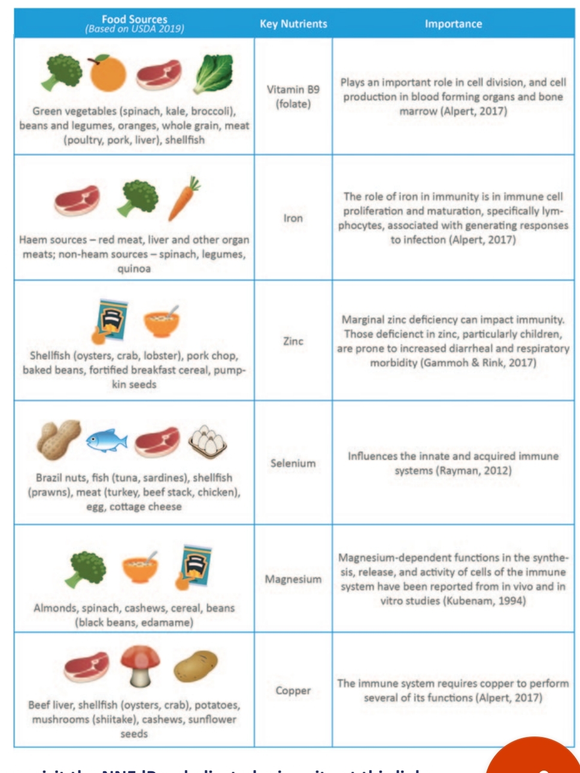

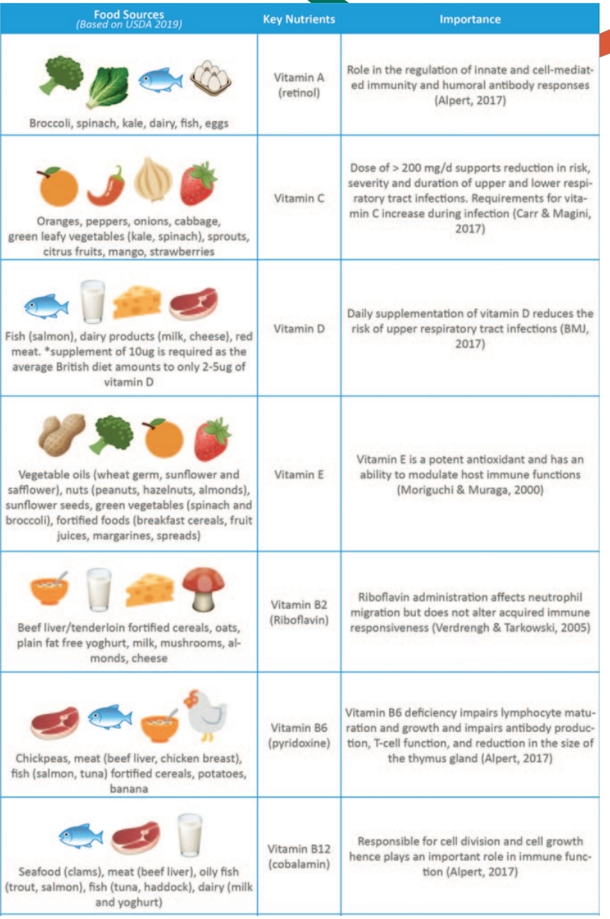

0161 701 5252communication-1293317_960_720

envelope-35392_960_720

[mft.rmchpaediatricdietitians@nhs.net](mailto:mft.rmchpaediatricdietitians@nhs.net)

www-1632431_960_720