­

**Royal Manchester Children’s Hospital**

**Information for Patients**

**Itch following a Burn Injury**

As the skin heals after a burn injury it can become itchy. This is a normal part of the healing process and is usually caused by altered sensation of the damaged nerve endings. Another reason for the itchiness you may experience is due to the skin’s oil glands not working properly yet so your skin may become dry which then causes the itch. In some cases itching can be a side effect of some medications, such as morphine. Itching may become worse in the heat or at night and can cause problems with sleep and carrying out daily activities. Over-the-counter or prescribed antihistamine (anti-itch) medications can reduce itching, but unfortunately there is no cure.

**What can I do to reduce the Itching?**

* Moisturise affected area three times a day – wash off moisturising cream residue before you reapply new moisturiser.
* Keep your moisturiser in the fridge to help cool the skin.
* Cool baths or using a cold flannel on the area, or place towels in the fridge to lie on
* Fans and portable air-conditioning units can be helpful on healed skin if the itching becomes worse in the heat.
* Using soft cotton clothes and bed sheets.
* Do not apply ice directly onto the skin as this can cause more damage.
* Do not scratch - this can damage your delicate new skin. Instead, try patting the area firmly. Keep nails trimmed short and filed smooth.

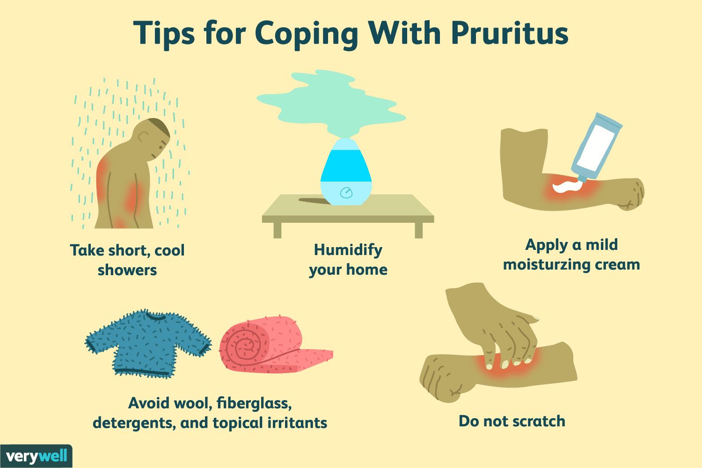

If you find that these methods don’t help and the itching is becoming a more severe problem, please speak to your Burns Team.

**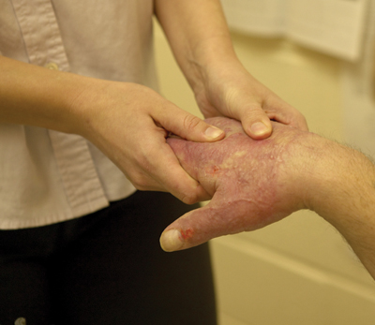What other things can help with pain and itching?**

Distracting yourself can be a powerful way of temporarily relieving even the most intense pain or itching. However, you may have to try several things before you find the distraction technique that is right for you, such as:

* Watching TV
* Exercising/being active
* Reading
* Drawing, knitting or model-making
* Doing a word puzzle
* Listening to music
* Deep breathing, relaxation or meditation
* Playing a computer game/iPad/computer based working
* Social activities/seeing friends and family

While distraction techniques may not take your pain or itching away, they may make your symptoms easier to manage.

## **In case of problems or advice please call your discharging ward:**

## Burns Unit 0161 701 8100

communication-1293317_960_720 Burns & Plastics Aftercare Clinic 0161 701 9250

envelope-35392_960_720

mft.bpacteam@nhs.net

www-1632431_960_720

https://mft.nhs.uk/rmch/our-wards/ward-81-burns-unit-2

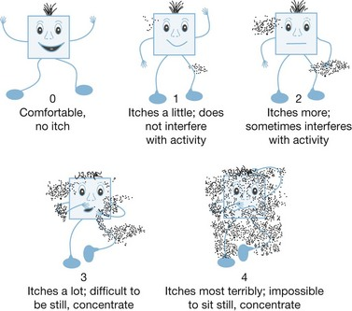

Itchman scale to rate itching intensity in children. Designed by Blakeney and Marvin 2000

|  |  |  |
| --- | --- | --- |
| Date | Level | What used, did it work |
|  |  |  |
|  |  |  |
|  |  |  |
|  |  |  |
|  |  |  |
|  |  |  |
|  |  |  |

|  |  |  |
| --- | --- | --- |
|  |  |  |
|  |  |  |
|  |  |  |
|  |  |  |
|  |  |  |
|  |  |  |
|  |  |  |
|  |  |  |
|  |  |  |
|  |  |  |
|  |  |  |
|  |  |  |
|  |  |  |
|  |  |  |
|  |  |  |
|  |  |  |
|  |  |  |
|  |  |  |
|  |  |  |
|  |  |  |
|  |  |  |
|  |  |  |
|  |  |  |