­

**Royal Manchester Children’s Hospital**

**Information for Patients**

**Manchester Children’s Burns Camp (MCBC)**

**Information For Patients and their Families**

**What’s it all about?**

**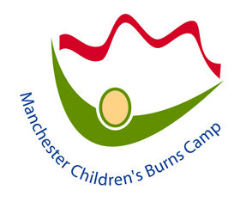**

**What is a Burns Camp?**

It is for children and young people aged 5 - 16 years who have had a burn or other traumatic injury that has left scars. Children and young people at all stages of care, whether still receiving treatment or not, may be invited to a camp. We stay at a residential activity centre for up to a week and try out many different activities. Although we spend lots of time out of doors, it is not really a camp with tents; we stay in an Outdoor Activity Centre with bunk beds!

# What happens at a Burns Camp?

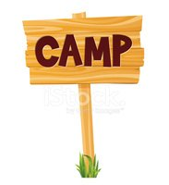There are lots of fun and exciting things to do at Camp! Some activities are physically challenging like rock-climbing, abseiling, canoeing, caving and swimming. Other things we do are quieter like music, arts and crafts. Some activities take place at the centre, but we also go on day trips and do activities like bowling which involve going out in the local area.

There are lots of chances to learn about things that can be important to people who have scars. For example:

* Sharing ideas and strategies about how to manage some of the challenges you have when you have scars.
* Working together in teams helps us get better at things like getting on with people.
* Taking part in fun and challenging activities can help you feel good about yourself.
* Speaking to peers who understand what it is like to live with scars.
* You will get lots of encouragement to wash, cream, wear pressure garments and look after your scars well.
* There are people from the hospital who can help you with things you may be finding difficult since your injury.

Being with other young people and adults who have had similar experiences means there are lots of chances for learning from each other.

Most importantly, all the activities involve having lots of fun! No one is made to take part in activities they may not want to. Children who have been to Camp before have had a great time, made lots of friends and learned things from each other and about themselves. Many want to come again and again!

# What’s in it for children?

We know having a burn injury can be difficult at times. Coming to Camp is not only fun but a great chance to make friends with people who have similar experiences to your own. You can try new things and feel good about yourself and what you achieve. You can get help with things that you might be finding difficult and learn new things that you may find helpful when you go back home. It can also feel good to see that you are not the only one who has been injured, and you are not alone.

Being away from home can be exciting but it can also be a challenge, especially if children have not been away by themselves before. This can be just as much a worry for parents. Families have told us that children come back from Camp happy and more confident. Despite their worries, parents are very pleased that their children came to Camp and want them to go again the next year.

# Who organises it?

1

Some of the people who organise Camp are from the Royal Manchester Children's Hospital, including doctors, nurses, clinical psychologists, play specialists, occupational therapists and physiotherapists - people you may have met during your treatment. Some people work for Greater Manchester Fire and Rescue Service, and some are adults who have had a burn injury themselves. We also have volunteers from outside the hospital.

# How did it all start?

The first Manchester Burn Camp was held 1993; it was organised by people from Booth Hall Children's Hospital (where the Manchester Children’s Burns Unit used to be) and volunteers. It began with a weekend Camp for a small number of children and has grown to include a range of programmes each year including week long residential camps for children aged 8-16 years, a family weekend and age-specific day activities for children from pre-school to 16 years. We also have a training programme for young people who have been to camp to learn how to become Camp Leaders.

There are burns camps all around the world as it is recognised as a really important part of a child’s treatment and therapy. We have developed links with other Burns Camps in this country, Europe and USA and have an exchange programme with the Denver Children’s Hospital Burns Camp programme in Colorado.

# How is Camp funded?

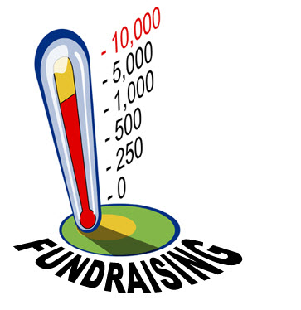

The camps are funded by donations and fund raising events.

Families of children attending Camp are not required to pay anything, but any voluntary donations or assistance with fundraising events is always welcomed. Please contact Alison Thomlinson if you would like more information about fundraising for Burns Camp.

Manchester Children’s Burns Camp is part of Manchester University NHS Foundation Trust Charity (Registered Charity No: 1049274).

**Contact details:**

If you would like any further information or think you may be able to help in some way, contact:

communication-1293317_960_720**Alison Thomlinson Tel. 0161 701 8142 / 07827 848240**

Burn Camp Co-ordinator

**E-mail: alison.thomlinson@mft.nhs.uk**

**Sarah Gaskell Tel. 0161 701 1043**

Consultant Clinical Psychologist

Director of MCBC

**Barbara Hensman Tel. 0161 701 8148**

Ward Manager (Burns Service)

envelope-35392_960_720

**Manchester Children’s Burns Camp**

**Burns Service**

**Royal Manchester Children’s Hospital**

**Oxford Road**

**Manchester**

**M13 9WL**

www-1632431_960_720