­

**Royal Manchester Children’s Hospital**

**Information for Patients**

**Pain Information for Burns and Plastics**

Your child has a wound which has been dressed on the Burns Unit (BU/Ward 81) or in the Burns & Plastics Aftercare Clinic (BPAC). This leaflet will provide information about pain relief once your child has been discharged home. Your nurse or doctor may provide you with additional instructions for your child’s procedure.

**Pain relief before dressing changes**

When your child has an appointment to have their dressing changed, it is important that they are given pain relief at least 1 hour before their appointment time, so that it is working when the dressings are changed. We advise that you give your child paracetamol and ibuprofen.

Your child may also have been given some oral morphine to take specifically before their dressing change, so please make sure that this is given 1 hour before their appointment time.

**Is my child in pain?**

You will probably already know how your child expresses pain or discomfort. You should encourage them to tell you if something hurts. If you have difficulty with this you can use the pain assessment tool which is used on our wards (see page 6)

**Common medicines**

The two most common medicines used are paracetamol and ibuprofen. You should always follow the instructions on the bottle or label. Never give more than the recommended dose. These medicines are not routinely provided by the hospital so it is important to buy some from a community pharmacy or supermarket before your child is discharged from hospital.

**Paracetamol (Brand names: Calpol, Medinol, Disprol, Tixymol)**

Paracetamol can relieve pain and bring down a temperature. It should be given regularly while your child is in pain. Paracetamol is safe to give regularly as long as you wait at least four hours between doses and do not give more than four doses in 24 hours. Side effects are rare with paracetamol. There are two strengths: 120mg in 5 ml (for children under 6 years) and 250mg in 5 ml (for children over 6 years) so please make sure your child is given the correct strength.

**Ibuprofen (Brand names: Nurofen, Calprofen, Junifen, Advil, Cuprofen)**

Ibuprofen can relieve pain and bring down a temperature. It can also be taken regularly. There will be instructions on the bottle. It is best given with or after food or milk. Ibuprofen may sometimes cause a tummy ache or diarrhoea (further information can be found in the leaflet which comes with the medicine). Ibuprofen is not suitable for some people, for example, those with asthma, kidney, liver or certain heart problems. Your doctor or pharmacist can help decide if ibuprofen is suitable for your child.

**Morphine or Oxycodone (Brand names: Oramorph, Sevredol, Oxynorm)**

If paracetamol and ibuprofen have been given and your child is still in pain, morphine or oxycodone are sometimes used. You should give the medicine on a “when needed” basis if your child still has pain after taking paracetamol and ibuprofen. Common side effects are feeling or being sick, drowsiness, dry mouth, sweating, flushing of the skin, constipation, confusion and shallow breathing (further information can be found in the leaflet which comes with the medicine).

**Can I give different medicines together?**

Your child may be asked to take more than one type of medicine for pain relief. Often, both paracetamol and ibuprofen are recommended. The medicines work in different ways so it is ok to give both together if the pain is bad. Be careful because some medicines may be the same medicine type but given a different brand name on the bottle or box. In the “common medicines” section above you can see some common brand names. If you are unsure ask a doctor, nurse or pharmacist.

**When should I give pain medicine?**

If your child is in pain you should give medicine to relieve it. You should continue to do this for as long as they have pain. For severe pain, give the medicine(s) regularly and do not wait until the pain worsens. If your child does not have constant pain, it is ok to give the medicine only when needed.

**Don’t delay pain medicines**

We do know from studies that a surprisingly large proportion of parents do not give pain medicines when their child has pain. This is not because they are being mean but parents are often concerned about side effects and drug addiction, or they feel medicines should only be given as a last resort. When given in recommended doses, side effects do not often occur. Giving your child effective pain relief will not only keep them comfortable but may improve their sleep, eating and recovery. If your child does not like the taste, different brands may have different flavours (ask at your local pharmacy).

**Are the medicines working?**

If you feel that your child still has pain despite giving the medicine(s) regularly, you should contact the ward or your GP. Do not give more than the recommended doses of medicines. Always follow the instructions on the medicine label.

**Storing medicines**

Store away from heat or sunlight and out of reach of children

**Your child’s pain relief recommendations**

In case of problems or advice please call your discharging ward:

communication-1293317_960_720 Burns Unit 0161 701 8100

Burns & Plastics Aftercare Clinic 0161 701 9250

Pain team 0161 701 5626 (Monday to Friday 07.30-17.00)

envelope-35392_960_720

www-1632431_960_720

**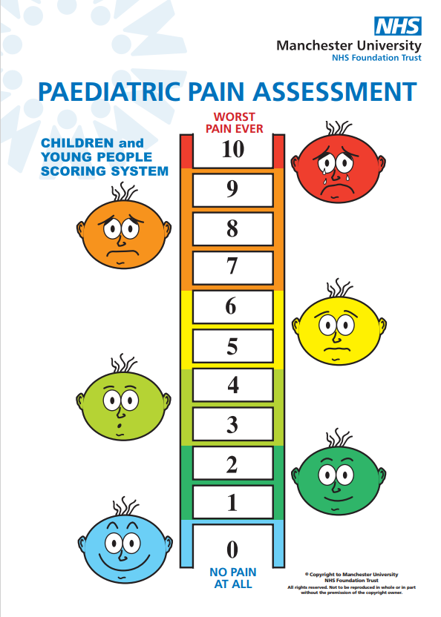**

The pain assessment tool may help your child to express how much pain they are experiencing. They can choose a number or facial expression on the ladder which best fits how sore they might be feeling.

• A child selecting a number or face corresponding to 1-3 (mild pain) should have regular paracetamol (4 doses a day)

• If they select a number or face corresponding to 4-6 (moderate pain) or above, you should also give ibuprofen if allowed

• If their pain is above 5 and particularly if it is 7-10 (severe pain) and your child has already had paracetamol and ibuprofen, then oral morphine or oxycodone should be given in addition, if prescribed to take home.

Other signs that your child may be experiencing pain might be:

• reluctance to eat or drink

• difficulty sleeping

• reluctance to move around or crying when picked up or moved

• difficult to distract or console

• very tense