­

**Royal Manchester Children’s Hospital**

**Information for Patients**

**Ward 81 – Burns Unit**

This booklet contains information for parents and families to refer to whist your child is a patient on Ward 81 at the Royal Manchester Children’s Hospital. Ward 81 is a 12 bedded unit, consisting of 8 cubicles and 1 bay with 4 beds. The specialties on the ward are mainly related to Burns and Plastics injuries but we also look after patients from other specialties who may need nursing care.

**Ward 81 Philosophy of care**

Whilst your child is a patient on Ward 81, we aim to provide a high standard of care by:

* Offering you, your child, and your family emotional and empathetic support
* Liaising with other health care professionals to give you a quality service.
* Encouraging parental participation in care
* Action as an important member of the health care team
* Empowering children and their families by respecting and understanding each child’s social, physical, emotional, and spiritual needs’.
* Acting as the child’s advocate by ensuring needs and rights are respected and provided.

# **Staff you may see on the ward.**

All staff should be wearing a visible ID badge, below are the uniforms that staff on Ward 81 will be wearing. There is a full-size poster near the entrance of the ward:

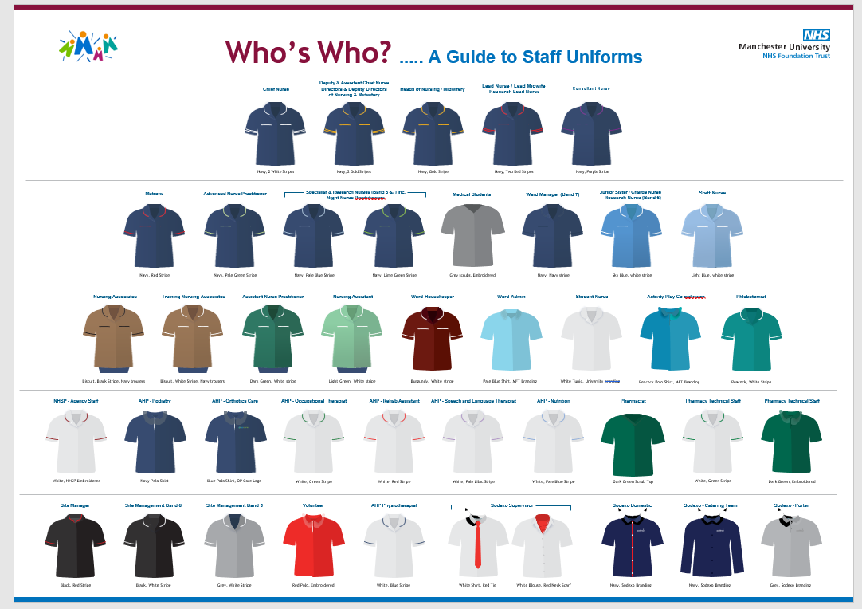

You may often see the burns staff, theatre staff, surgeons, and anaestheticdoctors change from uniforms into wearing theatre blues this is because we are aiming to keep our uniforms clean and prevent spread of infection to our patients, when completing wound assessments / dressings and surgery.

We ask the staff providing your care to introduce themselves. There are many members of staff which take part on ward rounds daily, usually completed in the morning, but times may vary during your stay. Please ask if you want to know more information about a member of the team providing your patient care.

**Visiting Times**

Parents/carers have opening visiting hours and access to the ward, but we ask that patients have a maximum of **3** visitors per stay (including parents/carers). These visitors should be the same **3** people throughout your stay, **but only 2 can be present on the ward at one time**.

Out of the **3** nominated visitors only 1 can stay overnight.

At 8pm the lights on the ward will be turned off, we will ask the visitor not staying overnight to leave the ward to allow the children to sleep.

The number of visitors and times for visiting, are subject to change in line with Infection Prevention and Control guidance.

No child under 16 years old, can visit the ward at any time.

# **Entry to and exiting the ward:**

To gain entry to the ward you must press the call button situated on the wall on the main corridor. When required, please talk into the speaker stating who you are and the name of the patient you wish to visit.

To exit the ward, please push the green button on the right wall by the door. Please do not let other visitors in; this is for everyone’s safety.

You will be given a colored wristband to support your entry to the ward and to monitor visitors for safety reasons.

**Patient’s facilities:**

Toilets and bathrooms are situated on the ward; these can be used by all patients. If assistance is needed, please alert a member of the nursing team. There are call bells situated on the wall by every bed space, this is the grey remote with the orange button, please press this button if assistance is needed and you cannot see a member of the nursing team, a member of the team will respond at the soonest opportunity. There is also a red triangle on the wall by every bed space: THIS IS TO BE USED IN EMERGENCIES ONLY.

# **Patient hygiene and personal cares:**

If your child requires assistance with personal hygiene, please speak to your allocated nurse. Please ask if you need a toothbrush or any hygiene products. 

**Parents’ facilities:**

The parents' toilet is by the entrance into the ward. There is also the use of a shower whilst staying, please ask a member of staff and they will show you the facilities.

A parents’ room is available to use during is your child’s stay, this is situated near the entrance of the ward on the left.

Within the parents’ room there is a fridge, microwave, toaster, and tea and coffee making facilities. **No children are allowed in this room.**

Please feel free to bring in food and put it in the fridge however we ask that anything you bring in is labelled it with your bed number, date, and child’s surname. There are yellow labels available to use.

Please be mindful that these facilities are used by all parents and relatives, so ensure that these are kept clean following your use. If there are any problems or concerns, please report these to a member of staff, if staff find food without a label **it** will be removed and disposed of.

We ask that you consume any hot food & drinks in the parent’s room as we **do not allow** any hot drinks at any bed space (this includes flasks/thermos).

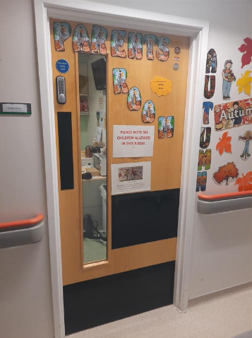 Parents room 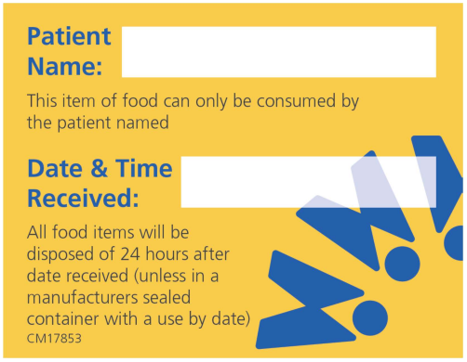 Food Label

There is a **parent** bed **for** each bed space to enable one parent to be resident with their child. If you wish to stay overnight at Ronald McDonald House, you should speak to the ward staff and ask them to complete a request form. If there is a room available, you will be notified accordingly. Sometimes there may be a waiting list. You will be charged a deposit of £25 which is refundable when you depart.

If you **are** not provided with a room, you can obtain day passes from the ward if you wish to use the facilities in Ronald Macdonald House.

# **Leaving the ward to take a break**

Although the ward is very busy, we understand that at times, you will need to leave your child for a number of reasons. If you feel that your child would require supervision whilst you leave the ward, please discuss this with your nurse, and we may be able to negotiate a mutually convenient time for us to support this.

# **Restaurant and shop opening times**.

The following facilities can be found on the ground floor of the children’s hospital:

RMCH “Kitchen works” restaurant- open 07.00-15.00 Monday-Friday

RMCH ‘Yard Bird’- open 11.30-14.00 Monday-Friday

RMCH WH-Smith – open 07.00-19.00 Monday-Friday, 10.00-15.00 Saturday and Sunday

RMCH Costa coffee – open 07.00-17.00 Monday-Friday, 09.00-15.00 Saturday and Sunday

Subway – open 07.00-20.00 Monday-Friday, 09.00-16.00 Saturday and Sunday

On the main corridor towards the Eye hospital the restaurant is open Monday- Sunday 24hrs.

Starbucks, M&S and Greggs are also located across the hospital site.

A cash machine is located opposite WH-Smith in RMCH atrium.

Free water is also available in this area. You can bring your own water bottle or the machine has bottles to purchase.

# **Patient observation**

Staff will use electronic devices to record patient care information. These devices can look like mobile phones.

# **Hand washing and infection prevention and control**

Whilst your child is in hospital you will notice all staff washing their hands or using alcohol gel. This is to prevent the spread of germs and infection.

Please take a few minutes to wash your hands and use the alcohol gel provided around the ward. If your child is in a cubicle due to an infection you may be asked to wear

an apron, gloves, and other forms of personal protective equipment.

As a precautionary measure, to check your child is not carrying certain germs, we screen patients on a regular basis.

Swabs are taken for MRSA and rectal swabs/stool specimens are taken for CPE.

If you are feeling unwell, we ask that you do not visit the hospital until you are symptom free.

RMCH MCS support a national ‘Gloves off’ campaign which promotes correct usage of non-sterile gloves and encourages visitors to challenge any staff who do not wash their hands before and after contact with patients.

# **Televisions and Mobile phones:**

There is a TV situated at every bed space, this can be used by children and young people with no charge**,** complimentary from MFT**,** between the hours of 07.00-21.00. If you wish to continue using the TV outside of these hours, purchases can be made using your TV telephone, which connects you directly to Hospedia, the service provider.

If you wish to use your television past 20.00 we ask that you use headphones to allow others to sleep, these are available from staff on

the ward. We also ask that mobile phones are kept on silent whilst on the main ward, and used with

mindfulness of other patients on the ward.

# **Mealtimes**

Breakfast is planned between 08.00-09.00, a member of staff will offer each child and resident parent cereal/toast and a cold drink. Lunch and tea are ordered through our ‘Saffron’ ordering system, **staff will ask you for choices for your child.**

During the hours of 12.30 to 13.30 and 17.00 to 18.00, the ward has ‘Protected Mealtimes’.

This means that during this time, the ward and staff promote a quieter and calmer environment, so the children can eat their meals in a more relaxed atmosphere. The lights will be switched off/lowered, if possible, to help create a calmer environment.

Children are encouraged to sit out of bed at mealtimes if they are able to do so. We advise that children are at their beds at mealtimes as we are unable to reheat food. If your child is off the ward for a medical intervention, you will be given an alternative option.

**Meals are not provided for parents or carers**

**If your child is hungry outside of these hours, we have snacks available, just ask a member of our team**.

Mums breastfeeding babies under 6 months are offered meals. Parents can eat alongside their child in the bays. Please be mindful of others in the bay. Hot drinks cannot be brought on to the ward **but can be consumed in the parents' room.**

# **Car parking**

Car parking is available in the Hathersage road multi-storey car park. As a parent you may be entitled to reduced parking fees. For more information, please speak to a member of staff who will complete a form for you. For all other visitors, there is a charge for the car park and the details are shown at the pay machines.

Website link: [www.mft.nhs.uk/rmch/patients-visitors/visitors/car-parking](http://www.mft.nhs.uk/rmch/patients-visitors/visitors/car-parking)

# **Multi-faith prayer rooms**

There are multi-faith prayer rooms available, one on the ground floor and one on the first floor. We have multi-faith chaplains in the hospital whose role is to care for children and families. If you wish to speak to a chaplain or a faith leader, please ask a member of staff. A spiritual support service and kosher kitchen is also available.

# **Reasonable adjustments and hospital passports**

If you or your child have a learning disability and/or require reasonable adjustments in your care or the care environment, please speak with a member of the clinical team.

If your child has a hospital passport or person-centered assessment, please share this with the clinical team so that it can be included within your child’s electronic medical notes and ‘flagged’ to aid communication. If you feel that your child would benefit from a person-centered care assessment, please discuss this with the clinical team who will support you.

# **Play and school**

Play is a very important part of any child’s recovery process. The play specialist assists in the management of anxiety, fear, phobias and non- compliance by providing psychological preparation, along with distraction and diversional therapies for a variety of procedures and treatments. The play leader provides play and recreation to help keep some normality for the child or young person in a hospital environment.

Each weekday the play leader will ensure that all patients have activities to do and is available to carry out 1:1 session on a referral basis.

The playroom is open **7 days a week till 8pm** Monday-Friday. All children in the playroom must be supervised. A multi-sensory room, is available by booking with the play leader.

The school is available for children who have been an inpatient for more than **five** days. One to one session are facilitated on the ward by a school teacher if your child is unable to leave the ward. If your child is mobile, they will be able to go to the school room. If you have any concerns about schoolwork, please talk to the teacher.

# **Feedback**

We ask that you share your patient experience feedback on our patient experience tracker, an electronic handheld device. It gives us feedback on how we are doing and helps us make our service as good as possible.

We also have posters with QR Codes so that you can download the survey to your mobile device and share feedback to enable us to make improvements.

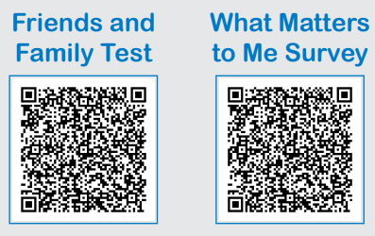

# **Raising concerns**

If you have any worries or fears, please speak to your allocated nurse. We recognise families know their child best. Any concerns you may have about your child’s condition are taken seriously.

Please be assured that raising concerns will not affect your child’s care.

If you are not satisfied with the response, please ask to speak to the Nurse in charge or the Ward Manager.

The ward is happy to take phone calls from concerned parents and family members. Please be reminded that there is only a certain amount of information we are able to give out over the phone, this is for confidentiality reasons.

communication-1293317_960_7200161 701 8100

envelope-35392_960_720

www-1632431_960_720

https://mft.nhs.uk/rmch/our-wards/ward-81-burns-unit-2