Royal Manchester Children’s Hospital

Information for Patients

Pressure Garments, Silicone and Face Masks

Your child may be required to wear a pressure garment. These are made from strong Lycra material which provide firm, even pressure over the affected area.
Each child is measured for their own individual garment, and remeasured when the garment becomes too small.
These garments are worn for 23₁/₂ hours out of 24 hours and only removed for washing, creaming and massaging.

How does the pressure garment help the scars?

After your child’s injury, the healed tissue changes especially within the first six months, after the accident. It can look worse rather than better during this time, but then it will steadily improve over the next two years.
- You will find that when your child is exposed to very cold temperatures the scarring will become dark purple. This is normal and occurs due to a decrease in blood supply.
- In a very warm environment, the scarring can be become very red in colour. This is also normal and occurs due to an increase in blood supply. These changes will also occur on the legs and feet (if involved) when the child stands for a long time.
- In burns and scalds you may also find that the scar tissue becomes red and raised. This is called hypertrophic scarring, but regular creaming, massaging and the wearing of a pressure garment can help to control the scarring, and through time the scar may become softer, paler and more supple.

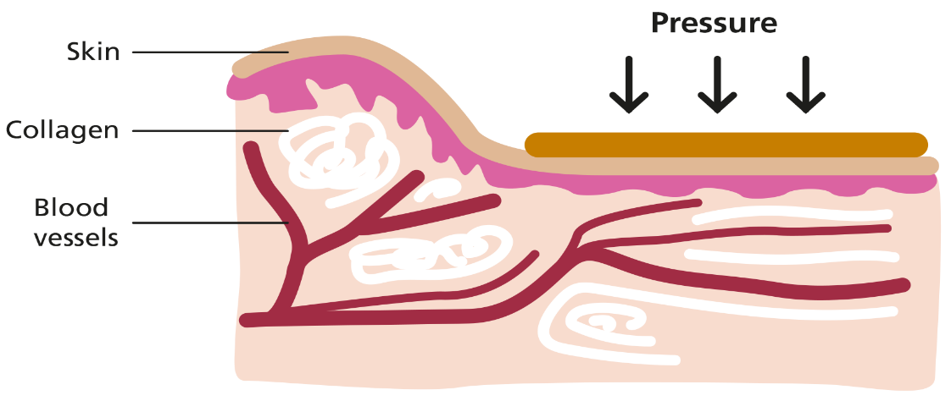

Difficulties in putting on pressure garments

Putting on the pressure garment may be difficult initially but with practice this will very soon become much easier. Staff at the clinic will show you how to apply the garment properly, as it is important that it fits correctly.
When applying garments over hands and feet – you will be given a sleeve to place over the hand/foot and then apply the garment, and remove the bag when garment is on.

Care of the pressure garments
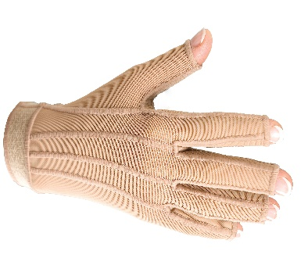
You will be given two pressure garments. One to wash and one to wear. There are a few simple instructions you must follow to care for your garment.
Wash the garment in the washing machine with non-biological washing powder. Do not use fabric conditioner and wash at 30 degrees.
Dry the garment by hanging on a hanger, to dry naturally. You will be given washing instructions with every garment given to you. Do not dry on radiators, tumble dryers, outside in the sun or any direct heat as this destroys the lycra in the garment.

How long will my child have to wear a garment?

To achieve the best results from the garment, your child will wear the garment 23₁/₂ hours out of 24 hours.
It should only be removed for washing and creaming the affected area(s).
The pressure garment will become part of your child’s life for the next 18 months to two years, and they will become accustomed to wearing it just like a pair of glasses or dental braces.
Most children dislike wearing the garment, but with perseverance the results will be rewarding, and well worth the effort that you have put in.

If your child objects to the garment, try to encourage your child back into the garment and praise or reward them when the garment is worn correctly.
If you find this is not working, please talk to one of the burn care team, as we may be able to help.

Silicone therapy

Depending on how the scar develops your child may be commenced on some form of silicone therapy. There are a variety of different products and so the best one for your child will be recommended to you. At this stage instructions for use and how to obtain future supplies will be given to you.

Face masks

If your child has sustained a deep scald or burns to their face they may be required to wear a face mask. This is made from a clear plastic material, specially made for your child. To make sure the face mask fits properly we need to make a mould of your child’s face. This can be done before you leave hospital, or as an out-patient when you come in for clinic appointments. The mask will then be fitted in the clinic gradually increasing the amount of time worn until achieving 23¹/₂ hours per day. As your child grows and the scar changes new face masks will be remolded to ensure that a current fit is always appropriate.

If you have any queries, about your child’s care on leaving the hospital, please do not hesitate to contact:
Burns and Plastics After Care Clinic on 0161 701 9250 from

8.00 am – 4.00 pm Monday to Friday.
Outside these hours contact the Burns Unit on 0161 701 8100.


mft.bpacteam@nhs.net

https://mft.nhs.uk/rmch/our-wards/ward-81-burns-unit-2

