**Manchester Newborn Screening Laboratory - User Survey 2023**

## Introduction

The user survey was first rolled out in 2018 and has been distributed each year to gain feedback from users to help improve the NBS laboratory service. (There was no user survey for 2020 or 2022 due to reduced staffing levels.) The 2023 user survey was developed using Google forms and was distributed to users of the Manchester Newborn Screening laboratory to receive feedback. The 2023 user survey consists of 9 questions which would take an estimated 5 minutes for someone to complete. The link to the survey was emailed to midwives, health visitors, child health departments, QA team and responses were collated over a two-month period.

## Results

The survey was available from 12th October to 31st November 2023.

Question 1 - To which staff group do you belong?

We received 16 responses from a variety of staff groups.

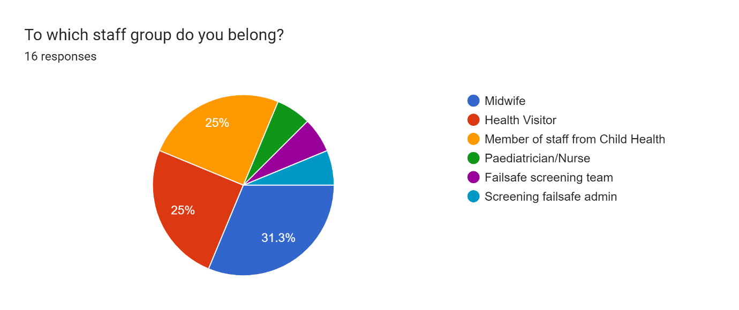

Questions 2-7

Users were asked whether they agreed or disagreed with a number of statements relating to different aspects of the laboratory. Each question was rated from 1-5. Where 1 was strongly disagree and 5 was strongly agree.

Question 2 - Enquiries are resolved in a timely manner by laboratory staff

15 people selected agree or strongly agree to the statement ‘Enquiries resolved in a timely manner by laboratory staff’. Only one person selected neither agree/nor disagree.

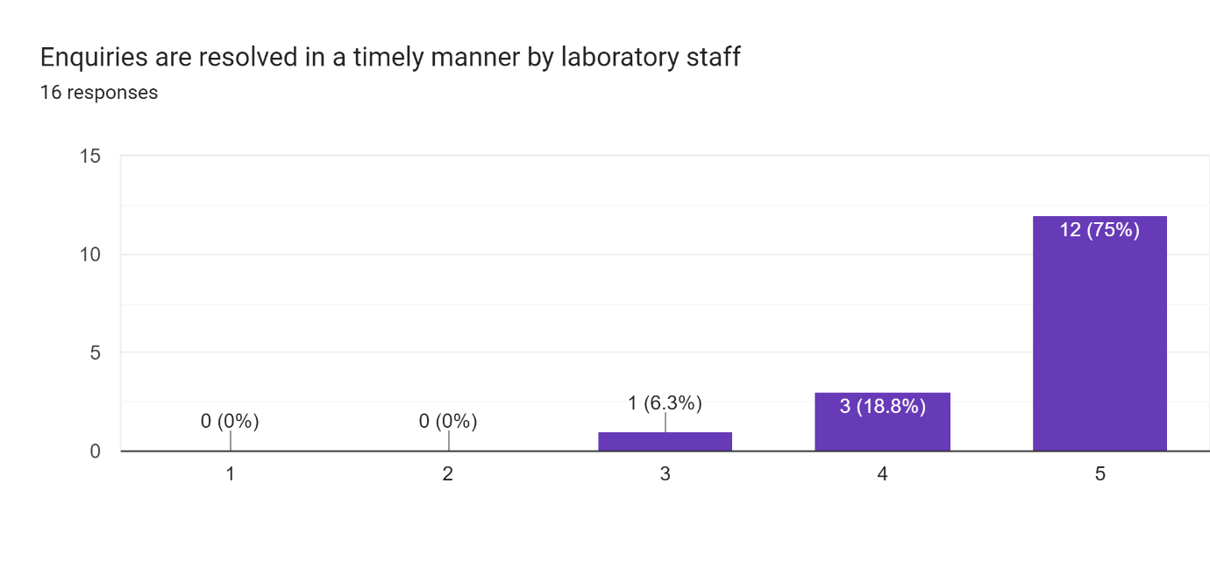

Question 3 - Staff are friendly and helpful

15 people selected agree or strongly agree to the statement ‘Staff are friendly and helpful’. One person selected disagree.

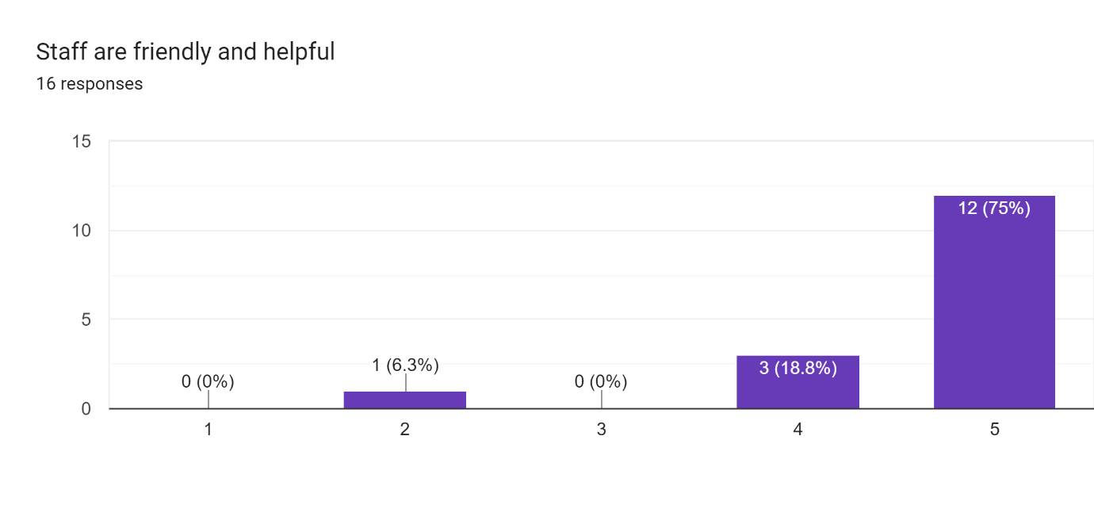

Question 4 - I am satisfied with the quality of professional advice that I receive from the laboratory

15 people selected agree or strongly agree to the statement ‘I am satisfied with the quality of professional advice that I receive from the laboratory’. One person selected neither agree/nor disagree.

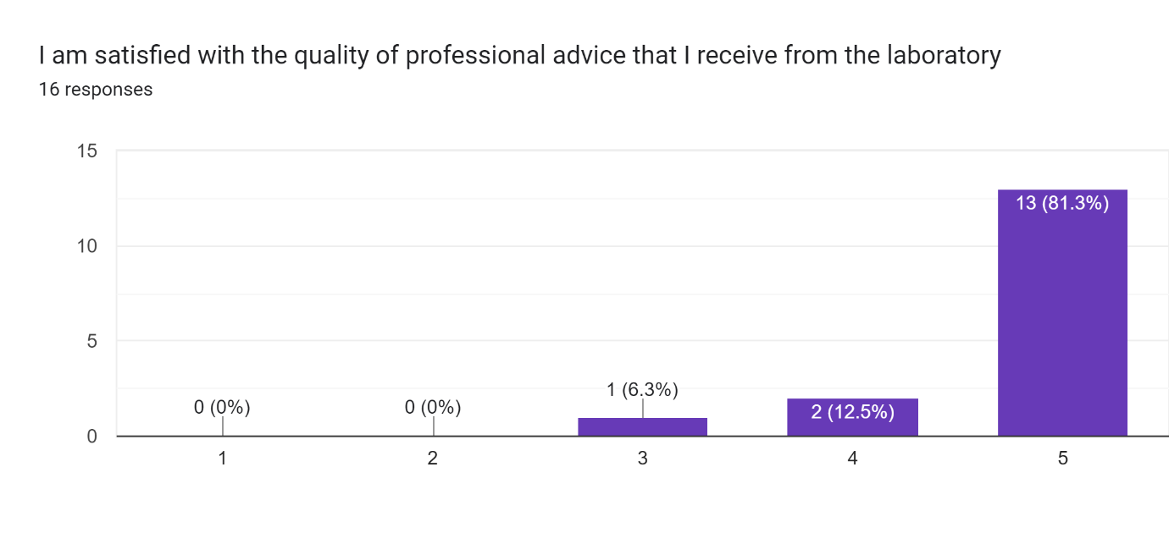

Question 5 - Any actions required following a positive newborn screening result are communicated clearly and promptly

13 people selected agree or strongly agree to the statement ‘Any actions required following a positive newborn screening result are communicated clearly and promptly’. Three people selected neither agree/nor disagree.

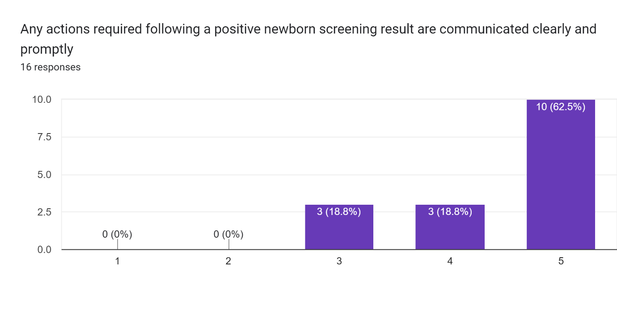

Question 6 – Reasons for repeat sample requests are clear

15 people selected agree or strongly agree to the statement ‘Reasons for repeat sample requests are clear’. 1 person selected disagree.

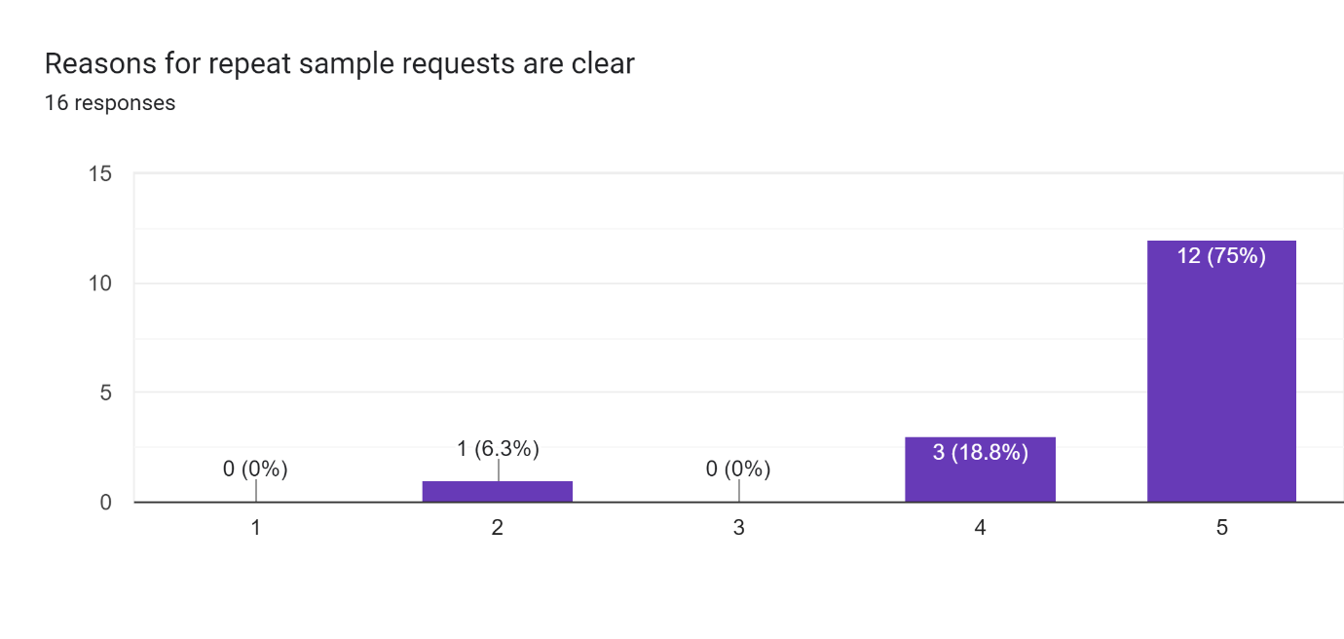

Question 7 - The newborn screening laboratory effectively communicates any changes to guidelines and policies

13 people selected agree or strongly agree to the statement ‘The newborn screening laboratory effectively communicates any changes to guidelines and policies’. 2 people selected neither agree/disagree, and one person selected strongly disagree.

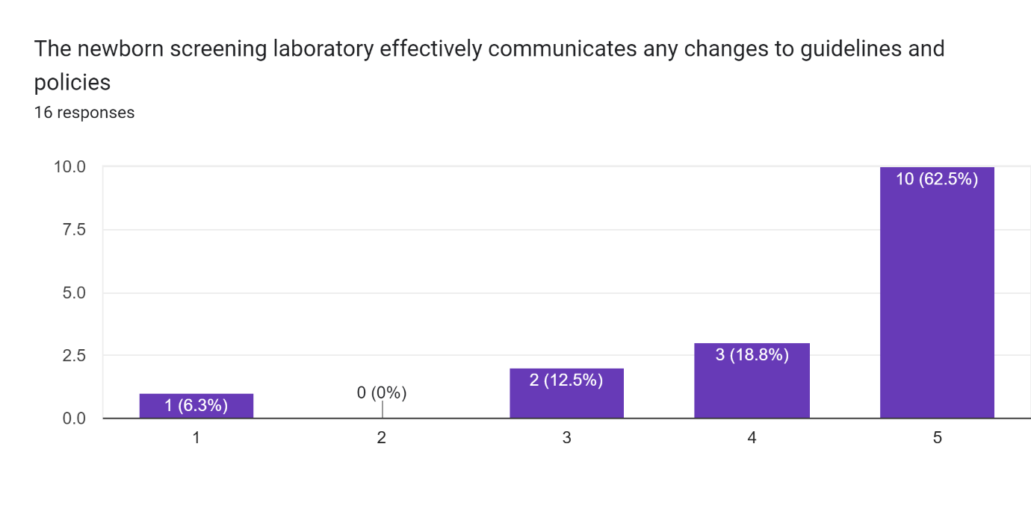

Question 8 - Overall, how would you rate the service provided by the Manchester Newborn Screening laboratory?

This question was answered on a scale of 1 to 5 with 1 = poor and 5= Excellent.

15 people selected 5 or 4 (excellent or good) to the statement ‘Overall, how would you rate the service provided by the Manchester Newborn Screening laboratory?’. 1 person selected neither agree/disagree.

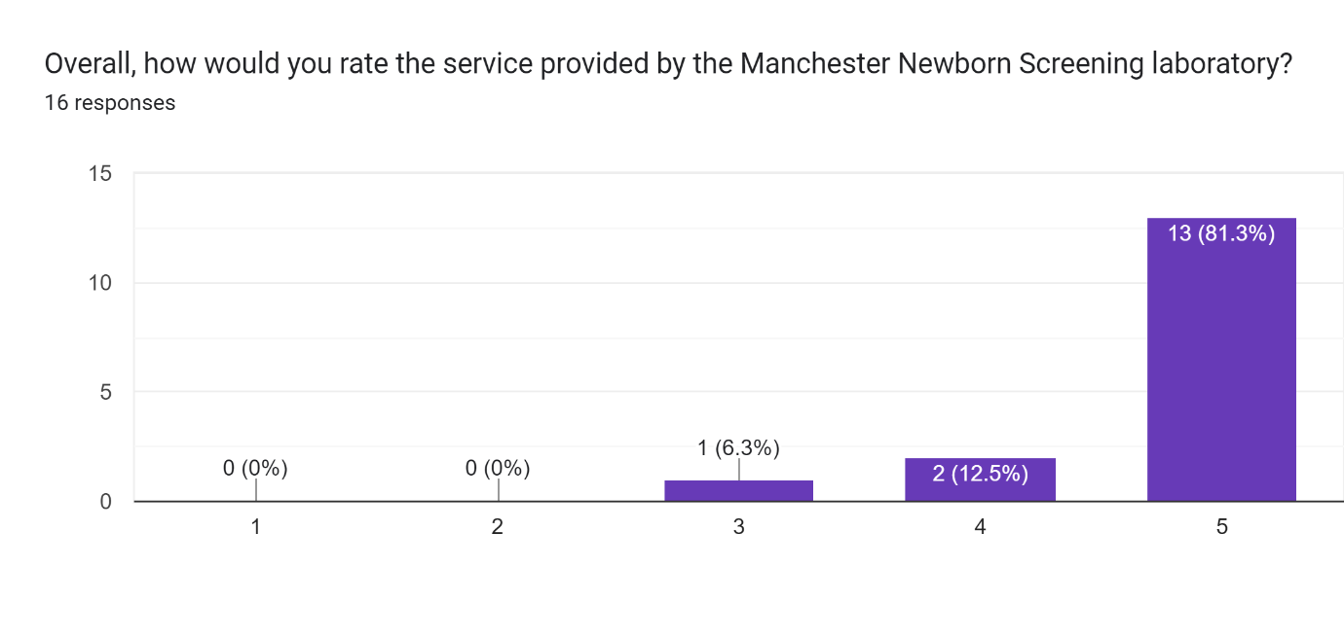

Question 9 - Do you have any other comments, questions or concerns?

The following comments were written in the survey:

* ‘Outstanding team and service’ **(Health visitor).**
* ‘Neera, Pat, Claire are lovely, always get back to you quickly and go the extra mile’ **(Failsafe Screening Team)**
* ‘We have asked for some clearer links on carrier letter to enable staff to select correct parent leaflet please I believe your team are looking at this Many Thanks’ **(Health Visitor)**
* ‘Always helpful and supportive thank you’ **(Health Visitor)**
* ‘The staff are all lovely and respond quickly to all my queries’ **(Screening Failsafe Admin)**
* ‘The team are very professional, approachable and always happy to offer support and guidance’ **(Health Visitor).**

**Conclusions**

The feedback from the user survey was very positive and although the number of responses was small, we did have a representation from all staff groups. There were several neutral responses where number 3 was selected (‘neither agree nor disagree to this statement’). As the survey did not allow n/a answers, it is possible that people selected a neutral response instead of leaving the answer blank. There was one person (a Paediatrician/Nurse) who responded with disagree to 3 of the statements. Unfortunately, this person did not leave any comments to provide any further information on why they disagreed, so it is difficult to respond with any actions.

One of the comments asked for some clearer links on the sickle cell carrier letter to enable staff to find the correct parent leaflet on the gov.uk website. These letters are sent as a pdf by email so unfortunately, we are not able to provide a link that can be clicked on, but we have adjusted the layout of the letter to make it easier to read and distinguish between the different letters available.

The remaining 5 comments were very complimentary about the NBS service and in particular the admin team who deal with our phone and email queries.

Overall, the 2023 user survey rated that the overall service provided by the NBS lab as either good or excellent and gave similar results to those received in 2021.