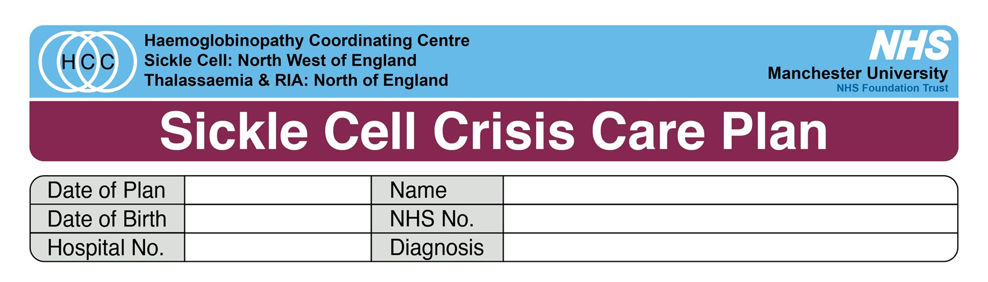

I am currently experiencing a painful crisis and require strong analgesia. Please see my care plan below and please inform the local haematology team.

TREAT AS A MEDICAL EMERGENCY

Seek urgent haematology advice if unwell or any concerning symptoms e.g., hypoxia, other respiratory signs or symptoms, neurological symptoms/drowsiness, priapism, sepsis

- Analgesia MUST be given within 30 minutes (NICE CG143)
- IV morphine bolus - 10mg in 10ml saline; gives slowly e.g., 2mg every 2 minutes as required, titrated to effect
- Sedation score must be carefully monitored during opiate administration as per local policy
- Use subcutaneous route if unable to get prompt IV access – do not cannulate legs/feet.
- Reassess and re-administer further boluses at 20 minutes intervals until pain controlled, monitor observation and sedation score.
- Adjunctive paracetamol and ibuprofen if not already had in last 4 hours and no contraindications.
- Once severe pain controlled and if multiple boluses required commence PCA.
- If PCA not available, consider oral alternative such as oxycodone and oxycontin but seek specialist advice.
- Consider other causes of pain if atypical.

Medical Assessment
- Full history and examination
- Initial bloods – FBC, reticulocytes, biochemistry, CRP, group and antibody screen.
- Check oxygen saturations on room air – if <94% or lower than steady state check patient is not hyperventilating due to pain or having respiratory depression due to opiates.
- If hypoxic - urgent medical review including arterial blood gas on room air, supplementary oxygen and inform haematology urgently.
- If temp >38 and no apparent source – blood cultures and commence antibiotics as per local Trust policy.
- Supplementary fluids if not drinking 3 litres in 24 hours.
- *Transfusion is only required in specific circumstances and must not be given without discussion with haematology*
- Adjuvant medication for patients being admitted - IV/PO paracetamol 1g tds, ibuprofen 400mg tds, chlorphenamine 4mg PO tds prn, cyclizine PO/IM 50mg tds prn.

Hospital Haemoglobinopathy Team Contacts
- Haematology SpR - insert contact here
- SCD Nurse Specialist – insert contact here
- Consultant Haematologist – insert contact here

