LINK: My processor is damaged
If your processor has been damaged (eg washed, crushed or physically damaged in any way) and we don’t think it can be fixed by the manufacturers or covered by their warranties:
- Contact us as soon as possible to let us know what has happened
- Fill in and sign a “damaged processor” form
  - We can send this out or you can fill it in when you come in to collect your loaner equipment.
- Come in to clinic to collect a loaner processor to use.
  - We need to ask for funding before we can provide you with a new set of equipment.

PLEASE NOTE: If you lose or damage (beyond repair) more than one processor, your loaner processor will be a body-worn processor
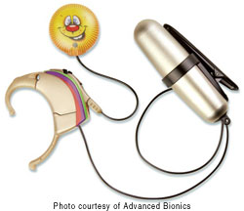
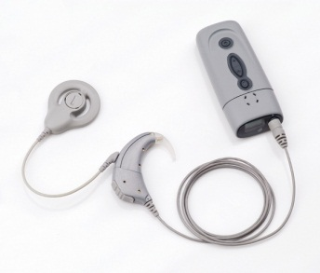
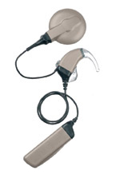

If your processor is not working, follow the troubleshooting guides as normal

