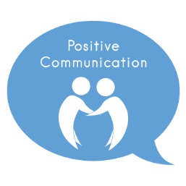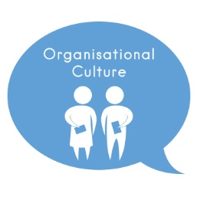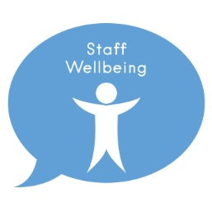

This week Joanne Rushton, Ward Manager, Ward A1, Wythenshawe Hospital, shares ***What Matters to Me*** work which she and members of her team have implemented to improve patient and staff experience.

Joanne tells us; ***“What Matters to Me*** feedback from patients is always utilised and improvements are implemented wherever possible, this includes reflecting on ***What Matters to Patient’s*** from their bedside WMTM bubble and feedback from the Friends and Family Test (FFT) which is currently showing 97% of patients who would be extremely likely to recommend the ward.

“Improvements from patient feedback include installation of mirrors in the bathrooms at a lower level which is invaluable to our patients who require wheelchairs to aid their mobility. We provide families with simple information such as car parking and passes, especially as we have families who travel a considerable distance to visit relatives, due to our ward being a specialist centre, and some of our patients can be with us for a considerable length of time. I also ensure that I am visible on the ward and engage with patients and their families and this has subsequently reduced any concerns being escalated and no complaints have been received in over 12 months”.

Joanne also ensures that patient’s pain relief is well managed for both chronic and acute pain, and has built a good relationship with the Acute Pain Team. She went on to say “the Acute Pain team call the ward every day and we discuss any patients with them and subsequently they provide telephone advice or call to see the patient the same day, which enables us to support the patients and ensure their pain is well managed. We also have a ward based Pharmacist which makes a massive difference to the patients experience.”

A display board reflecting post-operative care has also been developed on the ward which reflects the patients’ access to pain control, visible examples of treatment dressings and their pathway to the journey home. Joanne says “the board was developed by Chloe, our Practice Based Educator, originally to support new starters to the ward but we realised that this benefited patients and families too, as they were able to visibly see their treatment pathway”.

To encourage team retention and aid recruitment, Ward Manager Joanne promotes Wellbeing Wednesday once a month which provides staff members with mindfulness activities such as encouraging participation in a team jigsaw; additionally regular ward meetings take place, social events including shared lunches which staff members contribute to, and she always ensures she has an open door policy for both staff members, patients and their families. A study day has also been developed to support staff members to ensure their skills are up to date, due to the complexity of the patients and this has been planned to take place on a Saturday to aid with participation, and includes invitations to all multi-disciplinary staff members. Presenters at the event will include Joanne, a Vascular Consultant and a Specialist Vascular Nurse. The ward also has a Practice Based Educator to support retention, who works through competencies with staff members following previous feedback from staff who stated they felt overwhelmed by the complexities of the patient group and this has aided with retention too.

***What Matters to Me*** feedback from patients and staff members is reflected below:

**“**It’s been great, the staff can’t do enough for you and they keep me informed. What Matters to Me is they tell me what they are doing when they do my dressings and everything involving personal care”.

**“**I have been here lots and this is by far the best ward. You get a sense of feeling of being cared for, there’s been no issues whatsoever. You get to know the staff well. The Doctors and Nurses are good and everything is well organised and clean. I am communicated with at all times; it makes me feel comfortable with the personal care. ***What Matters to Me*** is things happening when they are supposed to, I feel this happens here.”

**“**Everything has been good, the Nurses have been great and the Doctors are okay. I feel well cared for and that I get the treatment that I need. My respect and dignity are maintained. Going home is ***What Matters to Me***.

The hospital needs to provide Freeview as so far the bedside TV has cost me £110 for the eleven days that I have been here. The food has changed quite a lot since I was last in, it’s much better now.”

Staff members ***What Matters to Me*** feedback***:***

**“**What matters to me is the family feeling on the ward; we share personal and professional life stories which helps us to bond. Personal care is important to patients and our team morale is the main thing behind. Our Ward Manager is very approachable and has an open door policy”.

**“**This is a really lovely ward, there’s a good team spirit and everyone works together which makes a difference and that’s ***What Matters to Me”***

**“**This is the most welcoming ward I have worked on. It’s a fresh team but works well. It’s busy but we manage it well as we work as a team. This ward has a good atmosphere.”

**“**I feel included with the team and I get invited to be involved even though I am not a nurse”.

