Instructions for use

To order Blood Collection Tubes:

KIT CFDNA COLLECTION TUBE 50 CEIVD (07785666001) – £437.59 + VAT (50 tubes in a pack)
Price valid till 31.03.26

Orders can be placed with Roche Diagnostics UK via the following routes:
- Send PO to customer services (burgesshill.customerservice@roche.com)

- Use the online ordering portal.
  - Register for the navify® Portal at navifyportal.roche.com and ensure all required staff can access the Online Ordering eService.
  - The navify® Portal administrator can invite staff to register to the navify® Portal and assign the Online Ordering eService using the User Management feature.
  - If you are unsure who your administrator is, any of your staff with navify® Portal access can check within their profile settings, as shown below.

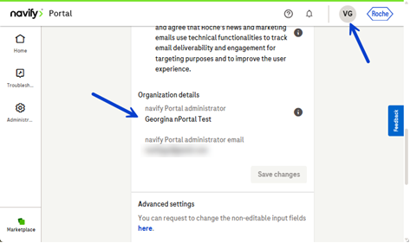

Please note only the Roche cell-safe blood tubes can be accepted for testing.

Instructions for Sample Collection:
Check blood tube expiry date and tubes contain only clear liquid and are free of any foreign matter.

Collect 2 x tubes of whole blood – 8.5ml per tube

Prevent backflow; tubes contain chemical additives and it is important to avoid backflow into the patient.

Collect specimen by venipuncture according to CLSI H3-A6¹

DO NOT FREEZE OR REFRIGERATE blood samples. Temperature is important. Keep at ambient temperature.

Label tubes with a minimum of 2 patient identifiers

Mix Tubes by inversion – mix by gentle inversion 8 to 10 times

Place labelled tubes with enough absorbent material to contain any leakage in a sealed plastic bag or 50 ml screw cap tube. Pack this bag or container in a box or other suitable packaging, cushioned so that the blood tube is protected from breakage, and include the completed request form.

Send to:
NW Genomic Laboratory Hub
Sample Reception
6th Floor
St Mary’s Hospital
Oxford Road
M13 9WL

nstructions1
